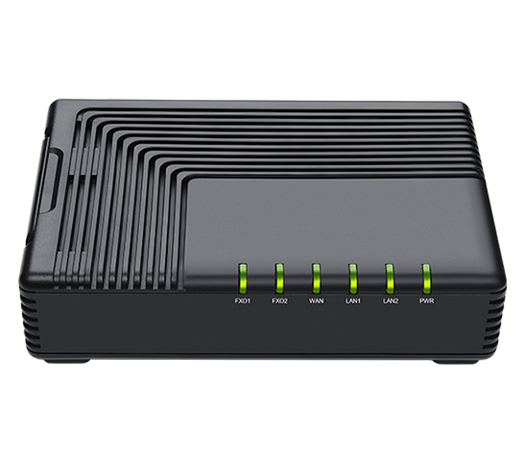

**SAS+Asterisk Configuration Guide**

**册**

FTA5120

**Directory**

一、 Introduction 2

二、 Configuration Process 2

三、 Configuration Operations 3

1、 Device Connection 3

2、 Configure Asterisk 3

3、 Log in to the web interface 4

4、 Configure FTA5120 4

① Configure SAS 4

② Configure SIP PnP 4

③ Configure Trunk 5

④ Configure the call route in the normal working state of the Asterisk PBX 7

⑤ Configure call rout when Asterisk PBX is not working 8

5、 Configure the IP Phone 9

四、 Configuration result verification 9

1、 Check extension registration status 9

2、 Call Test 10

Appendix 11

一、 Generate extension information 11

1、 Upload extension information 11

2、 Automatically generate extension information 12

3、 Add Manully 13

1. Introduction

Asterisk is an open source software version of the PBX system. It uses FTA5120 to cooperate with Asterisk 's high-availability IP communication solution. When Asterisk encounters network connection problems that may cause call interruptions, call failures and other communication obstacles, the FTA5120 adapter serves as a supporter of the SAS function. , which can provide independent networking capabilities when the enterprise network is abnormal, maintaining call quality and reliability.

1. Configuration Process

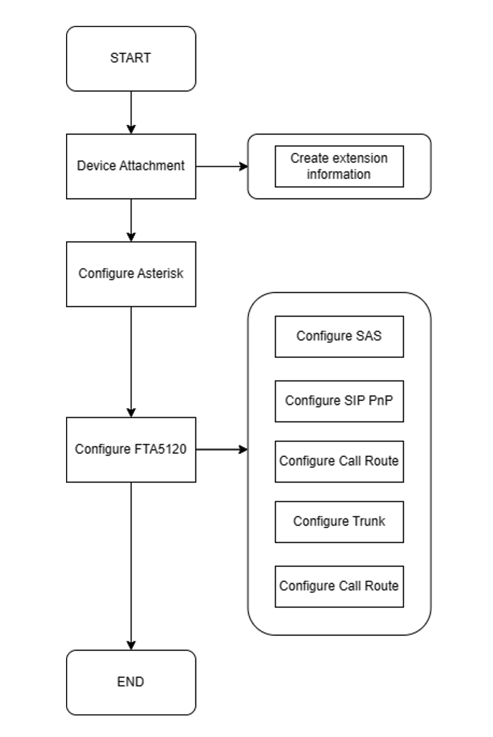

Figure 1 Configuration flow chart

1. Configuration Operations
2. **Device Connection**

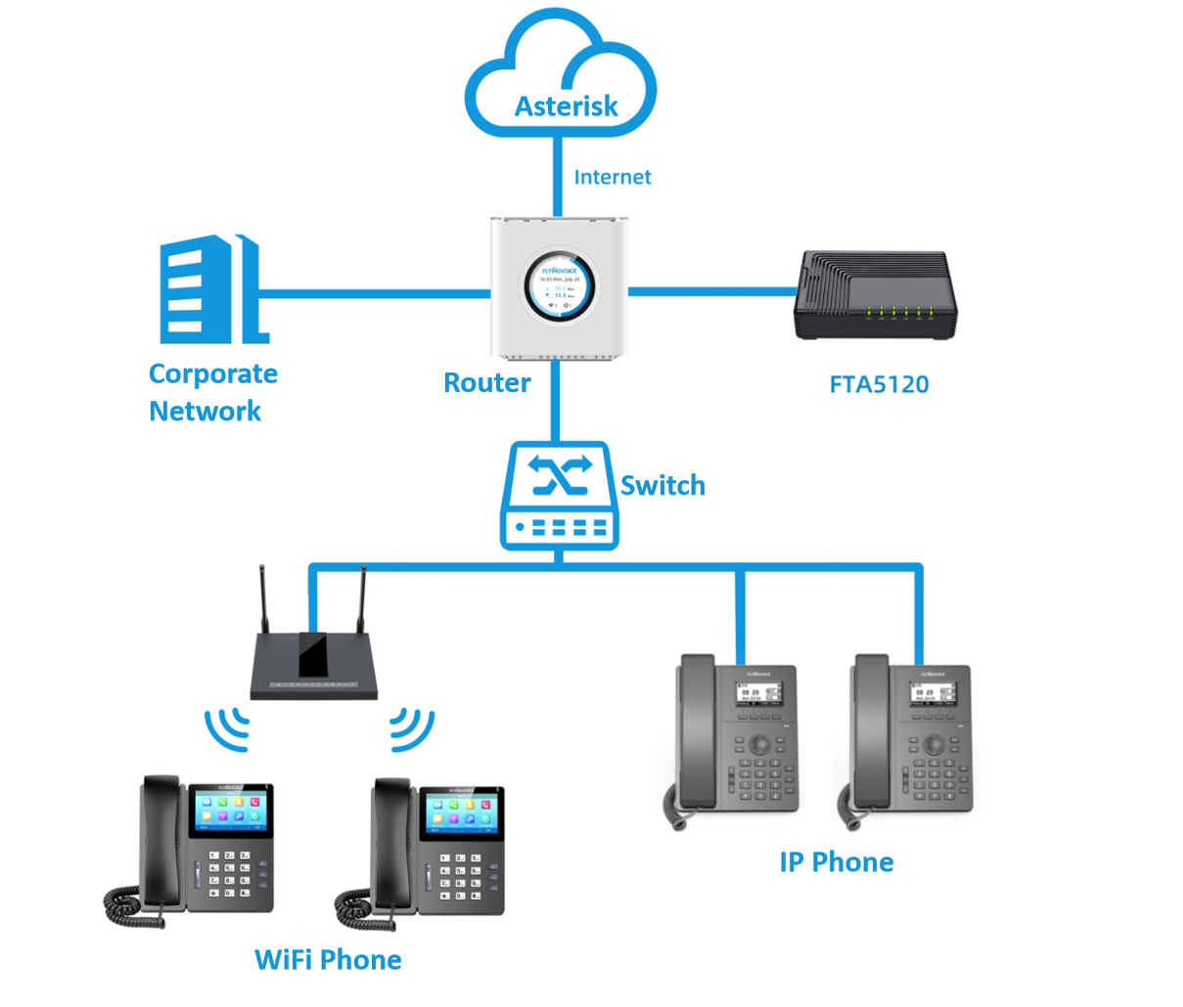

Figure 2 Equipment connection diagram

1. **Configure Asterisk**

Complete the configuration of the extension number information on the Asterisk platform. (There are no specific configuration instructions here. For details, you can check the Asterisk official website)

1. Log in to the web interface

http://192.168.1.1/index.asp in the browser. The default account and password are admin.

1. Configure FTA5120
2. **Configure SAS**

Fill in the public IP address or domain name of Asterisk under the SAS module to facilitate message forwarding by FTA5120.

**operating steps :**

Log in to the FTA5120 web interface--》SAS--》SAS Configuration --》Fill in the relevant configuration--》Save and Apply;

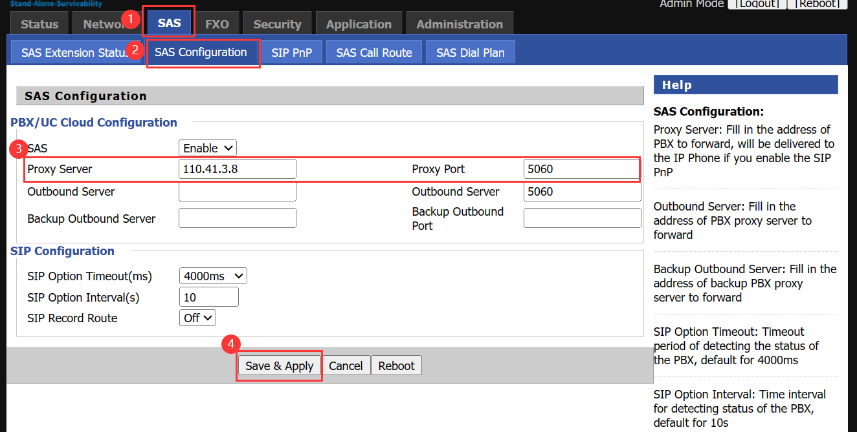

Figure 3 Configure SAS

|  |  |
| --- | --- |
| **Parameter** | **Describe** |
| **Proxy Server** | Fill in the domain name or IP of Asterisk |
| **Proxy Port** | Enter the port number of the registration server |

1. **Configure SIP PnP**

Enable the SIP PnP function of FTA5120 and import the extension information to be delivered. FTA5120 will automatically deliver extension registration information to the phone.

**Notice:**

The extension information imported here must be consistent with the extension information configured in Asterisk.

**Tips:**

There are three ways to generate extension information in SAS, namely uploading extension information, automatically generating extension information, and manually adding extension information. Here we take the method of uploading extension information as an example. For specific configuration details, please see the section on **Generate extension information** in the attached page .

**operating steps:**

Log in to the FTA 5120 web interface--》SAS--》SIP PnP --》Fill in the relevant configuration--》Save and Apply;

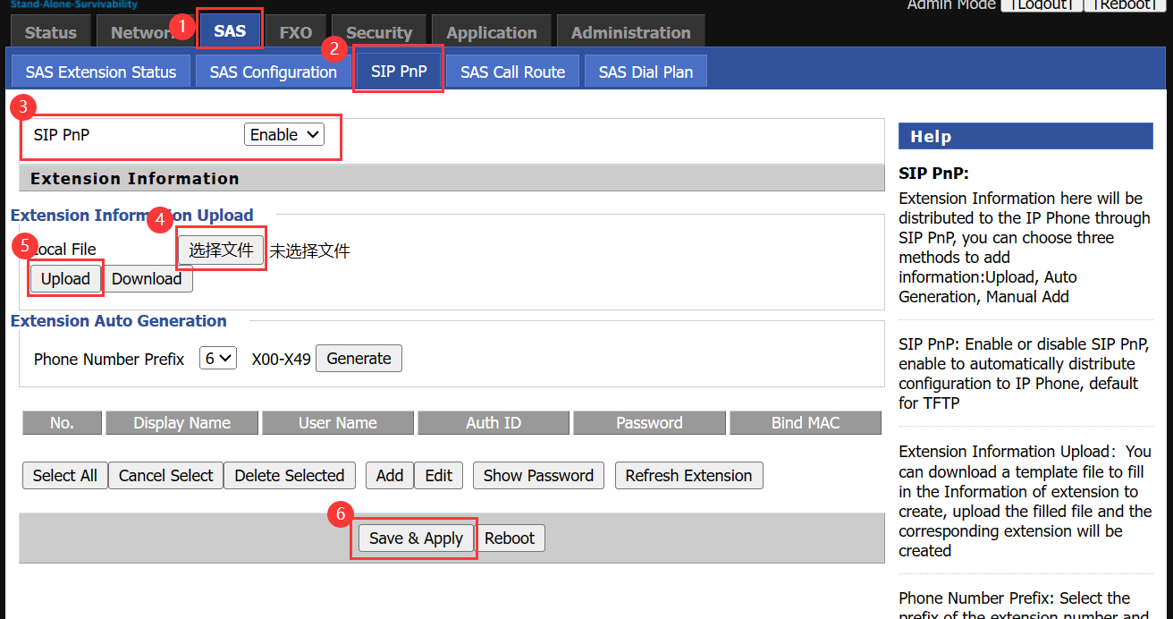

Figure 4 Configure SIP PnP

1. **Configure Trunk**

The trunk information is configured on the FTA5120 to dock with the Asterisk PBX to realize the external call in and out.

**operating steps:**

Log in to the web--》FXO--》SIP Trunk--》Fill in information--》Save and Apply；

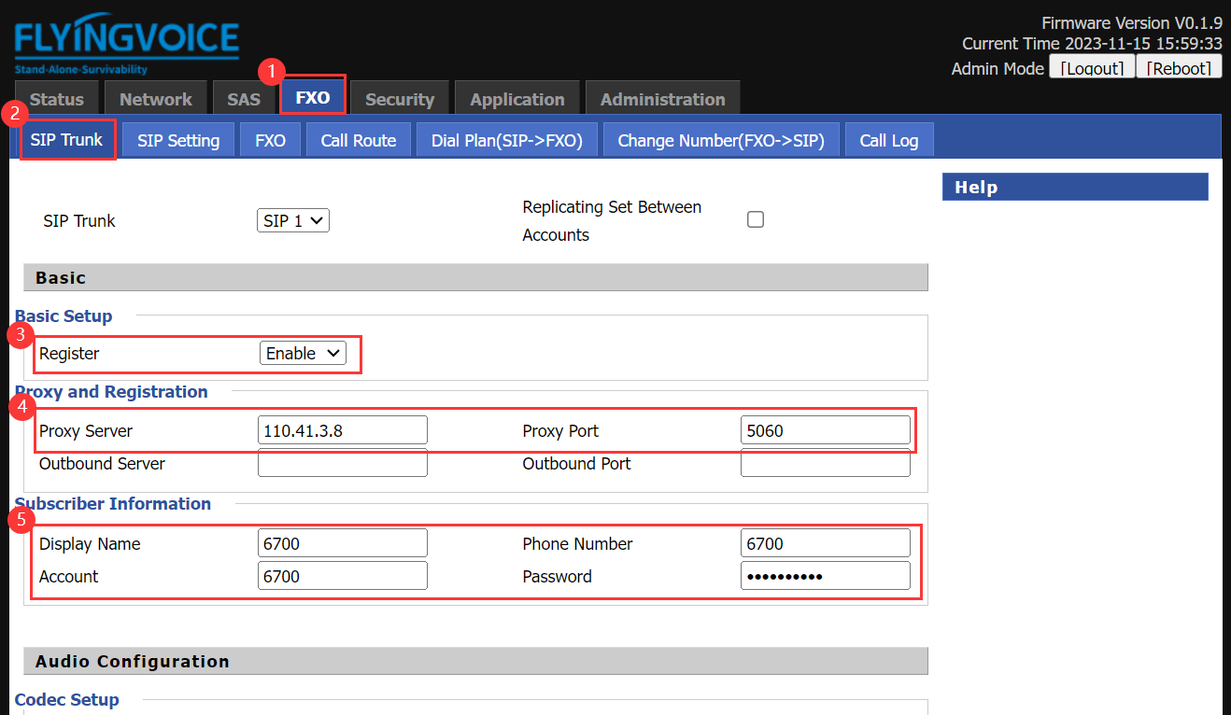

Figure 5 Set sip trunk

|  |  |
| --- | --- |
| **Parameter** | **Description** |
| **Register** | Enable |
| **Proxy Server** | Enter the domain name or IP of the PBX |
| **Proxy Port** | 5060 |
| **Display Name** | Fill in the trunk name |
| **Phone Number** | Fill in trunk account number |
| **Account** | Fill in the trunk authentication name |
| **Password** | Fill in the trunk password |

1. **Configure the call route in the normal working state of the Asterisk PBX**

When the Asterisk PBX works normally, the communication between the phone and the Asterisk PBX is forwarded by the FTA5120 to realize the call in and call out of the PSTN.

**operating steps:**

Log in to the web of FTA5120--》FXO--》Call Route--》Fill in information--》Save and Apply；

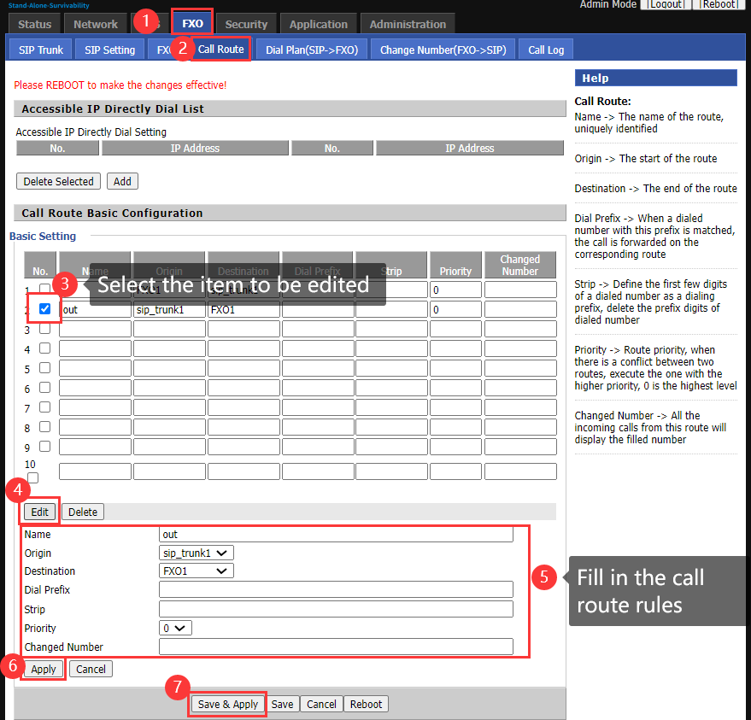

Figure 6 Set outbound route

|  |  |
| --- | --- |
| **Parameter** | **Description** |
| **Name** | Customize the route name |
| **Origin** | The start of route |
| **Destination** | The end of route |
| **Dial Prefix** | When a dialed number is matched with the prefix, the call is forwarded according to the corresponding route |
| **Strip** | The first few bits of the dial are defined as the dial prefix |
| **Priority** | Define the priority of this route. When two routes conflict, the higher priority is executed, and 0 is the highest level |
| **Changed Number** | External call in display uniform number |

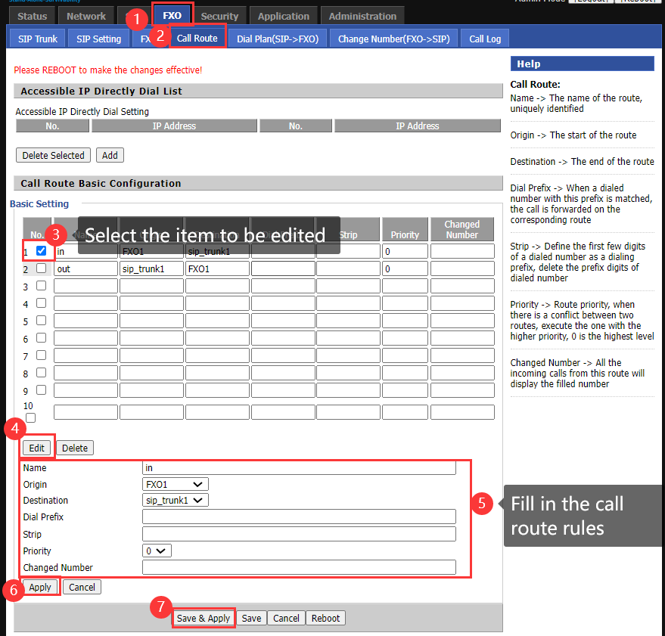

Figure 7 Set inbound route

1. **Configure call rout when Asterisk PBX is not working**

When Asterisk is unavailable, FTA5120 can provide independent networking capabilities, and the phone can directly implement incoming and outgoing calls through FTA5120.

**operating steps :**

Log in to the FTA 5120 web interface--》SAS--》SAS Call Route--》Fill in the relevant configuration--》Save and apply;

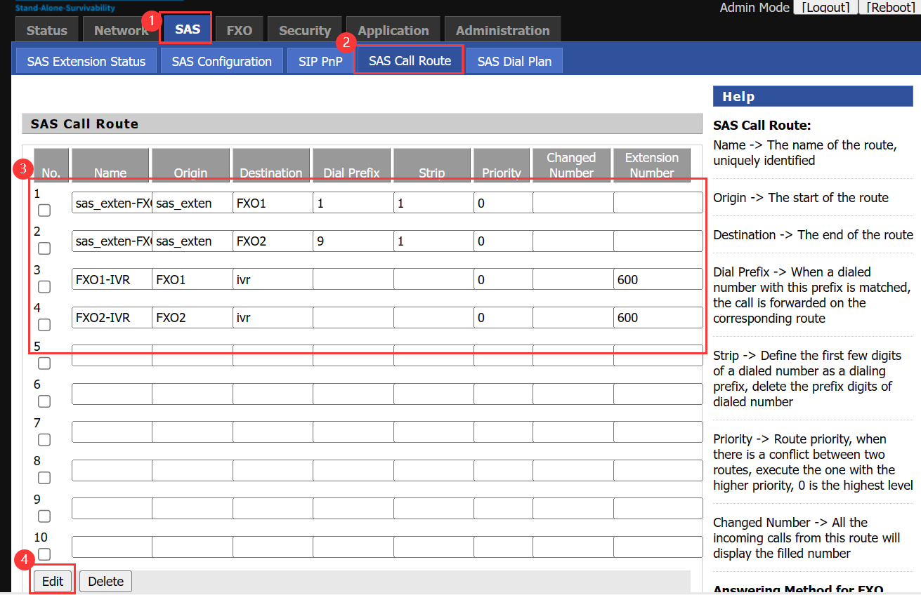

Figure 8 Call Route

1. **Configure the IP Phone**

The phone is powered on and connected to the Internet, waiting to obtain extension number information.

1. Configuration result verification
2. **Check extension registration status**

You can check the extension registration status through the FTA5120 extension status interface.

**operating steps:**

Log in to the web interface of FTA5120--》SAS--》SAS Extension Status;

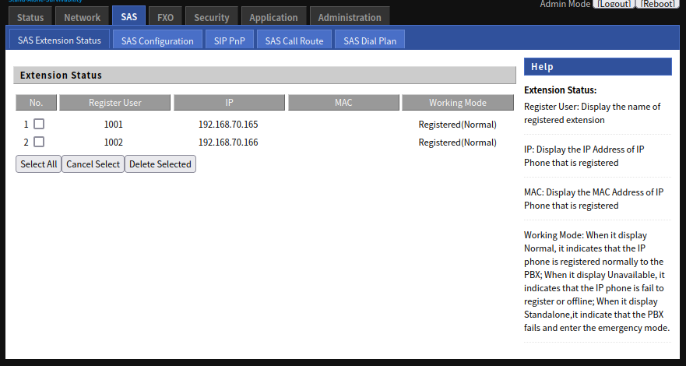

Figure 9 Extension registration status

1. **Call Test**

Test calls using extensions 1001 and 1002

# Appendix

1. Generate extension information
2. **Upload extension information**

We can download the extension information file template and fill in the form with the extension information configured on Asterisk.

**operating steps:**

Log in to the web interface of FTA5120--》 SAS--》 SIP PnP --》 Extension Information Upload--》Download;

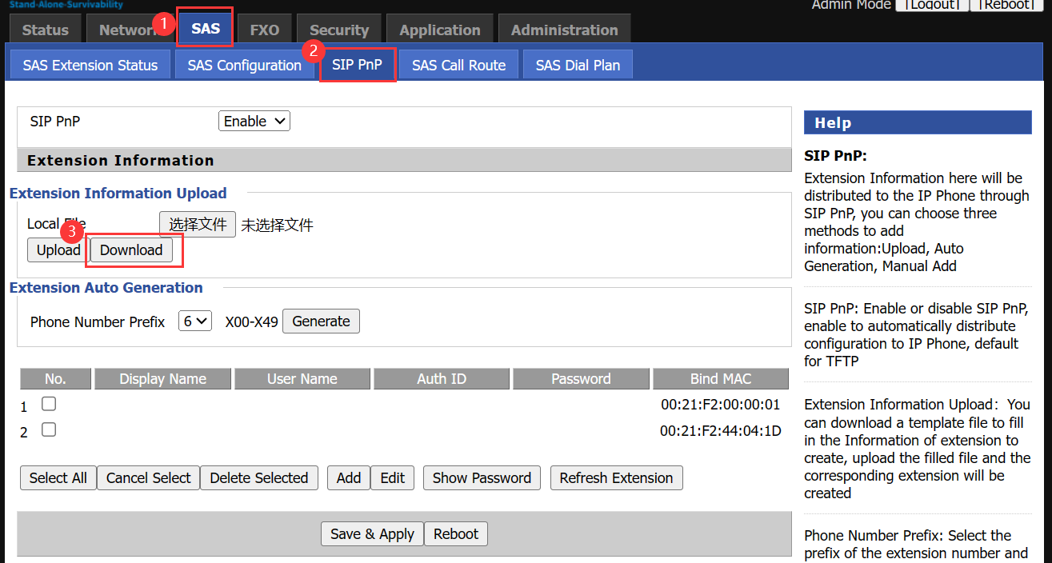

Figure 10 Download document template

Fill in the form with extension information.

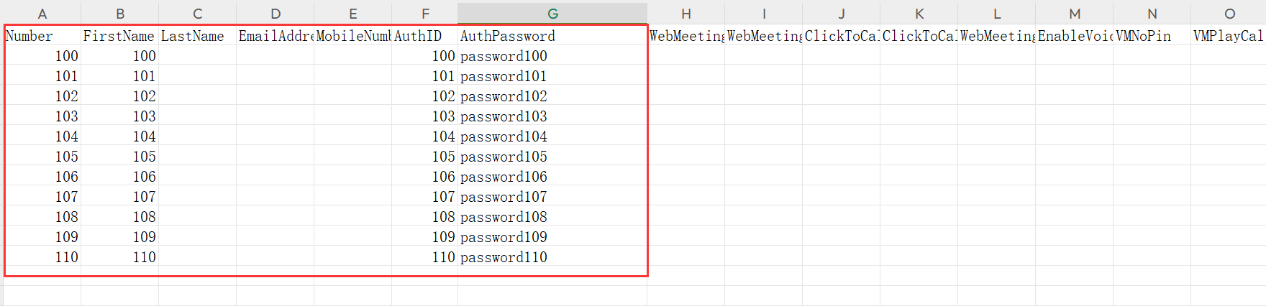

Figure 11 Document Template

|  |  |
| --- | --- |
| **Parameter** | **Describe** |
| **Number** | Fill in the display name |
| **FirstName** | Fill in username |
| **AuthID** | Fill in the certification name |
| **AuthPassword** | Fill in the authentication password |

1. **Automatically generate extension information**

SAS can automatically generate 50 consecutive extension information with extension numbers X00-X49 (X can be selected from 1-9). The default password is "Password+ extension number".

**operating steps:**

Log in to the web interface of FTA5120--》SAS--》SIP PnP--》Extension Auto Generation--》Fill in the information--》Generate;

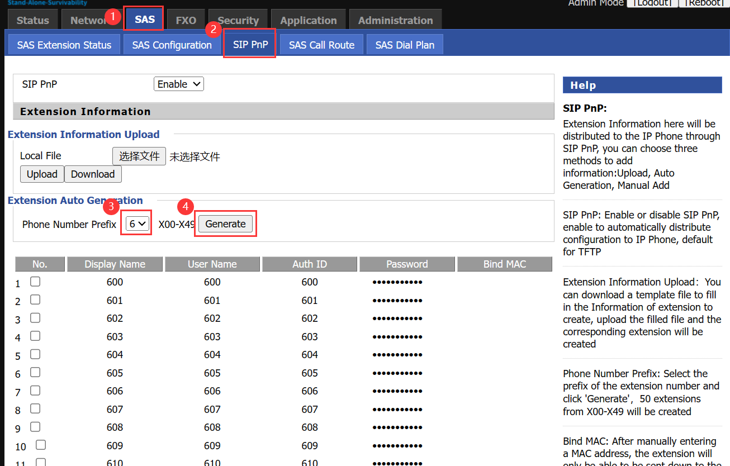

Figure 12 Extension information is automatically generated

1. **Add Manully**

SAS supports users to add extension information manually.

**operating steps:**

Log in to the web interface of FTA5120--》SAS--》SIP PnP--》Add--》Fill in the information--》Apply--》Save and apply;

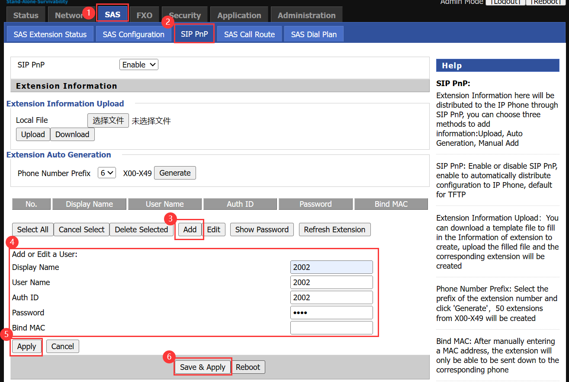

Figure 13 Manually add extension information

|  |  |
| --- | --- |
| **Parameter** | **Describe** |
| **Add or Edit a User** | Fill in user name |
| **Display Name** | Fill in the display name |
| **Auth ID** | Fill in the certification name |
| **Password** | Fill in the authentication password |
| **Bind MAC** | Manually enter a MAC address, and the extension will only be distributed to the corresponding phone. |