

Auto Provision the Flyingvoice Phone
with Metaswitch

Version: 1.0
May. 2021

About This Guide

Thank you for choosing the Flyingvoice SIP IP phones. The purpose of this guide introduces how to configure Flyingvoice SIP IP phones via CommPortal phone configurator.
The configuration process outlined in this guide applies to the following phone models:

Phone Model | Firmware
FIP10(P) | V0.5.32.3 or later
FIP11C(P) | V0.5.32.3 or later
FIP13G | V0.5.32.3 or later
FIP14G | V0.5.32.3 or later
FIP15G | V0.5.32.3 or later
FIP16 | V5.15.4 or later
Note

The configuration process described in this guide takes the Flyingvoice FIP13G IP phone as an example.

In This Guide
Topics provided in this guide include:

  - Chapter 1 Configuration Methods

  - Chapter 2 Customizing Your Phone

  - Chapter 3 Downloading Configuration Files to Phones

  - Chapter 4 Basic Call Features

  - Chapter 5 Advanced Phone Features

Table of Contents

About This Guide 1
In This Guide 1
Table of Contents 2
Configuration Methods 3
Phone User Interface 3
CommPortal Phone Configurator 3
Customizing Your Phone 4
Registering Accounts 4
Time & Date 5
Directory 10
Remote Phone Book 11
Line Keys Configuration 12
Downloading Configuration Files to Phones 18
Obtaining the Provisioning Server Address 18
Triggering the Phone to Perform Auto Provisioning 18
Basic Call Features 20
Do Not Disturb 20
Transferring Calls 21
Local Conference Call 22
Call Park and Call Retrieve 22
Directed Pickup 24
Group Pickup 25
Advanced Phone Features 27
Enhanced Monitor Extension 27
Intercom and Push-to-Talk 29
Multicast Paging 31
DTMF 34
Configuring Transmitting DTMF Digit Method 35
Call Jump 36

Configuration Methods

There are two ways to configure Flyingvoice SIP IP phones.

- Phone user interface: if you want to deploy a small number of phones, you can configure IP phones one by one via phone user interface.
- CommPortal Phone Configurator: if you want to deploy a mass of IP phones, you can configure IP phones via CommPortal phone configurator.

Phone User Interface
The phone user interface is made up of keypad and LCD screen, allowing users to perform all call operations and change basic configuration settings directly on the phone.

CommPortal Phone Configurator
The CommPortal Phone Configurator is an online graphical user interface for the Metaview SIP provisioning server. You can configure the phone by using this simple and intuitive interface. For more information, refer to: www.metaswitch.com.
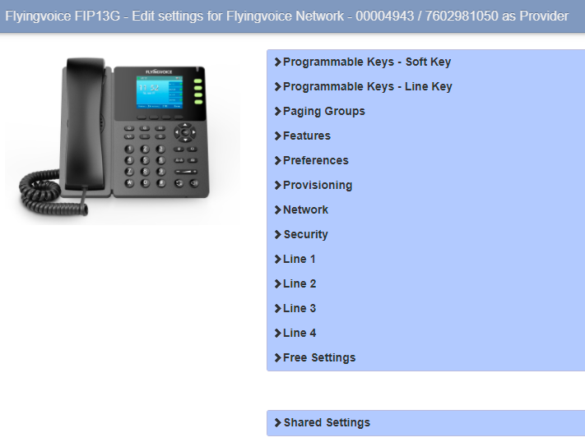

CommPortal Phone Configurator

Customizing Your Phone

Registering Accounts
You can register one or multiple accounts on the SIP IP phone.

To register an account via CommPortal phone configurator:

- Click Line X->User.
- Enter the desired values in Directory Number and Display Name fields respectively.
- Select the desired value from the Description field.
- Depending on your selection:
  - If you select Use directory number, the directory number will act as the account label to be displayed on the idle screen.
  - If you select Use extension, the extension will act as the account label to be displayed on the idle screen.
  - If you select Custom description, you can customize the label to be displayed on the idle screen in the Custom Description field.
- Click Line X->SIP Server.
- Enter the desired values in the SIP Server Address field. Contact your system administrator for more information.
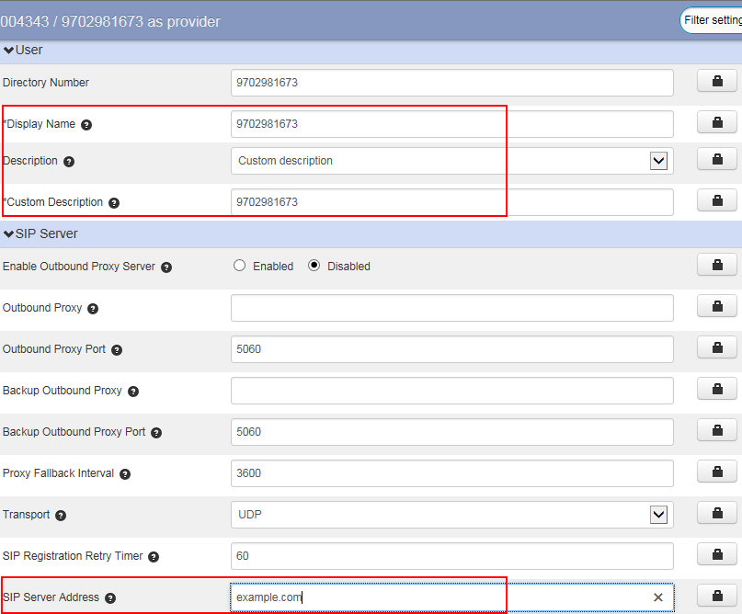

You can repeat steps 2 to 7 to register more accounts.
- Click Save changes to accept the change.
- Perform auto provisioning on the phone to download above configurations. For more information on how to perform auto provisioning.

Time & Date
Flyingvoice IP phones maintain a local clock. You can choose to get the time and date from SNTP (Simple Network Time Protocol) time server to have the most accurate time to make better use of daylight and to conserve energy, or you can set the time and date manually. The time and date can be displayed in several formats on the phone.

Time Zone

The following table lists the values you can use to set the time zone location.

Time Zone | Time Zone Name | Time Zone | Time Zone Name
-12 | Eniwetok,Kwajalein | +2 | Estonia(Tallinn)
-11 | Midway Island | +2 | Finland(Helsinki)
-11 | Samoa | +2 | Gaza Strip(Gaza)
-10 | United States-Hawaii-Aleutian | +2 | Greece(Athens)
-10 | United States-Alaska-Aleutian | +2 | Israel(Tel Aviv)
-9:30 | French Polynesia | +2 | Jordan(Amman)
-9 | United States-Alaska Time | +2 | Latvia(Riga)
-8 | Canada(Vancouver,Whitehorse) | +2 | Lebanon(Beirut)
-8 | Mexico(Tijuana,Mexicali) | +2 | Moldova(Kishinev)
-8 | United States-Pacific Time | +2 | Jerusalem
-8 | Baja California | +2 | Russia(Kaliningrad)
-7 | Canada(Edmonton,Calgary) | +2 | Bulgaria(Sofia)
-7 | Mexico(Mazatlan,Chihuahua) | +2 | Lithuania(Vilnius)
-7 | United States-Mountain Time | +2 | Cairo
-7 | United States-MST no DST | +2 | Istanbul
-7 | Chihuahua,La Paz | +2 | E.Europe
-7 | Arizona | +2 | Harare,Pretoria
-6 | Guatemala | +2 | Tripoli
-6 | El Salvador | +2 | Romania(Bucharest)
-6 | Honduras | +2 | Syria(Damascus)

Time Zone | Time Zone Name | Time Zone | Time Zone Name
-6 | Nicaragua | +2 | Turkey(Ankara)
-6 | Costa Rica | +2 | Ukraine(Kyiv, Odessa)
-6 | Belize | +3 | East Africa Time
-6 | Canada-Manitoba(Winnipeg) | +3 | Iraq(Baghdad)
-6 | Chile(Easter Islands) | +3 | Russia(Moscow)
-6 | Guadalajara | +3 | St.Petersburg
-6 | Monterrey | +3 | Kuwait,Riyadh
-6 | Mexico(Mexico City,Acapulco) | +3 | Nairobi
-6 | Saskatchewan | +3 | Minsk
-6 | United States-Central Time | +3 | Volgograd (RTZ 2)
-5 | Bogota,Lima | +3:30 | Iran(Teheran)
-5 | Quito | +4 | Armenia(Yerevan)
-5 | Peru | +4 | Azerbaijan(Baku)
-5 | Indiana (East) | +4 | Georgia(Tbilisi)
-5 | Bahamas(Nassau) | +4 | Kazakhstan(Aktau)
-5 | Canada(Montreal,Ottawa,Quebec) | +4 | Russia(Samara)
-5 | Cuba(Havana) | +4 | Abu Dhabi,Muscat
-5 | United States-Eastern Time | +4 | Izhevsk,Samara (RTZ 3)
-4:30 | Venezuela(Caracas) | +4 | Port Louis
-4 | Canada(Halifax,Saint John) | +4:30 | Afghanistan(Kabul)
-4 | Atlantic Time (Canada) | +5 | Kazakhstan(Aqtobe)
-4 | San Juan | +5 | Kyrgyzstan(Bishkek)
-4 | Manaus,Cuiaba | +5 | Ekaterinburg (RTZ 4)
-4 | Georgetown | +5 | Karachi
-4 | Chile(Santiago) | +5 | Tashkent
-4 | Paraguay(Asuncion) | +5 | Pakistan(Islamabad)
-4 | United Kingdom-Bermuda(Bermuda) | +5 | Russia(Chelyabinsk)
-4 | United Kingdom(Falkland Islands) | +5:30 | India(Calcutta)
-4 | Trinidad&Tobago | +5:30 | Mumbai,Chennai
-3:30 | Canada-New Foundland(St.Johns) | +5:30 | Kolkata,New Delhi
-3 | Greenland(Nuuk) | +5:30 | Sri Jayawardenepura
-3 | Argentina(Buenos Aires) | +5:45 | Nepal(Katmandu)

Time Zone | Time Zone Name | Time Zone | Time Zone Name
-3 | Brazil(no DST) | +6 | Kazakhstan(Astana, Almaty)
-3 | Brasilia | +6 | Russia(Novosibirsk,Omsk)
-3 | Cayenne,Fortaleza | +6 | Bangladesh(Dhaka)
-3 | Montevideo | +6:30 | Myanmar(Naypyitaw)
-3 | Salvador | +6:30 | Yangon (Rangoon)
-3 | Brazil(DST) | +7 | Russia(Krasnoyarsk)
-2:30 | Newfoundland and Labrador | +7 | Thailand(Bangkok)
-2 | Brazil(no DST) | +7 | Vietnam(Hanoi)
-2 | Mid-Atlantic | +7 | Jakarta
-1 | Portugal(Azores) | +8 | China(Beijing)
-1 | Cape Verde Islands | +8 | Singapore(Singapore)
0 | GMT | +8 | Hong Kong,Urumqi
0 | Western Europe Time | +8 | Taipei
0 | Monrovia | +8 | Kuala Lumpur
0 | Reykjavik | +8 | Australia(Perth)
0 | Casablanca | +8 | Russia(Irkutsk, Ulan-Ude)
0 | Denmark-Faroe Islands(Torshavn) | +8 | Ulaanbaatar
0 | Ireland(Dublin) | +8:45 | Eucla
0 | Edinburgh | +9 | Korea(Seoul)
0 | Portugal(Lisboa,Porto,Funchal) | +9 | Japan(Tokyo)
0 | Spain-Canary Islands(Las Palmas) | +9 | Russia(Yakutsk,Chita)
0 | United Kingdom(London) | +9:30 | Australia(Adelaide)
0 | Lisbon | +9:30 | Australia(Darwin)
0 | Morocco | +10 | Australia(Sydney,Melboume,Canberra)
+1 | Albania(Tirane) | +10 | Australia(Brisbane)
+1 | Austria(Vienna) | +10 | Australia(Hobart)
+1 | Belgium(Brussels) | +10 | Russia(Vladivostok)
+1 | Caicos | +10 | Magadan (RTZ 9)
+1 | Belgrade | +10 | Guam,Port Moresby
+1 | Bratislava | +10 | Solomon Islands
+1 | Ljubljana | +10:30 | Australia(Lord Howe Islands)
+1 | Chad | +11 | New Caledonia(Noumea)

Time Zone | Time Zone Name | Time Zone | Time Zone Name
+1 | Copenhagen | +11 | Chokurdakh (RTZ 10)
+1 | West Central Africa | +11 | Russia(Srednekolymsk Time)
+1 | Poland(Warsaw) | +11:30 | Norfolk Island
+1 | Spain(Madrid) | +12 | New Zealand(Wellington,Auckland)
+1 | Croatia(Zagreb) | +12 | Fiji Islands
+1 | Czech Republic(Prague) | +12 | Russia(Kamchatka Time)
+1 | Denmark(Kopenhagen) | +12 | Anadyr
+1 | France(Paris) | +12 | Petropavlovsk-Kamchatsky (RTZ 11)
+1 | Germany(Berlin) | +12 | Marshall Islands
+1 | Hungary(Budapest) | +12:45 | New Zealand(Chatham Islands)
+1 | Italy(Rome) | +13 | Nuku'alofa
+1 | Switzerland(Bern) | +13 | Tonga(Nukualofa)
+1 | Sweden(Stockholm) | +13:30 | Chatham Islands
+1 | Luxembourg(Luxembourg) | +14 | Kiribati
+1 | Macedonia(Skopje)
+1 | Netherlands(Amsterdam)
+1 | Namibia(Windhoek)

Configuring NTP Server

You can set an NTP time server for the desired area as required. The NTP time server address can be offered by the DHCP server or configured manually.

To configure the NTP settings via CommPortal phone configurator:

- Click Preferences->Time&Date.
- Select NTP from the drop-down menu of Obtain Time Method.
- Select the priority for the IP phone to use the NTP server address offered by the DHCP server.
  - High, the phone uses the NTP server address offered by the DHCP server preferentially.
  - Low, the phone uses the NTP server address configured manually preferentially.
- Enter the domain names or IP addresses in the Primary NTP Server and Secondary NTP Server fields respectively.

- 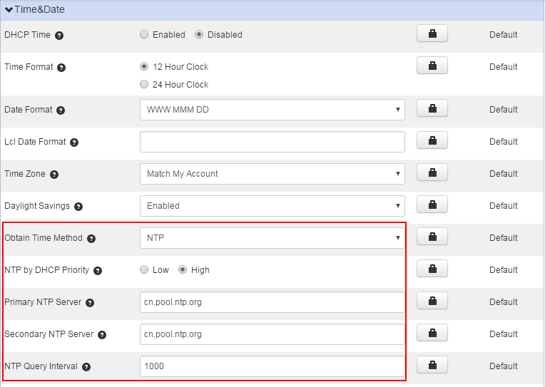Enter the desired interval to update time and date from the NTP server in the NTP Query Interval field.

- Click Save changes to accept the change.
- Perform auto provisioning on the phone to download above configurations.

Configuring the Method to Obtain Time and Date
By default, the phones obtain the time and date from the NTP time server, you can also set the time and date manually.

To configure the time and date format via CommPortal phone configurator:

- Click Preferences->Time&Date.
- Select the desired value from the drop-down menu of Obtain Time Method.
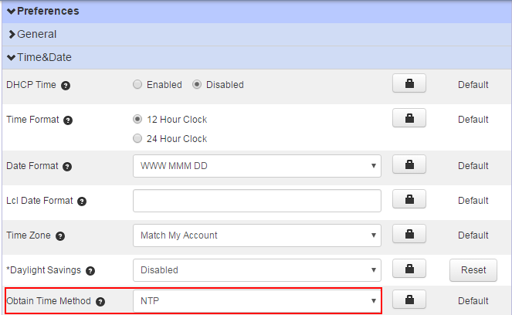
- Click Save changes to accept the change.
- Perform auto provisioning on the phone to download above configurations.

Configuring Time and Date Format
You can customize the time and date by choosing between a variety of time and date formats. The available date formats are as follow:
Date Format | Example (2018-07-27)
WWW MMM DD | Fri Jul 27
DD-MMM-YY | 27- Jul -18
YYYY-MM-DD | 2018-07-27
DD/MM/YYYY | 27/07/2018
MM/DD/YY | 07/27/18
DD MMM YYYY | 27 Jul, 2018
WWW DD MMM | Fri 27, Jul

To configure the time and date format via CommPortal phone configurator:

- Click Preferences->Time&Date.
- Mark the desired radio box of the Time Format field.
- Select the desired date format from the drop-down menu of Date Format.
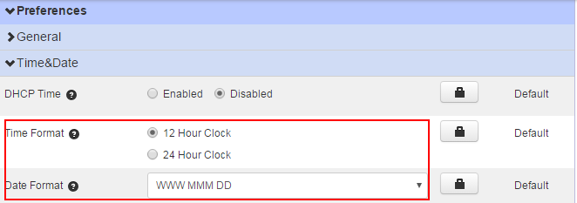

- Click Save changes to accept the change.
- Perform auto provisioning on the phone to download above configurations.

Directory
The directory provides easy access to frequently used lists. The lists may contain Local Directory, History, Remote Phone Book and LDAP.
If Remote Phone Book and LDAP are not configured in advance, you cannot see them on the phone user interface.

Note

Remote Phone Book
The remote phone book is a centrally maintained phone book, stored on the remote server. Users only need the access URL of the remote phone book. The IP phone can establish a connection with the remote server and download the phone book, and then display the remote phone book entries on the phone.

Configuring Access URL of the Remote Phone Book

To configure an access URL for a remote phone book via CommPortal phone configurator:
- Click Features->Remote Phone Book.
- Enter the access URL in the Remote Phonebook URL N field.
- Enter the name in the Display Item Name N field.
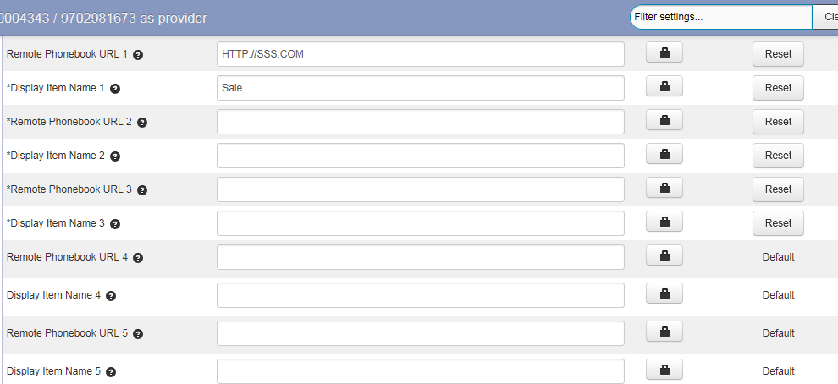

- Click Save changes to accept the change.
- Perform auto provisioning on the phone to download above configurations.

Viewing Remote Phone Book on the Phone

To view your remote phone book via phone user interface:

- Do one of the following.
  - Press Menu->Directory->Remote Phone Book.
- Select the desired group, and then press the Enter soft key.
The phone connects to the remote phone book and proceeds to load it.

Placing a Call from Remote Phone Book

To place a call from the remote phone book:

- Do one of the following.
  - Press Menu->Directory->Remote Phone Book.
- Select the desired remote group, and then press the Enter soft key.
- Select the desired contact in the remote phone book.
- Press the Send soft key.

Line Keys Configuration
You can assign predefined features to line keys. So that you can quickly access features.
Line key is not applicable to FIP12WP and FIP16 phones.
Note

To assign features to line keys via CommPortal phone configurator:

- Click Programmable Keys - Line Key->Key X.
- Select desired key type from the Soft key action field.
- Assign a feature to the key.
- (Optional.) Enter a string that will appear on the LCD screen in the Label field.
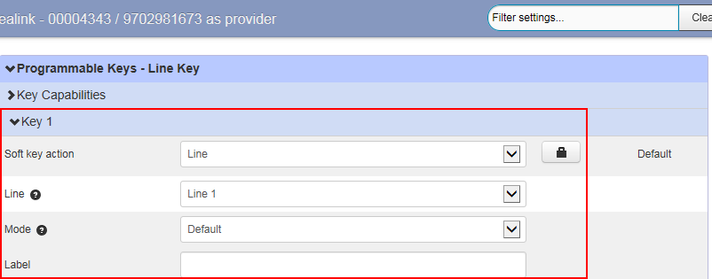
- Click Save changes to accept the change.
- Perform auto provisioning on the phone to download above configurations.

Line Key Features

You can assign the following features to your line keys. Some features may vary in different phone models.
Line | Directed Pickup | Directory | DND | Enhanced Monitor Extension | Group Listening | Group Pickup | Hold
Intercom/ PTT | LDAP | Line Identity | Multicast Paging | Paging List | Park Call | Private Call Hold | Retrieved Parked Call
Speed Dial | History

Line

You can use this key feature to accept incoming calls, place active calls on hold or resume a held call.
Dependencies: Soft key action (Line)

Line (the account this feature will be applied to)
Mode (Default/Lock)

Label (key label displayed on the LCD screen)
Usage: When receiving an incoming call, the Line key LED flashes green:
- Press the DSS key to accept the incoming call.
- Press the DSS key to place a new call and the active call is placed on hold.
- Press the DSS key again to resume the held call.

Automatic Call Back
This feature allows the user, after making a call and experiencing a busy signal, to queue a callback request when that line is free.
Dependencies: Soft key action (Automatic Call Back)

Line (the account this feature will be applied to) Access code (the automatic call back access code) Label (key label displayed on the LCD screen)
Usage: Press the DSS key to queue a callback request for the busy number you last dialed, and then the phone will automatically call back when the line is free.

Automatic Recall
This feature allows the user to find the number of the last received call, and return a call to that number.
Dependencies: Soft key action (Automatic Recall)

Line (the account this feature will be applied to) Access code (the automatic recall access code) Label (key label displayed on the LCD screen)
Usage: Press the DSS key to place a call to the last received call.

Directed Pickup
You can use this key feature to answer someone else’s incoming call on the phone.
Dependencies: Soft key action (Directed Pickup)

Line (the account this feature will be applied to) Access Code (the directed pickup access code) Extension (the target phone number)

Label (key label displayed on the LCD screen)

Usage: Press the DSS key on your phone when the target phone number receives an incoming call. The call is then answered on your phone.

Group Pickup
You can use this key feature to pick up incoming calls within a pre-defined group of phone numbers.
Dependencies: Soft key action (Group Pickup)

Line (the account this feature will be applied to) Access Code (the group pickup access code) Label (key label displayed on the LCD screen)
Usage: Press the DSS key on your phone when a phone number in the group receives an incoming call. The call is answered on your phone.

Directory
You can use this key feature to easily access frequently used lists.
Dependencies: Soft key action (Directory)

Label (key label displayed on the LCD screen)
Usage: Press the DSS key to immediately access to frequently used lists.
The DSS key performs the same function as the Directory soft key when the phone is idle.
Note

DND (Do Not Disturb)
You can use this key feature to activate or deactivate the DND mode. You can also use this key feature to access the custom DND screen.
Dependencies: Soft key action (DND)

Label (key label displayed on the LCD screen)

Usage:
When DND is in phone mode:
- Press the DSS key to activate DND.
- Press the DSS key again to deactivate DND.

Park Call
You can use this key feature to park an active call to an available orbit.
Dependencies: Soft key action (Park Call)
Access Code (the park call access code)

Label (key label displayed on the LCD screen)
Usage: Press the DSS key during an active call to park an active call to an available orbit.

Retrieved Parked Call
You can use this key feature to retrieve a parked call by pressing the retrieved parked call key on the phone.
Dependencies: Soft key action (Retrieved Parked Call)

Line (the account this feature will be applied to)
Park Orbit (the orbit where you retrieve the parked call)
Label (key label displayed on the LCD screen)

Usage:

Press the DSS key to retrieve the parked call specified in the Park Orbit field.

Enhanced Monitor Extension
You can use this key feature to monitor a specific line for status changes on the phone.
You can press an enhanced monitor extension key to dial out the monitored phone number when the monitored line is idle. You can receive a visual or/and an audio alert (if enabled), and also pick up calls that are received on the monitored line.
Dependencies: Soft key action (Enhanced Monitor Extension) Line (the account this feature will be applied to) Extension (the extension you want to monitor) Label (key label displayed on the LCD screen)

Intercom/PTT
You can use this key feature to quickly connect with the operator or the secretary.
Dependencies: Soft key action (Intercom/PTT)

Line (the account this feature will be applied to)
Number (the target extension number)

Label (key label displayed on the LCD screen)

Usage:
Press the DSS key to automatically connect with a pre-configured target extension for outgoing intercom calls

LDAP

You can use this key feature to quickly access an LDAP search screen.
Dependencies: Soft key action (LDAP)

Label (key label displayed on the LCD screen)

Usage:

- Press the DSS key to access the LDAP search screen.
- Enter a few continuous characters of the contact name or continuous numbers of the contact number using the keypad.
The contacts whose name or phone number matches the characters entered will appear on the LCD screen.

Line Identity
You can use this key feature to announce the full Directory Number of the line back to the caller.
Dependencies: Soft key action (Line Identity)

Line (the account this feature will be applied to) Access code (the Line Identity access code) Label (key label displayed on the LCD screen)
Usage: Press the DSS key when the phone is idle, the full Directory Number of your line will be announced back.

Multicast Paging
You can use this key feature to quickly and easily broadcast time-sensitive announcements to users who are listening to a specific multicast group.
Dependencies: Soft key action (multicast paging)
IP Address (multicast IP address)
Port (multicast IP port)

Label (key label displayed on the LCD screen)

Usage: Press the DSS key to send a Real-time Transport Protocol (RTP) stream to the pre-configured multicast address(es).

Paging List
You can use this key feature to view a list of multicast paging groups.
Dependencies: Soft key action (Paging List)

Label (key label displayed on the LCD screen)

Usage: Press the DSS key to view a list of multicast paging groups.

Private Call Hold
Hold feature allows any shared line to retrieve the held call. While private call hold only allows the hold party to retrieve the held call.
Dependencies: Soft key action (private call hold)

Label (key label displayed on the LCD screen)
Usage: Press the DSS key to place the active call on private hold.

Speed Dial
You can use this key feature to speed up dialing the numbers frequently used or hard to remember.
Dependencies: Soft key action (Speed Dial)

Line (the account this feature will be applied to) Label (key label displayed on the LCD screen) Number (the number you want to dial out)
Usage: Press the DSS key to dial out the number specified in the Number field, using the account selected from the Line field.

History
You can use this key feature to quickly access network call lists.
Dependencies: Soft key action (History)

Label (key label displayed on the LCD screen)

Downloading Configuration Files to Phones

After you configuring features on the CommPortal phone configurator, you need to deploy your phones to download all the configuration files from it.
You can use MAC authentication method to deploy phones. For more information on MAC authentication, refer to: www.metaswitch.com. You can also use HTTP digest authentication as defined in RFC 2617 to deploy phones. You only need to provide authentication user name and password to the users, and then users can complete phone deployment on their own.
The following takes HTTP digest authentication method as an example to introduce phone deployment.

Obtaining the Provisioning Server Address

Flyingvoice IP phones support many ways to obtain the provisioning server address, for example:
- Obtain the provisioning server address automatically by detecting DHCP options 66.
- Enter provisioning server address manually.
When using DHCP option 66 to obtain the provisioning server address, make sure DHCP server is configured in advance.
Contact your system administrator for the provisioning server address.
Note

Triggering the Phone to Perform Auto Provisioning

If you use DHCP option to obtain the provisioning server address, the phone performs auto provisioning automatically after it is powered on. If you want to trigger the phone to perform auto provisioning again, you can use one of the following commonly used methods:
  - Power On
  - Re-plug the Ethernet cable
  - Auto Provision Now
If you enter provisioning server address into the phone manually, you can trigger the phone to perform auto provisioning using one of the following commonly used methods:
  - Power On
  - Auto Provision Now
The following sections introduce common methods to trigger the phone to perform auto provisioning.
  - Power On
  - Auto Provision Now

Power On

You can power on the phone to trigger it to perform auto provisioning.

To trigger auto provisioning via powered on:

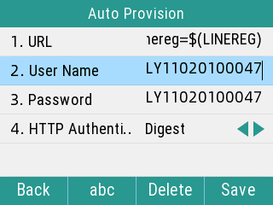
- After powered on, the phone needs your provisioning credentials to download configuration files from the CommPortal phone configurator.

If you enter valid provisioning credential, the phone will download configuration files successfully, it reboots and download configurations from the CommonPortal phone configurator.

Auto Provision Now

You can go to use Auto Provision now to trigger the IP phone to perform the auto provisioning immediately.

To trigger auto provisioning via auto provision now:

- Press Menu-> Advanced->Auto Provision.
- Enter the provisioning server address in the Server URL field.
- Enter valid provisioning credential in the User Name and Password fields.
- Press the Save soft key.
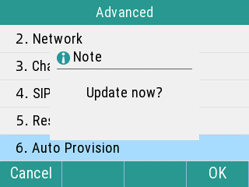
The LCD screen will be displayed as below:

- Press the Ok soft key.
The phone reboots and download configurations from the CommonPortal phone configurator.

Basic Call Features

The SIP IP phone is designed to be easily used like a regular phone on a public switched telephone network (PSTN). You can place calls, answer calls, transfer a call to someone else, or conduct a conference call.
Most features on the phones are intuitive. This chapter only provides detailed instructions about a few features that may not be so intuitive. Topics include:
  - Do Not Disturb

  - Transferring Calls

  - Local Conference Call

  - Call Park and Call Retrieve

  - Directed Pickup

  - Group Pickup

If you require additional information or assistance with your new phone, contact your system administrator.

Do Not Disturb
You can use DND to reject incoming calls automatically on the phone. The prompt message "n New Missed Call(s)" ("n" indicates the number of missed calls) will appear on the LCD screen, and callers will receive a busy message. All calls you receive while DND is enabled are logged to your missed calls list.

Choosing a DND Mode

You can enable DND for all accounts.
There are two DND modes:

  - Phone: DND is effective for the phone system.

To choose the DND mode via CommPortal phone configurator:

- Click Features-> DND & Forward.
- Select the Phone mode from the DND Mode field.
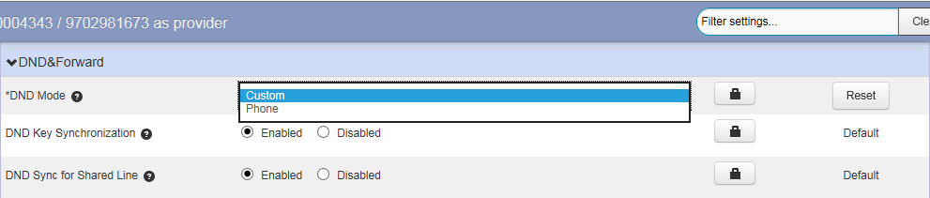

- Click Save changes to accept the change.
- Perform auto provisioning on the phone to download above configurations.

Activating DND in Phone Mode

To activate DND in phone mode:

Press the DND soft key when the phone is idle. The DND icon on the status bar indicates that
DND is enabled.

Transferring Calls
During a call, you can transfer the call to another contact in one of three ways:
- Blind Transfer: Transfer a call directly to the third party without consulting.
- Semi-Attended Transfer: Transfer a call when receiving ringback.
- Attended Transfer (Consultative Transfer): Transfer a call with prior consulting.

Performing a Blind Transfer

You can transfer calls to other contacts immediately without consulting with them first.

To perform a blind transfer:

- Press the Transfer key during a call.
- Enter the number you want to transfer the call to.
- Press the Transfer key to complete the transfer.

Performing a Semi-Attended/Attended Transfer

You can transfer calls to other contacts immediately when receiving ringback or after consulting with them first.

To perform a semi-attended transfer:

- Press the Transfer soft key during a call.
- Do one of the following:
  - Enter the number you want to transfer the call to.
  - Press the Directory soft key to select the desired contact.
- Press the OK key or Send.
- Do one of the following:
  - When you hear the ringback tone, press the Transfer soft key to finish a semi-attended transfer.
  - After the contact answers the call, press the Transfer soft key to finish an attended transfer.

Local Conference Call

Setting Up a Local Conference Call

The IP phones support three-way (including yourself) conference call.

To set up a conference call:

- Place a call to the first party.
- When the first party answers the call, press the Conference (Conf) soft key to place a new call.
The active call is placed on hold.
- Enter the number of the second party and press the Send soft key.
- When the second party answers the call, press the Conference (Conf) soft key again to join all parties in the conference.

Joining Two Calls in a Conference

You can select a hold call to join into a conference call with the active call.

To join two calls in a conference:

- Place two or more calls using the same or different accounts on the phone.
- Select the call for a conference and ensure that the call is active.
- Press the Conference (Conf) soft key.
- Select the desired hold call, and then press the Send soft key.

Call Park and Call Retrieve
You can use this feature to park a call, and then retrieve the call either from your phone or another phone. After you park a call, the call is placed on hold, you can continue the conversation after retrieving it.
IP phone supports park call and enhanced park call.
- Park call feature, the server will automatically hunt for the first available orbit in the call park orbits and parks the call there. The call park orbits should be predefined, contact your system administrator for more information.
- Enhanced park call feature, you should specify a target orbit where you want to park the call to.

Configuring a Park Call Key

You can configure a Park Call key to park an active call.
You cannot configure a park call key via CommPortal phone configurator for FIP12WP and FIP16.
Note

To configure a Park Call key via the CommPortal phone configurator:

- Click Programmable Keys - Line Key->Key X.
- Select Park Call from the Soft key action field.
- Select the desired line to apply this feature from the Line field.
- Enter the access code for parking call in the Access Code field.
- Enter the string that will appear on the LCD screen in the Label field.
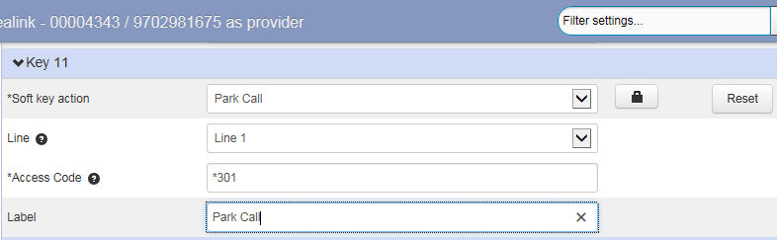

- Click Save changes to accept the change.
- Perform auto provisioning on the phone to download above configurations.

Configuring a Retrieve Parked Call Key

You can retrieve the parked call by pressing a retrieve parked call key or dialing the retrieve access code followed by the orbit number (for example: *302100).

To configure a retrieve parked call key via the CommPortal phone configurator:

- Click Programmable Keys - Line Key->Key X.
- Select Retrieve Parked Call from the Soft key action field.
- Select the desired line to apply this feature from the Line field.
- Enter the access code for retrieving parked call in the Access Code field.
- Select the desired orbit where you want to retrieve the parked call from the Park Orbit
field.
- Enter the string that will appear on the LCD screen in the Label field.
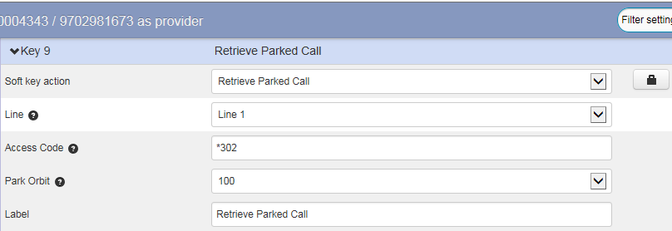

- Click Save changes to accept the change.
- Perform auto provisioning on the phone to download above configurations.

Parking a Call

To park a call on the phone:

- During a call, do one of the following:
  - If you press the park call key:
When the call is parked successfully, you will hear a voice prompt informing you of the extension where the call is parked.
Press the Transfer soft key to complete the park.
  - If you press the enhanced park call key:
The call will be parked to the orbit you designated in the Park Orbit field.

Retrieving a Call

To retrieve a call on the phone:

Dial the call park retrieve code followed by the target orbit (for example: *302100) or press the retrieve parked call key to retrieve the parked call.
If the parked call is not retrieved within a period of time assigned by the system, the phone performing call park will receive a call back.
Note

Directed Pickup
Directed call pickup is used for picking up an incoming call on a specific extension. You can answer a call that rings on a specific phone. If there are multiple incoming calls on the phone at the same time, you can only pick up the first incoming call.
You cannot configure call pickup feature via CommPortal phone configurator for FIP12WP and FIP16.
Note

Configuring a Directed Pickup key

You can set a Directed Pickup key, and specify a contact whose calls you want to pick up.

To configure a directed pickup key via the CommPortal phone configurator:

- Click Programmable Keys - Line Key->Key X.
- Select Directed Pickup from the Soft key action field.
- Enter the directed pickup code in the Access Code field.
- Enter the target phone number in the Extension field.
- Enter the string that will appear on the LCD screen in the Label field.
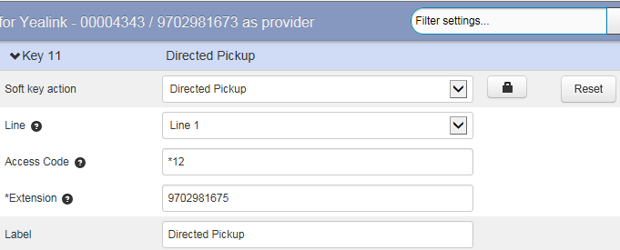

- Click Save changes to accept the change.

- Perform auto provisioning on the phone to download above configurations.
When the target phone number receives an incoming call, you can press the directed pickup key to answer the call on your phone.

Picking up a Call

When the target number (for example: 9702981675) receives an incoming call, you can dial the directed pickup code followed by the target number (for example: *129702981675) or press the directed pickup key (if configured) to pick up the parked call directly.

Group Pickup
Group call pickup is used for picking up incoming calls within a pre-defined group. When any phone within a predefined group of phones receives an incoming call, you can pick up that call easily on the phone.
You cannot configure call pickup feature via CommPortal phone configurator for FIP12WP and FIP16.
Note

Configuring a Directed Pickup key

You can set a group pickup key, and use it to pick up incoming calls for your group.

To configure a group pickup key via the CommPortal phone configurator:

- Click Programmable Keys - Line Key->Key X.
- Select Group Pickup from the Soft key action field.
- Enter the group pickup code in the Access Code field.
- Enter the string that will appear on the LCD screen in the Label field.
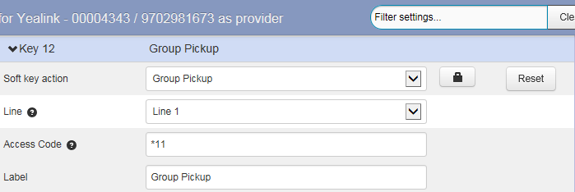

- Click Save changes to accept the change.
- Perform auto provisioning on the phone to download above configurations.

Picking up a Call for a Group

When a phone in the predefined group receives an incoming call, you can dial the group pickup code (for example: *11) or press the group pickup key to pick up the call directly. The call will be answered on your phone.

Advanced Phone Features

This chapter provides operating instructions for the advanced features of the IP phone. Topics include:
  - Enhanced Monitor Extension

  - Intercom and Push-to-Talk

  - Multicast Paging

  - DTMF

  - Call Jump

Enhanced Monitor Extension
You can use enhanced monitor extension feature to monitor a specific line for status changes on the phone.
Enhanced monitor extension feature is not applicable to FIP12WP and FIP16.
Note

Configuring an Enhanced Monitor Extension key

You can configure an enhanced monitor extension key on the phone to monitor the status of a desired phone number. You can press an enhanced monitor extension key to dial out the monitored phone number when the monitored line is idle.

To configure an enhanced monitor extension key via CommPortal phone configurator:

- Click Programmable Keys - Line Key->Key X.
- Select Enhanced Monitor Extension from the Soft key action field.
- Select the desired line to apply this feature from the Line field.
- Enter the phone number or extension you want to monitor in the Extension field.
- Enter the string that will appear on the LCD screen in the Label field.
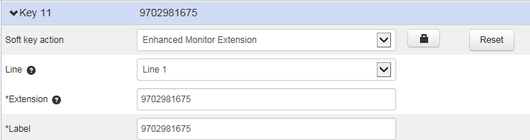

- Click Save changes to accept the change.
- Perform auto provisioning on the phone to download above configurations.

LED Indicator

The following table shows the LED indicator associated with the line you are monitoring.

LED Status | Description
Solid green | The monitored user is idle.
Flashing red | The monitored user receives an incoming call.
Solid red | The monitored user is busy.  The monitored user’s conversation is placed on hold (This LED status requires server support).
Off | The monitored user does not exist.

Configuring Transfer Mode via Dsskey Feature

When there is an active call on your phone, you can transfer the active call to the monitored phone number directly by pressing the enhanced monitor extension key. The phone handles the active call differently depending on the transfer mode via DSS key.

To configure Transfer Mode via Dsskey feature via CommPortal phone configurator:

- Click Features->Transfer.
- Select the desired type from the Transfer Mode via Dsskey field.
- Depending on your selection:
  - If you select Blind Transfer, press the enhanced monitor extension key to complete the blind transfer to the monitored number.
  - If you select Attended Transfer, press the enhanced monitor extension key to dial out the monitored number, and then perform the attended or semi-attended transfer.
  - 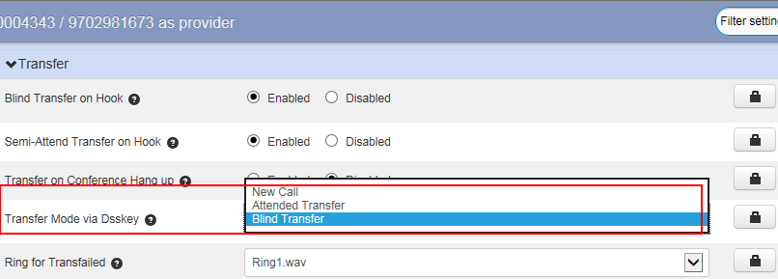If you select New Call, press the enhanced monitor extension key to place a new call to the monitored number.
- Click Save changes to accept the change.
- Perform auto provisioning on the phone to download above configurations.

Intercom and Push-to-Talk
Intercom is a useful feature in an office environment to quickly connect with the operator or the secretary. You can short press the Intercom/PTT key to automatically connect with a
pre-configured target extension for outgoing intercom calls, and the target extension will automatically answer incoming intercom calls by default.
Push-to-talk is a variant of Intercom, you need to press and hold the Intercom/PTT key during the push-to-talk call. As soon as the key is released, the push-to-talk call is disconnected.
You cannot configure Intercom and Push-to-Talk via CommPortal phone configurator for FIP12WP and FIP16.
Note

Enabling Push to Talk Mode

You can enable or disable the push-to-talk mode for the phone. If the push-to-talk mode is enabled, you can long press the Intercom/PTT key for 1.5 seconds to automatically connect with a pre-configured target extension, and the target extension will automatically answer incoming intercom calls by default. You need to press and hold the Intercom/PTT key during the
push-to-talk call and release it to end the call.
If the push-to-talk mode is disabled, the Intercom/PTT key works as an Intercom key only.
Note

To enable push-to-talk mode via CommPortal phone configurator:
The push-to-talk mode is not applicable to FIP12WP and FIP16.

- Click Features->Intercom.
- Mark the desired radio box in the Push to Talk Mode Enable field.
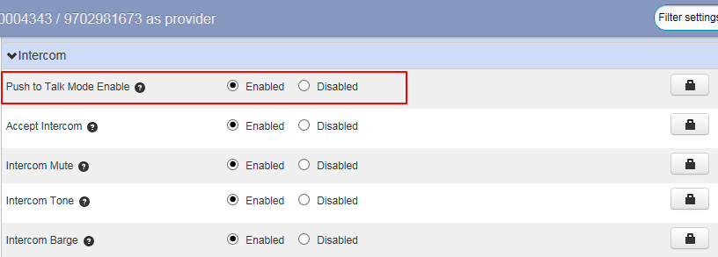

- Click Save changes to accept the change.
- Perform auto provisioning on the phone to download above configurations.

Configuring an Intercom/PTT Key

You can configure an Intercom/PTT key to provide users the ability to initiate intercom calls directly to the specified contact.
Intercom/PTT key is not applicable to FIP12WP and FIP16.
Note

To configure an Intercom/PTT key via CommPortal phone configurator:

- Click Programmable Keys - Line Key->Key X.
- Select Intercom/PTT from the Soft key action field.
- Select the desired line to apply this feature from the Line field.
- Enter the target extension number in the Number field.
- Enter the string that will appear on the LCD screen in the Label field.
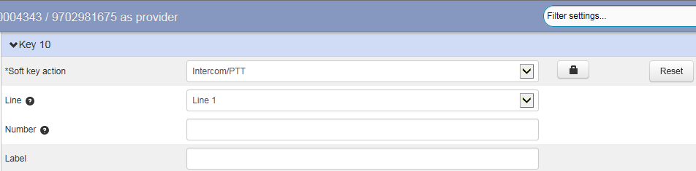

- Click Save changes to accept the change.

- Perform auto provisioning on the phone to download above configurations.

Using Push-to-Talk

To use push-to-talk on the phone:

- Long press the Intercom/PTT key for 1.5 seconds when the phone is idle.
The called destination plays a warning tone and automatically answers the call in the speakerphone mode by default.
- Keep pressing the Intercom/PTT key during the push-to-talk call.
- To end the push-to-talk call, release the Intercom/PTT key.

Placing an Intercom Call

To place an Intercom call on the phone:

- Short press the Intercom/PTT key when the phone is idle.
The called destination plays a warning tone and automatically answers the call in the speakerphone mode by default.
- To end the intercom call, press the Intercom/PTT key again or the EndCall soft key.

Multicast Paging
You can use multicast paging to quickly and easily broadcast time-sensitive announcements to users who are listening to a specific multicast group.
You cannot configure multicast paging via CommPortal phone configurator for FIP12WP and FIP16.
Note

Configuring a Multicast Paging key

You can configure a multicast paging key, which allows you to send a Real-time Transport Protocol (RTP) stream to the pre-configured multicast address(es) without involving SIP signaling.

To configure a multicast paging key via the CommPortal phone configurator:

- Click on Programmable Keys - Line Key->Key X.
- Select Multicast Paging from the Soft key action field.
- Enter the multicast IP address (for example: 224.5.6.20:10008) in the IP address field. The valid multicast IP addresses range from 224.0.0.0 to 239.255.255.255.
- Enter the multicast IP port number (for example: 10008) in the Port field.
- Enter the string that will appear on the LCD screen in the Label field.
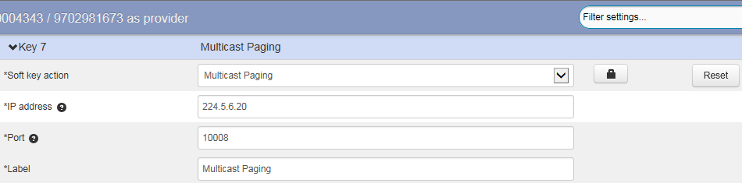

- Click Save changes to accept the change.
- Perform auto provisioning on the phone to download above configurations.

Configure a Paging List key

You can configure a paging list key on the phone, which allows you to view a list of
pre-configured multicast address(es), you can send a Real-time Transport Protocol (RTP) stream to the pre-configured multicast address(es) without involving SIP signaling.

To configure a paging list key via the CommPortal phone configurator:

- Click on Programmable Keys - Line Key->Key X.
- Select Paging List from the Soft key action field.
- Enter the string that will appear on the LCD screen in the Label field.
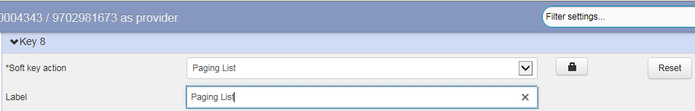

- Click Save changes to accept the change.
- Perform auto provisioning on the phone to download above configurations.

Configuring Paging List

You can configure the IP address and port number of the multicast paging group to be displayed in the paging list.

To configure paging list via CommPortal phone configurator:

- Click on Paging Groups->Paging Group N.
- Enter the group name in the Description field.
- Enter the multicast IP address (for example: 224.5.6.20) in the Address field. The valid multicast IP addresses range from 224.0.0.0 to 239.255.255.255.
- Enter the multicast IP port number (for example: 10008) in the Port field.
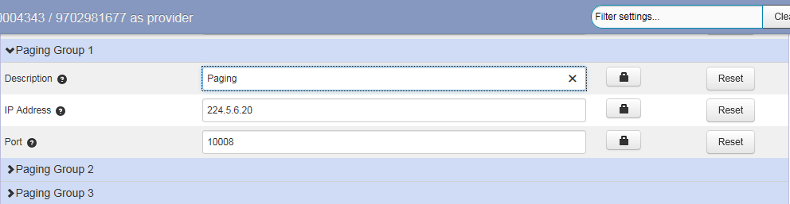

- Repeat the step 2-4, you can add more paging groups.
- Click Save changes to accept the change.
- Perform auto provisioning on the phone to download above configurations.

Configuring Multicast Listening Addresses

You can configure the phone to receive a Real-time Transport Protocol (RTP) stream from the pre-configured multicast address(es) without involving SIP signaling. You can specify up to 10 multicast addresses that the phone listens to on the network.

To configure multicast listening addresses via web user interface:

- Click on Paging Groups->Listening Group N.
- Enter the group name in the Description field.
- Enter the multicast IP address (for example: 224.5.6.21) in the IP Address field. The valid multicast IP addresses range from 224.0.0.0 to 239.255.255.255.
- Enter the multicast IP port number (for example: 10008) in the Port field.
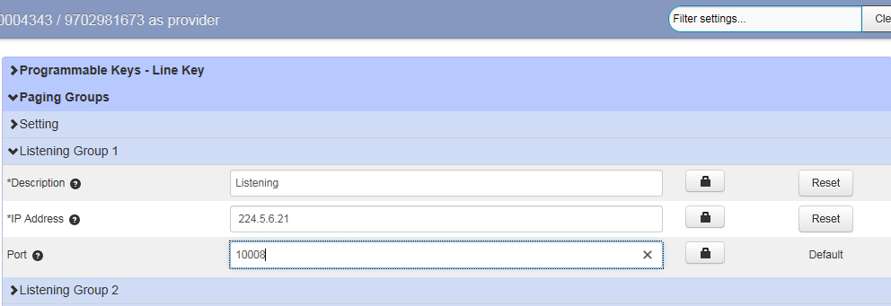

- Repeat the step 2-4, you can add more listening groups.
- Click Save changes to accept the change.
- Perform auto provisioning on the phone to download above configurations.

Handling Incoming Multicast Paging Calls

How the phone handles incoming multicast paging calls depends on Paging Barge and Paging Priority Active parameters configured via CommPortal phone configurator.

Priority Paging Group

The priority paging group defines the priority of the voice call in progress. If the priority of an incoming multicast paging call is lower than that of the active call, it will be ignored automatically. If priority paging group is disabled, the voice call in progress will take precedence over all incoming multicast paging calls. Valid values in the priority paging group field:
  - 1 to 10: Define the priority of the active call, 1 with the highest priority, 10 with the lowest.

  - 0: The voice call in progress will take precedence over all incoming paging calls.

Paging Priority Enable
The paging priority enable parameter decides how the phone handles incoming multicast paging calls when there is already a multicast paging call on the phone. If enabled, the phone will ignore incoming multicast paging calls with lower priorities, otherwise, the phone will answer incoming multicast paging calls automatically and place the previous multicast paging call on hold. If disabled, the phone will automatically ignore all incoming multicast paging calls.

To handle incoming multicast paging calls via CommPortal phone configurator:

- Click on Paging Groups->Setting.
- Mark the desired radio box in the Paging Priority Enable field.
- Select the desired value from the drop-down menu of Priority Paging Group.
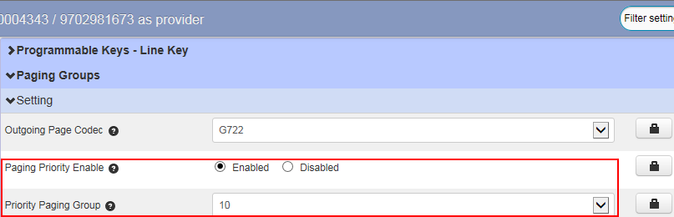

- Click Save changes to accept the change.
- Perform auto provisioning on the phone to download above configurations.

Sending RTP Stream via a Multicast Paging Key

To send RTP stream via a multicast paging key when the receiver’s phone is idle:

- Press the multicast paging key when the phone is idle.
The phone sends RTP to a pre-configured multicast address (IP: Port).
Both the sender’s and receiver’s phones play a warning tone and the receiver automatically answers the multicast RTP session in the speakerphone mode.
The multicast paging key LED illuminates solid green.
- To place the current multicast RTP session on hold, press the Hold soft key.
The sender’s phone places the multicast RTP session on hold and receiver’s phone releases the session.
- To resume the held multicast RTP session, press the Resume soft key. The multicast RTP session is established again.
- To end the multicast RTP session, press the multicast paging key again or press the EndCall soft key.

Sending RTP Stream via a Paging List Key

To send RTP stream via a paging key list when the receiver’s phone is idle:

- Press the paging list key when the phone is idle.
- Select the desired group.
- Press the Paging soft key to send RTP.
- To place the current multicast RTP session on hold, press the Hold soft key.
The sender’s phone places the multicast RTP session on hold and receiver’s phone releases the session.
- To resume the held multicast RTP session, press the Resume soft key. The multicast RTP session is established again.
- To end the multicast RTP session, press the multicast paging key again or press the
EndCall soft key.

DTMF
DTMF is the signal sent from the IP phone to the network, which is generated when pressing the IP phone’s keypad during a call. Each key pressed on the IP phone generates one sinusoidal tone of two frequencies. One is generated from a high-frequency group and the other from a low-frequency group.

DTMF Keypad

The DTMF keypad is laid out in a 4×4 matrix, with each row representing a low-frequency, and each column representing a high frequency. Pressing a digit key (such as '1') will generate a sinusoidal tone for each of two frequencies (697 and 1209 hertz (Hz)).

DTMF Keypad Frequencies:

 | 1209 Hz | 1336 Hz | 1477 Hz | 1633 Hz
697 Hz | 1 | 2 | 3 | A
770 Hz | 4 | 5 | 6 | B
852 Hz | 7 | 8 | 9 | C
941 Hz | * | 0 | # | D

Transmitting DTMF Digit

Three methods of transmitting DTMF digits on SIP calls:

- RFC 2833 -- DTMF digits are transmitted by RTP Events compliant with RFC 2833. You can configure the payload type and sending times of the end RTP Event packet. The RTP Event packet contains 4 bytes. The 4 bytes are distributed over several fields denoted as Event, End bit, R-bit, Volume and Duration. If the End bit is set to 1, the packet contains the end of the DTMF event. You can configure the sending times of the end RTP Event packet.
- INBAND -- DTMF digits are transmitted in the voice band. It uses the same codec as your voice and is audible to conversation partners.
- SIP INFO -- DTMF digits are transmitted by SIP INFO messages. DTMF digits are transmitted by the SIP INFO messages when the voice stream is established after a successful SIP 200 OK-ACK message sequence. The SIP INFO message can transmit DTMF digits in three ways: DTMF, DTMF-Relay and Telephone-Event.

Configuring Transmitting DTMF Digit Method

To configure the method of transmitting DTMF digits via CommPortal phone configurator:
- Click Line X->DTMF.
- Select the desired value from the drop-down menu of DTMF Type.
- If SIP INFO or AUTO or SIP INFO is selected, select the desired value from the drop-down menu of DTMF Info Type.
- Enter the desired value in the DTMF Payload Type (96~127) field to configure the RFC 2833 payload type.
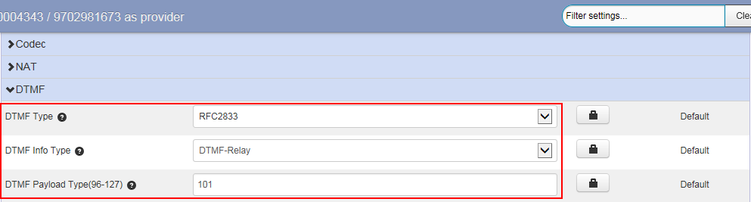

- Click Save changes to accept the change.
- Perform auto provisioning on the phone to download above configurations.

Call Jump
Call Jump allows users to seamlessly jump the current call to a predefined alternate or wireless
number by entering the designated hotkey.
The main difference between call jump and call transfer is that when you transfer a call via call jump, the current call stays connected instead of being placed on hold.
The following table lists the default call jump hotkeys configured by Metaswitch. Internet Telephony Service Provider can modify the hotkeys, depending on your actual needs.

Hotkey | Description
*94 | Dial *94 to jump to the number that jumps the call to you.
*95 | Dial *95 to jump to your alternate number.
*96 | Dial *96 to jump to your wireless number.
*90 | Dial *90 to temporarily disable call jump feature temporarily for  avoiding hotkey conflict issues.
Note
The hotkey is transmitted through DTMF. To use call jump feature, you need to set the value of the DTMF Type to AUTO or SIP INFO and the value of the DTMF Info Type to DTMF-Relay.

Scenarios A:

A and B are during a call, and then A jump this call to C. C can dial *94 to jump the call to A.

Scenarios B:

The system administrator has configured the alternate number (B) that phone A may want to transfer calls to.

To transfer an active call to an alternate extension:

If C needs to consult A and B frequently, A can dial *95 to jump the call to B during a call with C, then C can continue consulting B. Before B answers the call, A and C will stay connected.

Scenarios C:

The system administrator has configured a wireless number that phone A may want to transfer calls to.

To transfer an active call to an alternate wireless device:

If A and C have chatted on a phone for a long time, but A needs to leave home. In this case, A can dial *96 to quickly jump the current call to a wireless number without interrupting the conversation. Before A uses the mobile phone to answer the call, the call stays connected.

Scenarios D:

To avoid hotkey conflict issues when listening to voice mails:

User A dials the voice mail access code to listen to voice mails. To avoid the call jump hotkeys to conflict with voice mailbox hotkeys, User A can dial *90 to disable the call jump feature temporarily when listening to voice mails. After A hangs up the call, the call jump hotkeys will work again.
The destination you want to jump your call to must be predefined in CommPortal. For more information, contact your administrator.
Note

