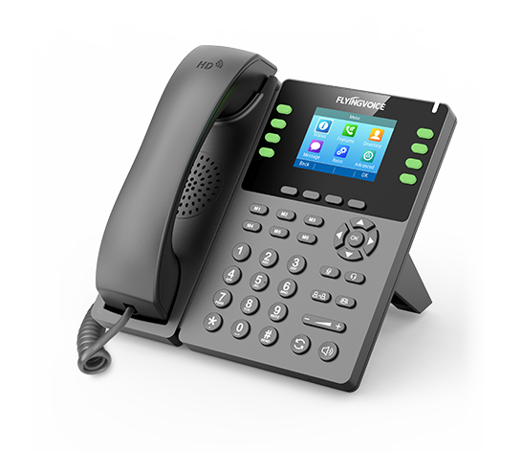

**Fusion PBX Call Flows**

**Configuration Guide**

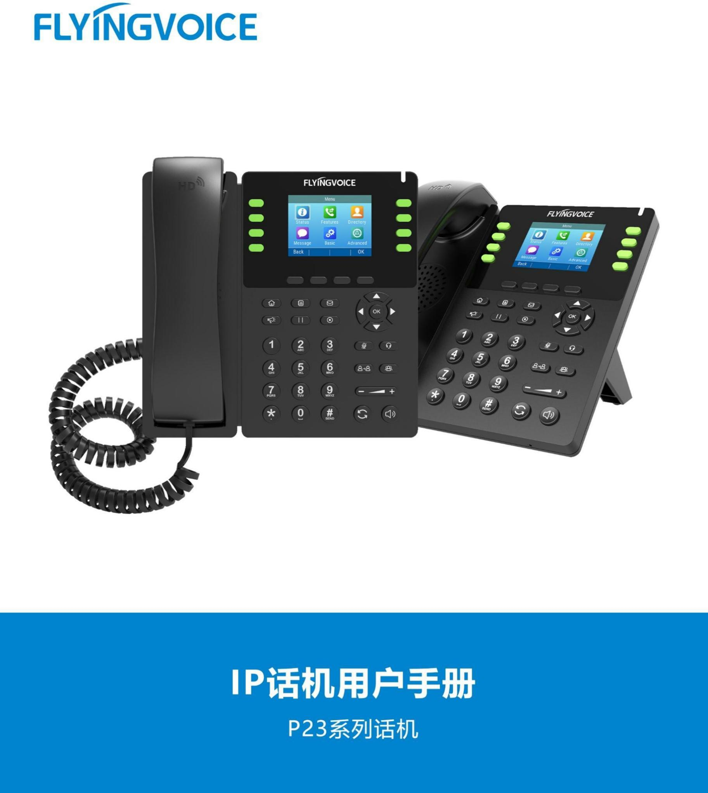

# Catalogue

Ⅰ Call Flows Introduction 1

Ⅱ Configuration Flow 1

Ⅲ Configuration Operation 1

1.Login the PBX management web 1

2. Configure call flows 2

2.1 Set up a new call 2

2.2 Fill in the sepecific parameters 2

2.3 Save 4

3. Application 4

3.1 Manually switch between primary and backup mode 4

3.2 Use feature code to switch the primary and backup lines 5

Ⅳ Test result verification 6

1.Call switchboard extension 6

2. Switch the lines 6

# Ⅰ Call Flows Introduction

The call flows function of Fusion pbx provides a customizable call flow. It provides an switchboard number that can switch between primary and secondary extension numbers. When the user dials the switchboard number, the call usually goes directly to the primary number. The seat only needs to complete the line switch on the phone.

# Ⅱ Configuration Flow

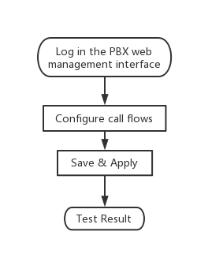

# Ⅲ Configuration Operation

## 1.Login the PBX management web

Contact the network administrator to obtain PBX domain name, user name and password information, login PBX web page management page.

Steps:input the domain name of pbx--》input the username and password --》Click Login

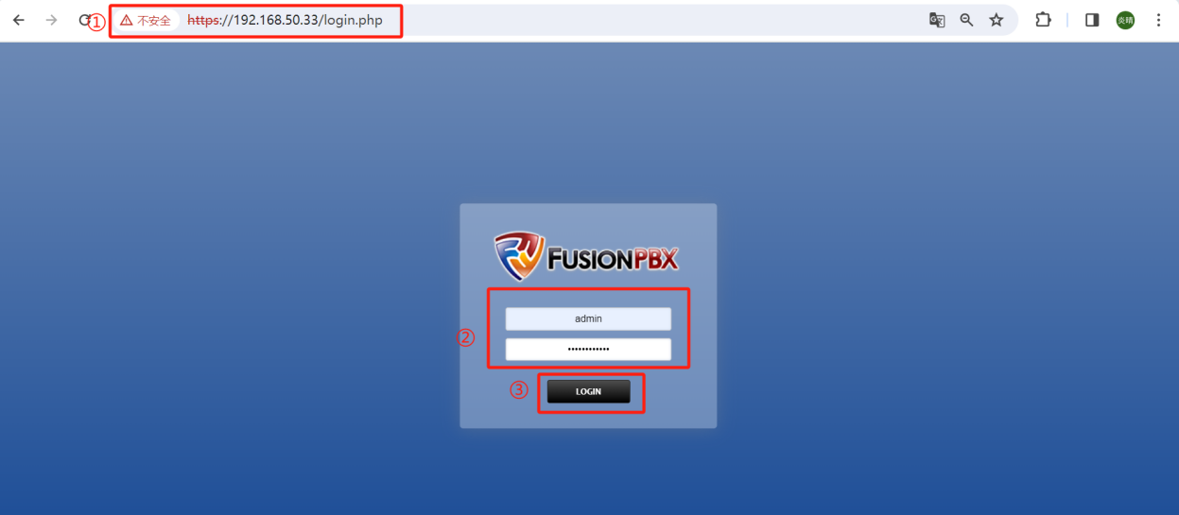

## Configure call flows

### 2.1 Set up a new call

Steps:Applications--》Call Flows--》+ ADD

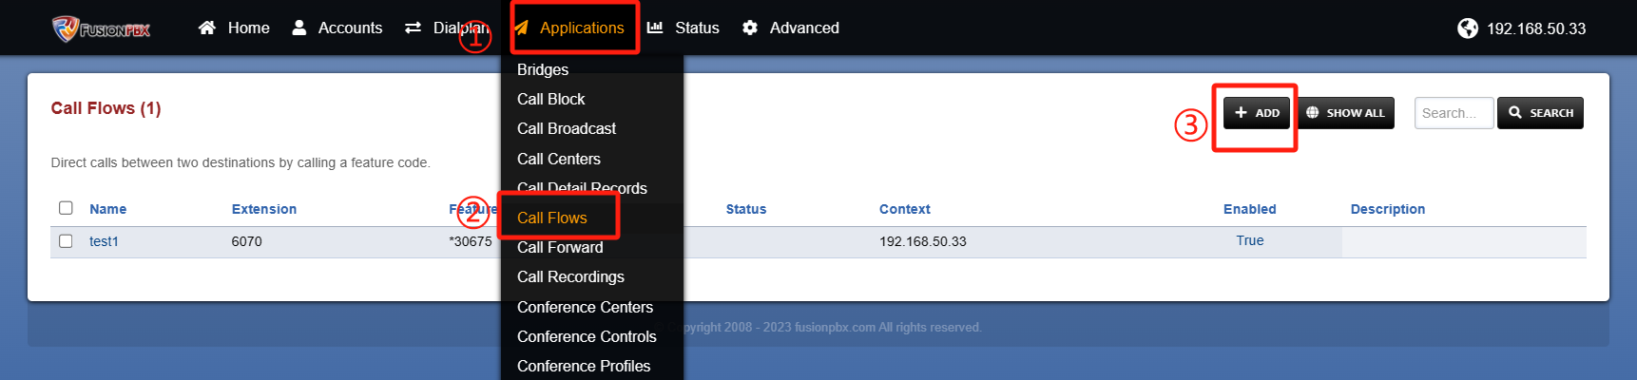

### 2.2 Fill in the sepecific parameters

In the figure, the red box is selected as the important parameter.See Table 1 for a description of the parameters.

Steps:Fill in parameters.

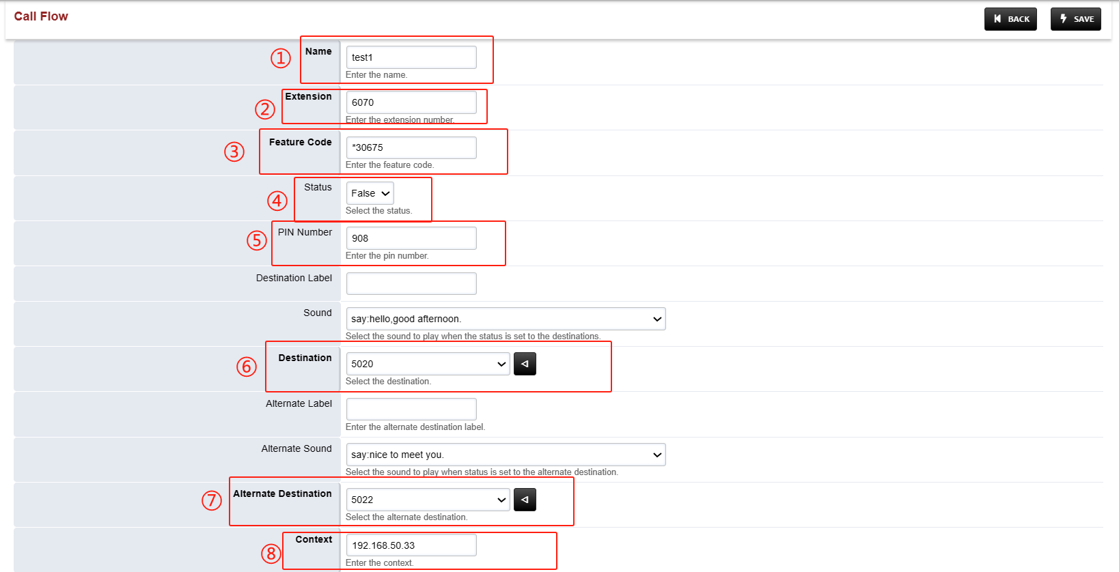



|  |  |
| --- | --- |
| Parameters | Description |
| Name | Define the name of the call flow. |
| Extension | Define what extension to use. (This will make an extension not already created) |
| Feature Code | Define what * number to use. |
| Status | Define what currently is in use. |
| PIN Number | Define a pin number in order to execute either mode. |
| Destination | Define where the call will go in the intial mode. |
| Alternative Destination | Define where the call will go in the alternative mode. |
| Context | Domain context (typically leave as is) |
| Enabled | Select to true. |
| Sound | Define the sound that will play once mode is engaged. |
| Alternative Sound | Define the sound that will play once alternative mode is engaged. |

**Table1 Description of parameters**

### 2.3 Save

Steps:After filling in the parameters, click save -- 》Save successfully will automatically return to the upper level interface and prompt update conplete

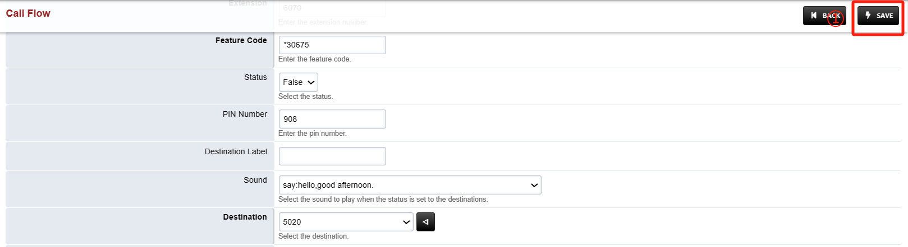

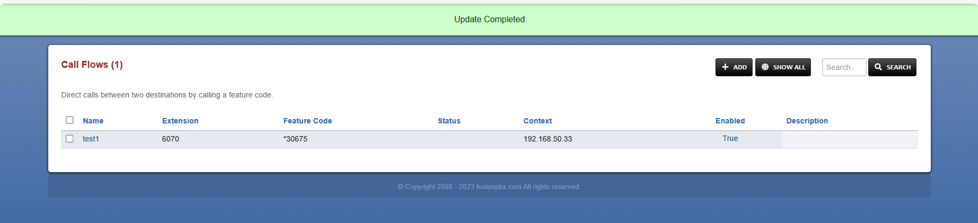

## Application

### 3.1 Manually switch between primary and backup mode

If your primary and secondary line is IVR or another number that cannot operate dialing, choose manual switching.

Steps:

Application-- 》Call Flows--》click the item to be edited -- 》select true/flase (open/close the main line) --》save;

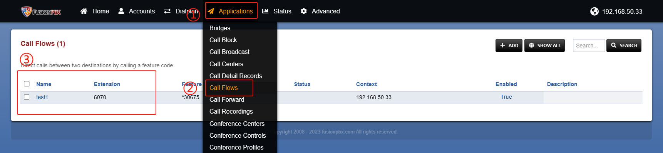

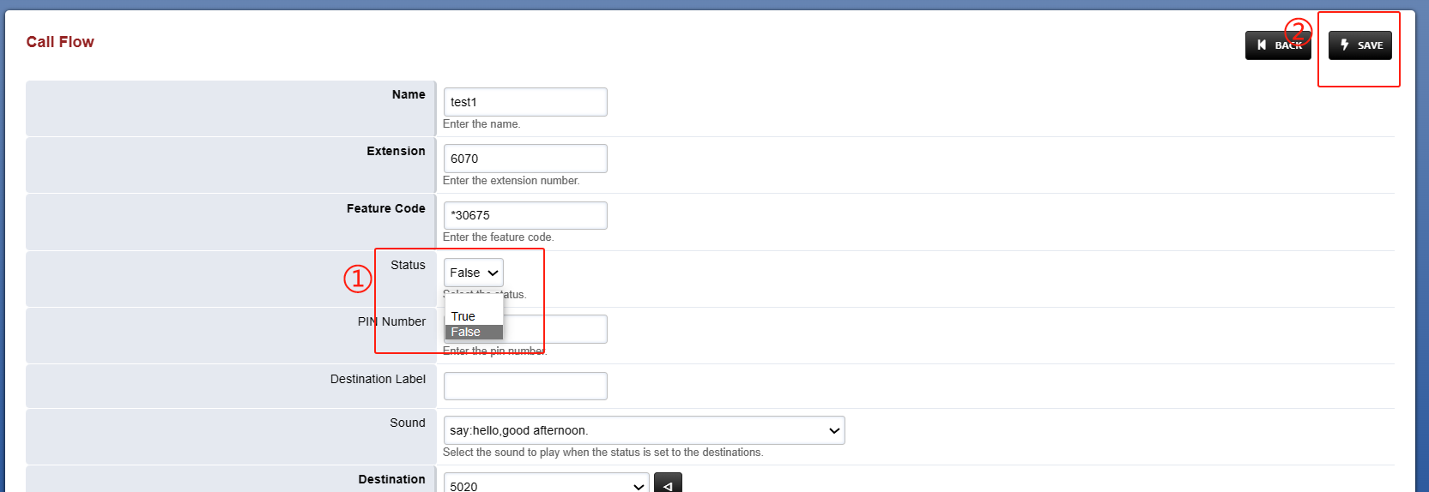

### 3.2 Use feature code to switch the primary and backup lines

If your primary and secondary line is an extension number, you can choose to switch in this way. This operation needs to configure the call flows parameters on the web in advance.

Steps: Configure call flows parameters and save -- 》Primary line 5020 dial feature code --》Enter PIN code -- 》Hear the set mode prompt tone, successfully switch;

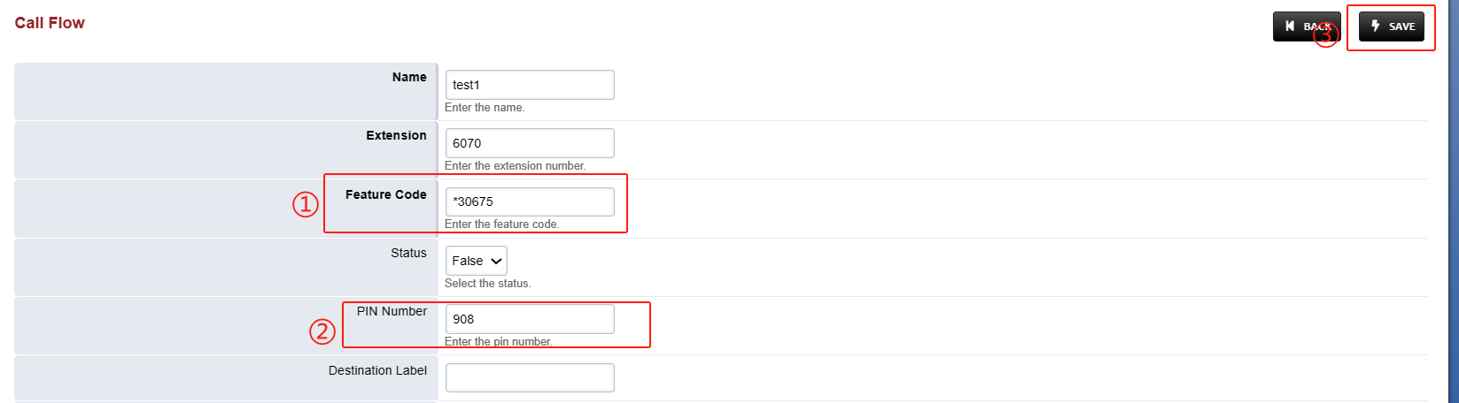

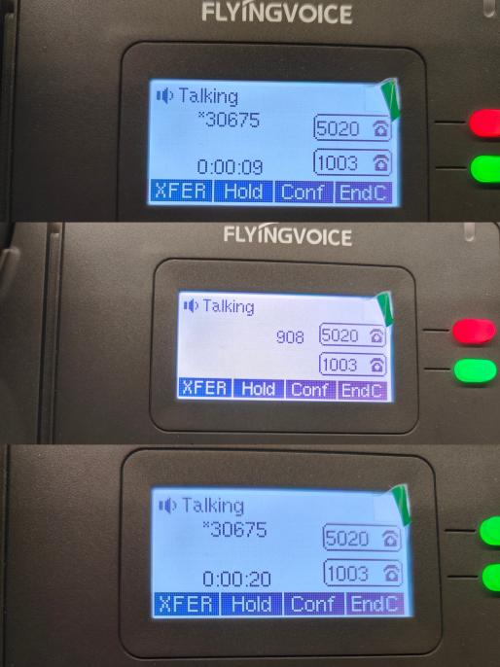

# Ⅳ Test result verification

## 1.Call switchboard extension

Now that the configuration is complete, we can test that wheter it works.

Steps: extension 5026 dial the switchboard extension 6070 -- 》the call switch to the primary line 5020--》 judge the primary line is working;

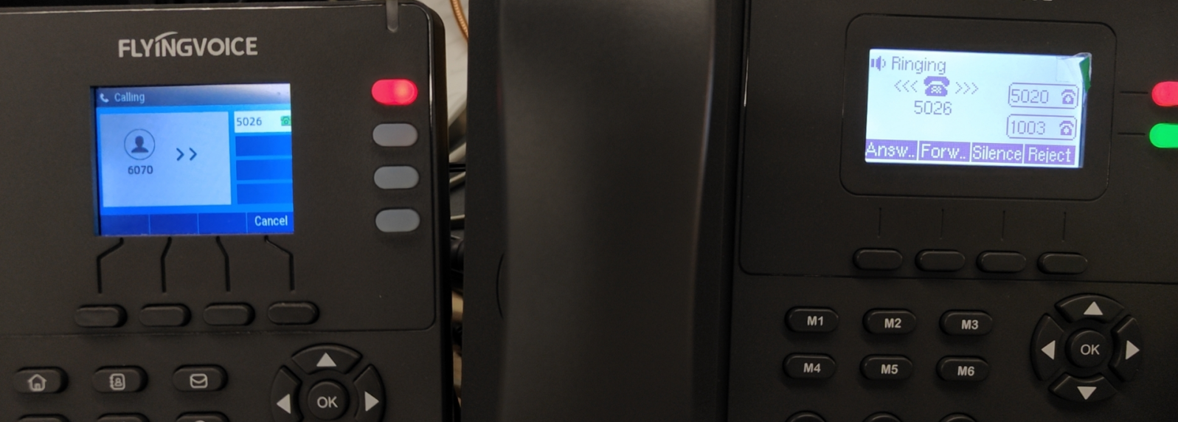

## Switch the lines

Please refer to *the* ***third application in Chapter III***for switching operation. After successful switching, refer to the following test steps to test whether the switching is successful.

Test steps: the extension 5026 call the primary number 6070--》the call switch to the backup line 5022--》judge that the backup line is working -- 》switch successfully;

