# Yeastar auto-provision with FLYINGVOICE IP phones

# (FQDN/Port mapping+RPS,Cloud Auto-provisioning)

This article will introduce how to use the RPS method of Yeastar P series IPPBX to carry out the remote batch auto-provisioning across the network. It will help you to quickly initialize the configuration of the equipment, which will greatly save the time and cost of batch deployment.

## Ⅰ Premise

1. Pre-input phone’s device information (model, MAC address and SN number) in the FRPS system.
2. The phone, IPPBX and FRPS are not in the same network, but the network is interoperable.

## Ⅱ Application Scenario

1. FQDN + FRPS Solution

Yeastar P-series IPPBX and IP phones are deployed in different networks. The IPPBX is enabled and configured with FQDN functionality.

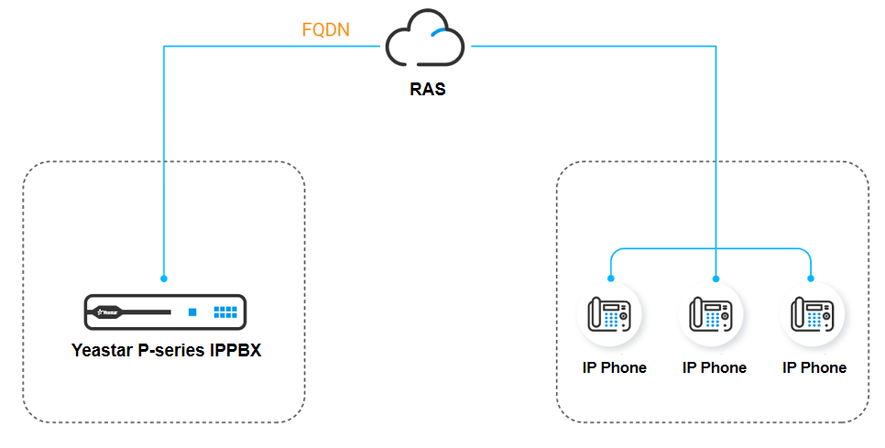

1. Port mapping + FRPS Solution

● Yeastar P-series IPPBX and IP phones are deployed in different networks. The PBX is connected to the router and has been port mapped on the router.

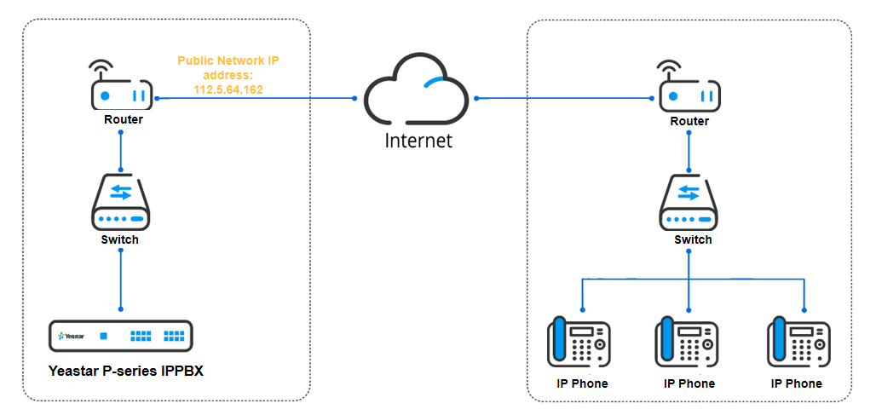

1. Cloud PBX + FRPS Solution

● Centralized management and auto-provisioning of local IP phone on Yeastar P-series cloud PBX.

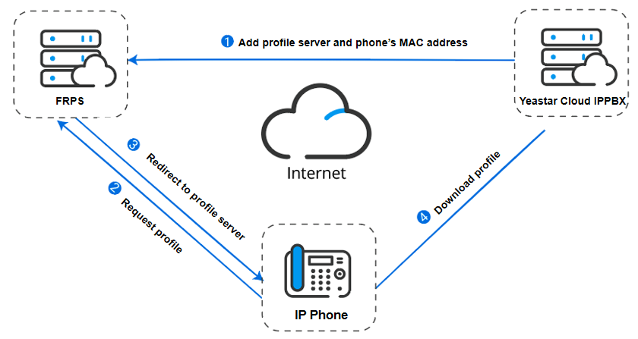

## Ⅲ Configuration operation

## Pre-configuration(Record phone information in the FRPS)

Considering the safety of the device, it is necessary to input the device information in advance on the FLYINGVOICE FRPS system to complete the SN/MAC verification of the device. You can contact FLYINGVOICE technical support in advance to apply for FRPS account or apply for equipment registration.

1. Log in to the FRPS system of FLYINGVOICE, click **Device Init**, click **Import**.

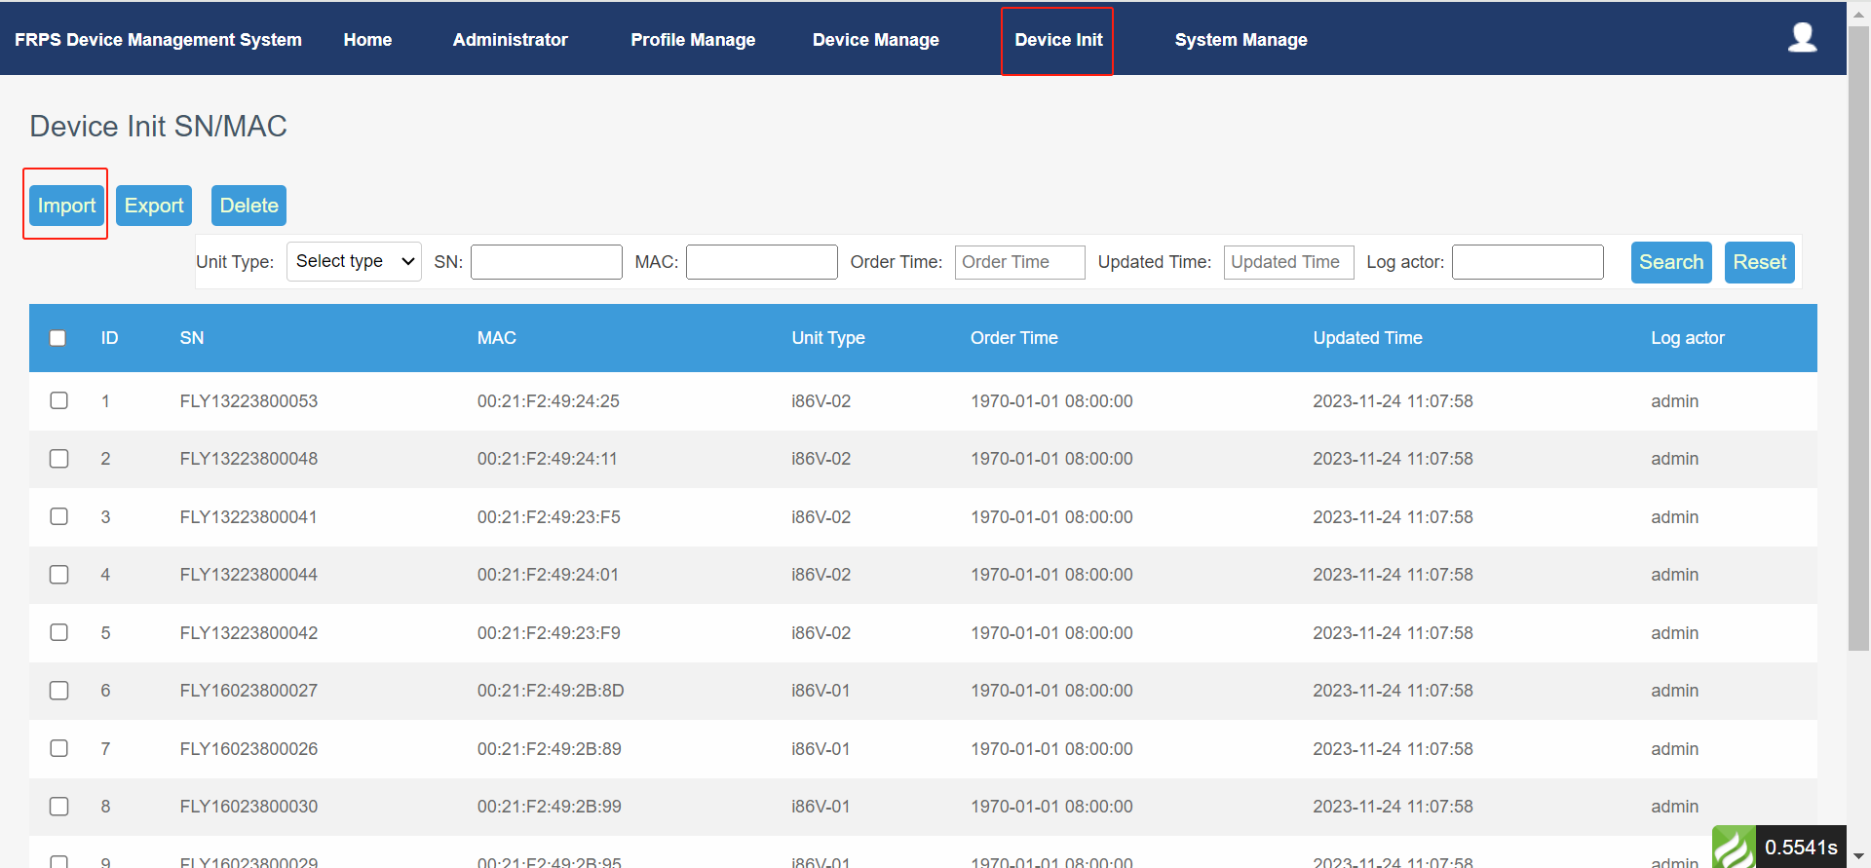

1. In the **Device Init** page, click **Please cclick to download the template**.

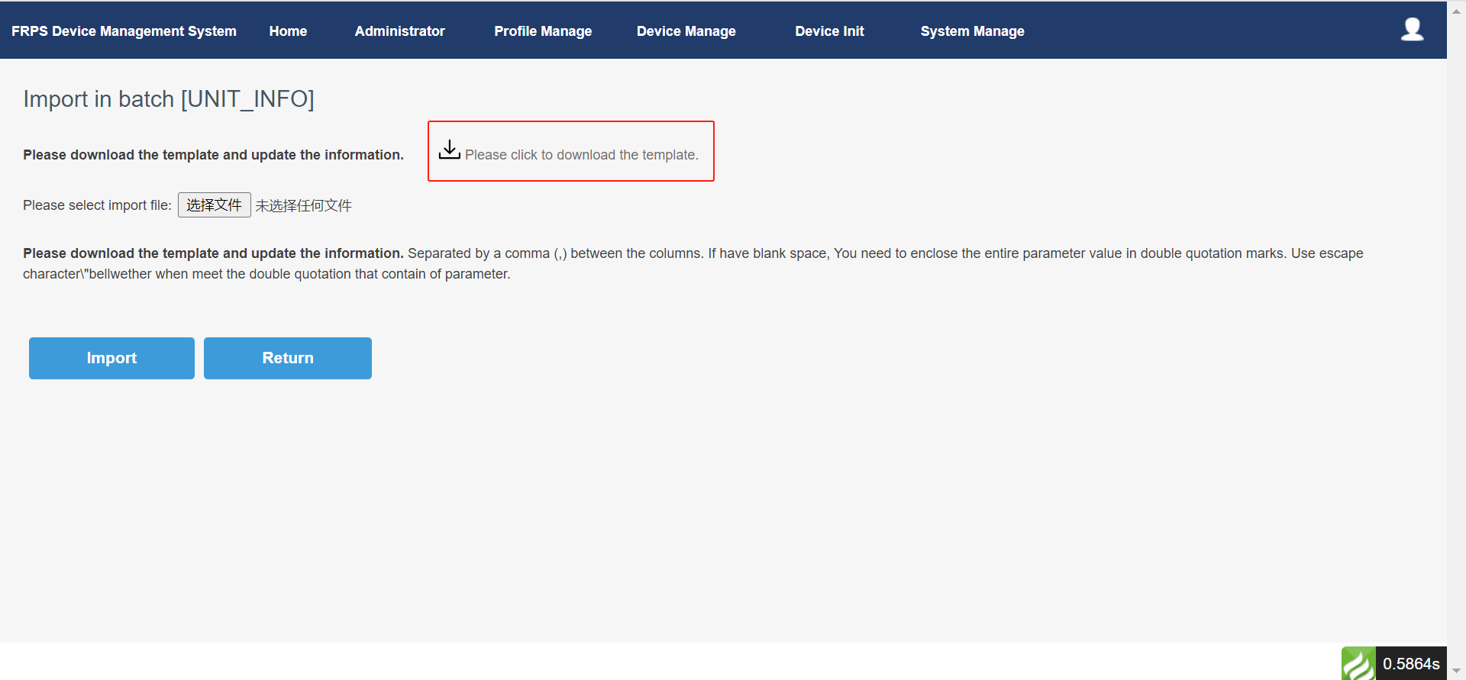

1. Fill in the phone unit type, device SN and device MAC in the template file.

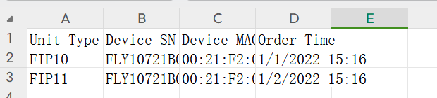

1. After the template is filled with the device information, import it into the FRPS system.

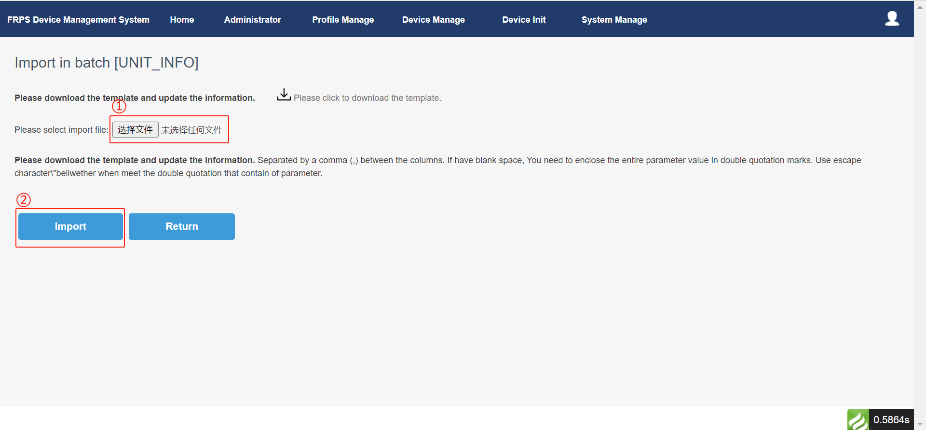

## **2.FQDN+RPS**

Yeastar P-series IPPBX supports RPS (Redirection and Configuration Service) mode auto-provisioning through FQDN when IP phone is deployed in remote network. The FQDN service provided by Yeastar allows you to get rid of complex network setup and quickly set up a secure tunnel for remote phone configuration. Therefore, using Yeastar FQDN for automatic deployment and configuration of remote phones can greatly save the time and cost of batch deployment, and ensure the security of remote access.

**Tips:**

1. The IPPBX needs to subscribe to a tunnel or videoconferencing service to use the FQDN functionality.
2. The FQDN domain name is available and interoperable with the IP phone network.
3. Pre-input phone information (model number, MAC and SN number) into the RPS system;

**Operation Steps:**

1. Generate the phone’s profile on IPPBX.
2. If the phone has been used, please reset it to factory default setting first.
3. Log in IPPBX management page and enter **Auto Provisioning > Phones**.
4. Click Add (or bulk add) to add IP phone.
5. In the **IP phone** bar, configure the IP phone information.
6. In the **options** bar, complete the auto-provisioning setting.

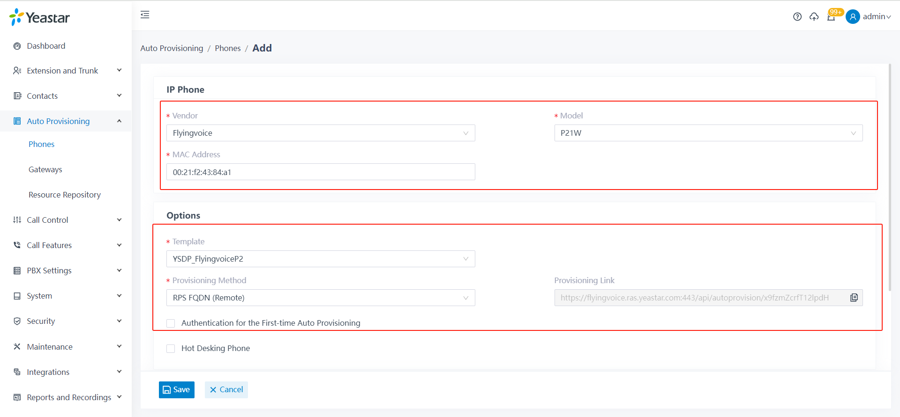

**Tips:**

1. Provisioning method Select to **RPS FQDN (remote)**.
2. Disabled **authentication for the First-time Auto Provisioning**.
3. Assign an extension for the phone.

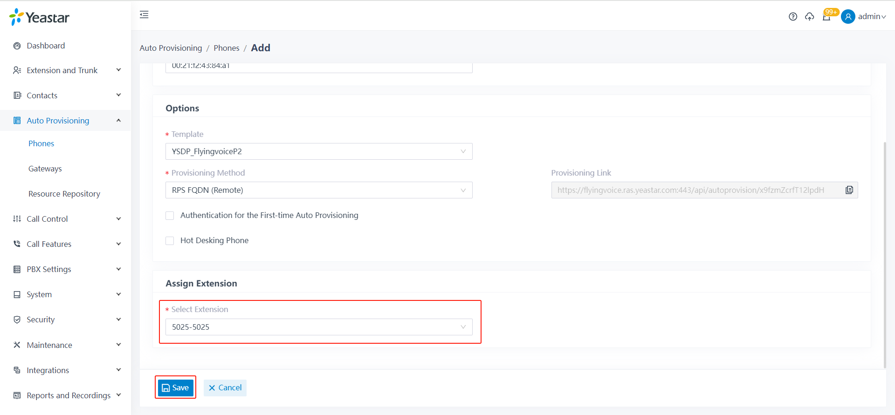

1. Click **Save**. The IPPBX automatically generates the profile of the phone and sends an event notification of a successful RPS request, indicating that the MAC address of the phone has been successfully added to FRPS.
2. Phone get the profile.

IP phone power on (or restart), so that the phone immediately obtain the acquired profile.

1. Check the result.

You can check the registration status of the extension on the configured phone in A**uto Provisioning > Phones**.

* ：The assigned extension is registered on the phone.
* ：The assigned extension is unregistered on the phone.

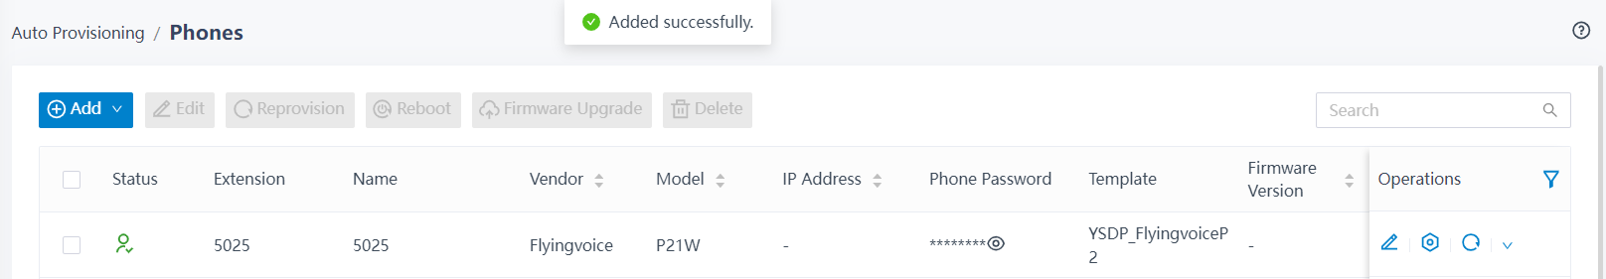

## **3.Port mapping + RPS**

When the IP phone is located in the remote network, Yeastar P-series IPPBX supports the use of RPS auto-provisioning mode to remotely deploy and update the IP phone configuration through the public IP address/domain name and port, which greatly saves the time and cost of batch deployment.

**Tips:**

1. You need to set up port mapping on the router and SIP NAT on the PBX to ensure that the phone can be registered remotely.
2. The IPPBX configuration needs to be mapped: RTP port, SIP port, Web service port.

**Steps:**

1. Configure the public network address and port on the IPPBX.

In order to ensure that the remote FLYINGVOICE IP phone can communicate with the IPPBX normally, you need to configure the public IP address and port on the IPPBX.

Assumes that your network environment is as follows:

● Domain: pbx.flyingvoice.com

● Local network:

○ 192.168.6.0/24

○ 192.168.5.0/24

The mapping is:

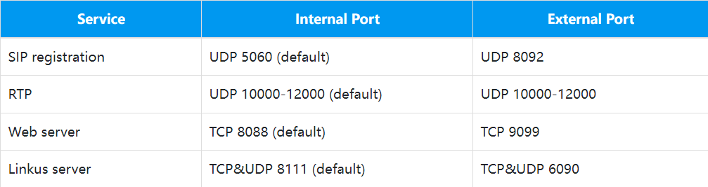

1. Log in PBX management page, go to **System > Network > Public IP and Ports**.
2. In the Public IP (NAT) bar, do the following configuration:

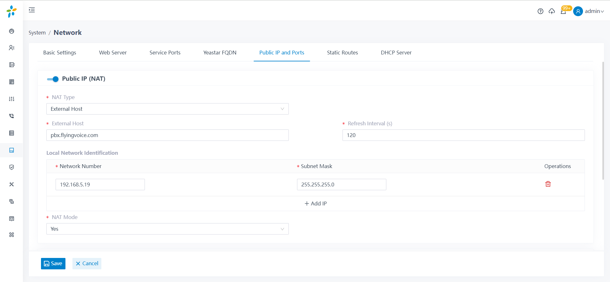

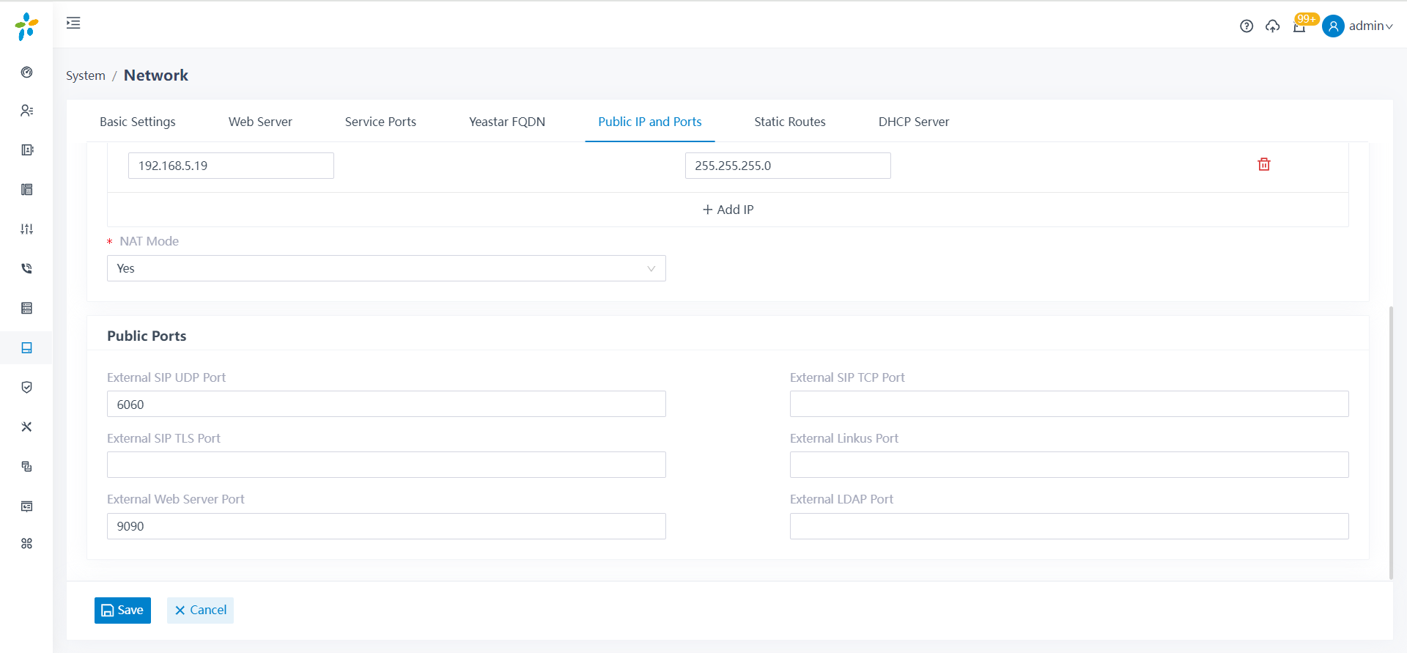

1. Set up a remote extension.
2. Go to **Extension and Trunk > Extension** and edit the extension to be assigned.
3. Click on the **Advanced** TAB, and in **VoIP Settings**, check **NAT**.

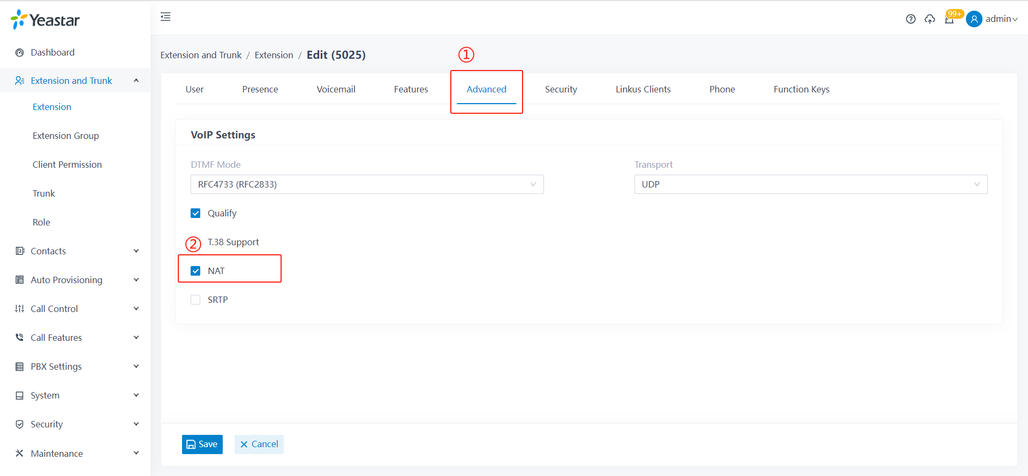

1. Click on the **Security** TAB, and in **SIP Security**, check **Allow Remote Registeration**.

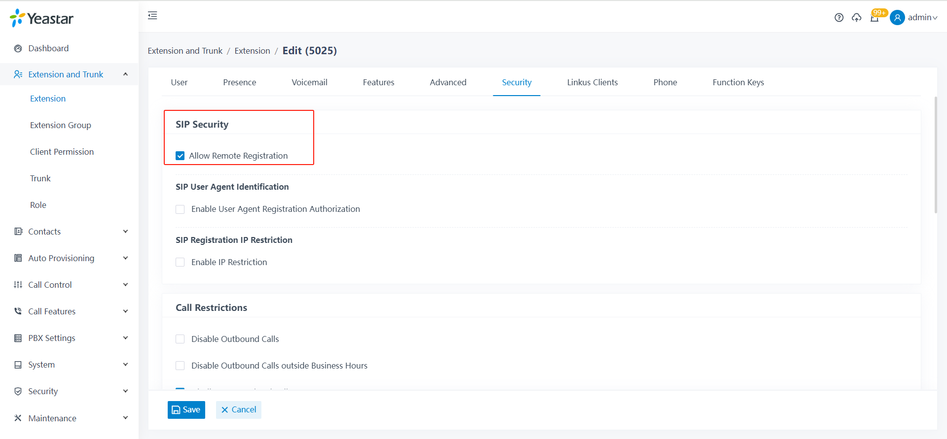

1. Click **Save** and **apply**. After the completion of the setup, the extension can be registered in different network segments of the local area network or in the remote network.
2. The IPPBX generates the phone profile.
3. If the phone has been used, please reset it first.
4. Log in IPPBX management page and go to **Auto Provisioning > Phones**.
5. Click **Add** to add IP phone.
6. Configure IP phone information in the **IP phone** bar.
7. In the **options** bar, complete the auto provisioning setting.



1. Click **Save**. The IPPBX automatically generates the profile of the phone and sends an event notification of a successful RPS request, indicating that the MAC address of the phone has been successfully added to FRPS.
2. Phone get the profile

IP phone power on (or restart), so that the phone immediately obtain the acquired profile

1. Check the result

You can check the registration status of the extension on the configured phone in A**uto Provisioning > Phones**.

* ：The assigned extension is registered on the phone.
* ：The assigned extension is unregistered on the phone.



## **4.Cloud IPBX + RPS**

Using cloud IPPBX+RPS function, Yeastar P-series cloud PBX can centrally manage and provision FLYINGVOICE IP phone. Using this function, the configuration and management process of FLYINGVOICE IP phone can be simplified, making the management and provisioning process of equipment more efficient and convenient.

**Steps:**

1. Set up a remote extension.
2. Go to **Extension and Trunk > Extension** and edit the extension to be assigned.
3. Click on the **Advanced** TAB, and in **VoIP Settings**, check **NAT**.

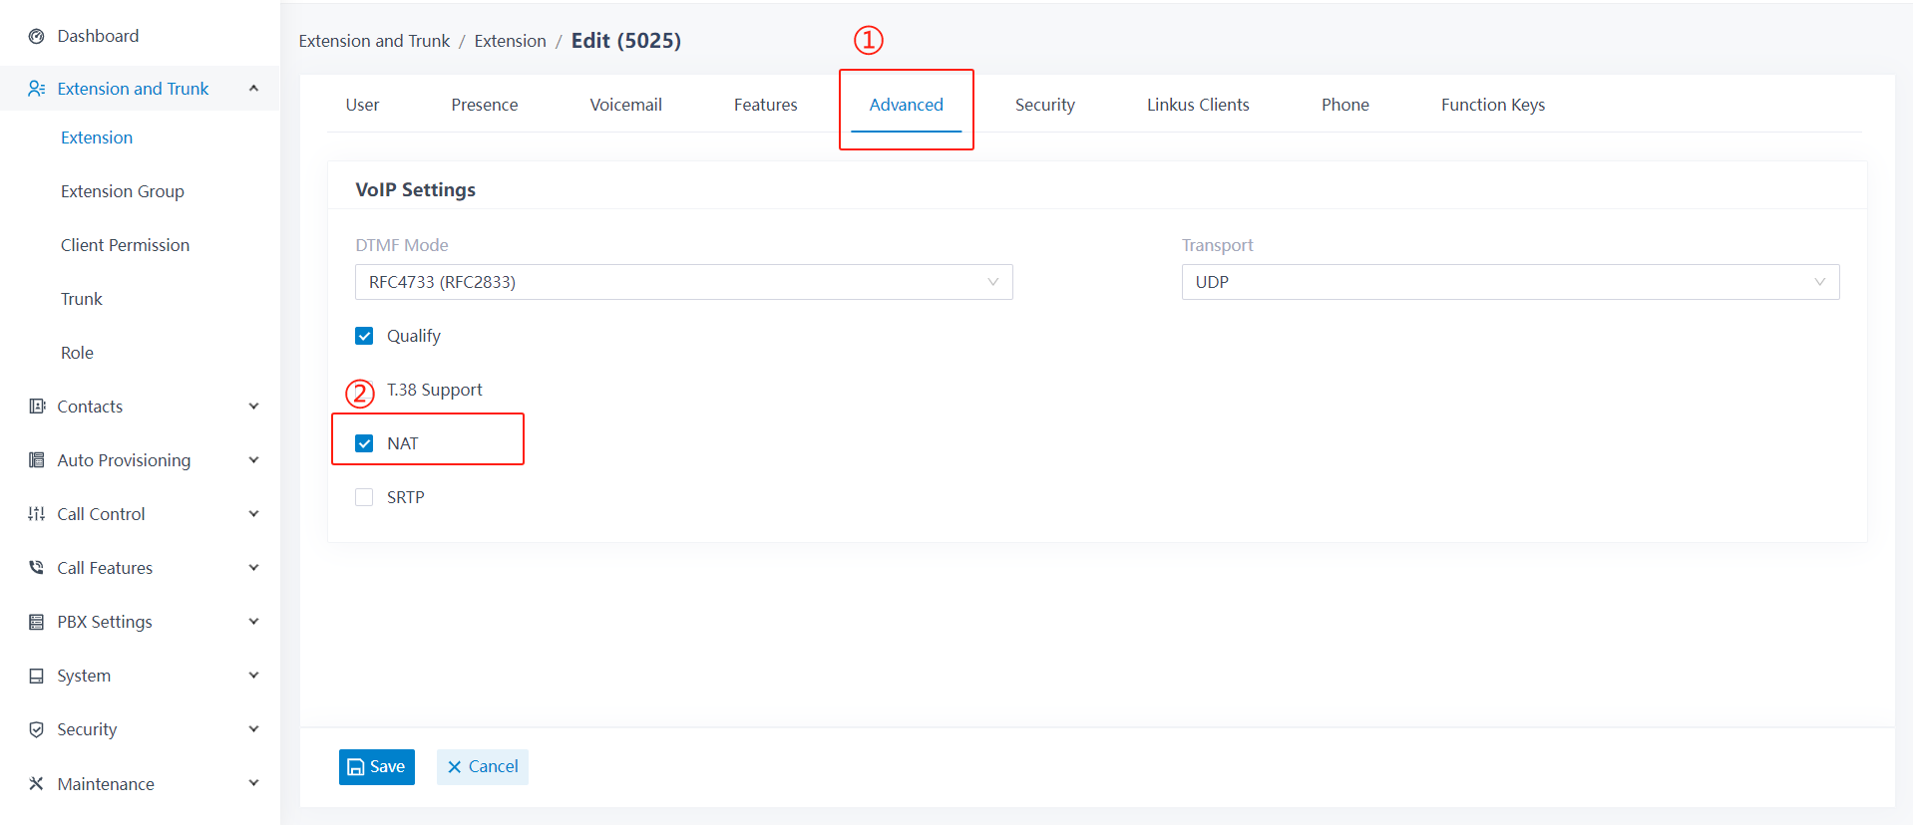

1. Click on the **Security** TAB, and in **SIP Security**, check **Allow Remote Registeration**.

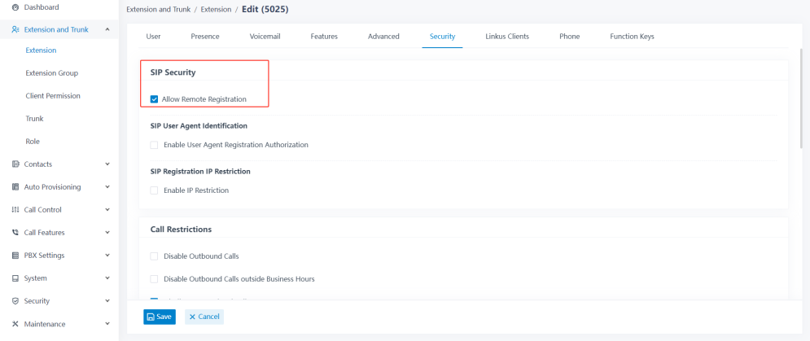

1. Click **Save** and **apply**. After the completion of the setup, the extension can be registered in different network segments of the local area network or in the remote network.

(2)The IPPBX generates the phone profile.

1. If the phone has been used, please reset it first.
2. Log in IPPBX management page and go to **Auto Provisioning > Phones**.
3. Click **Add** to add IP phone.
4. Configure IP phone information in the **IP phone** bar.
5. In the **options** bar, complete the auto provisioning setting.

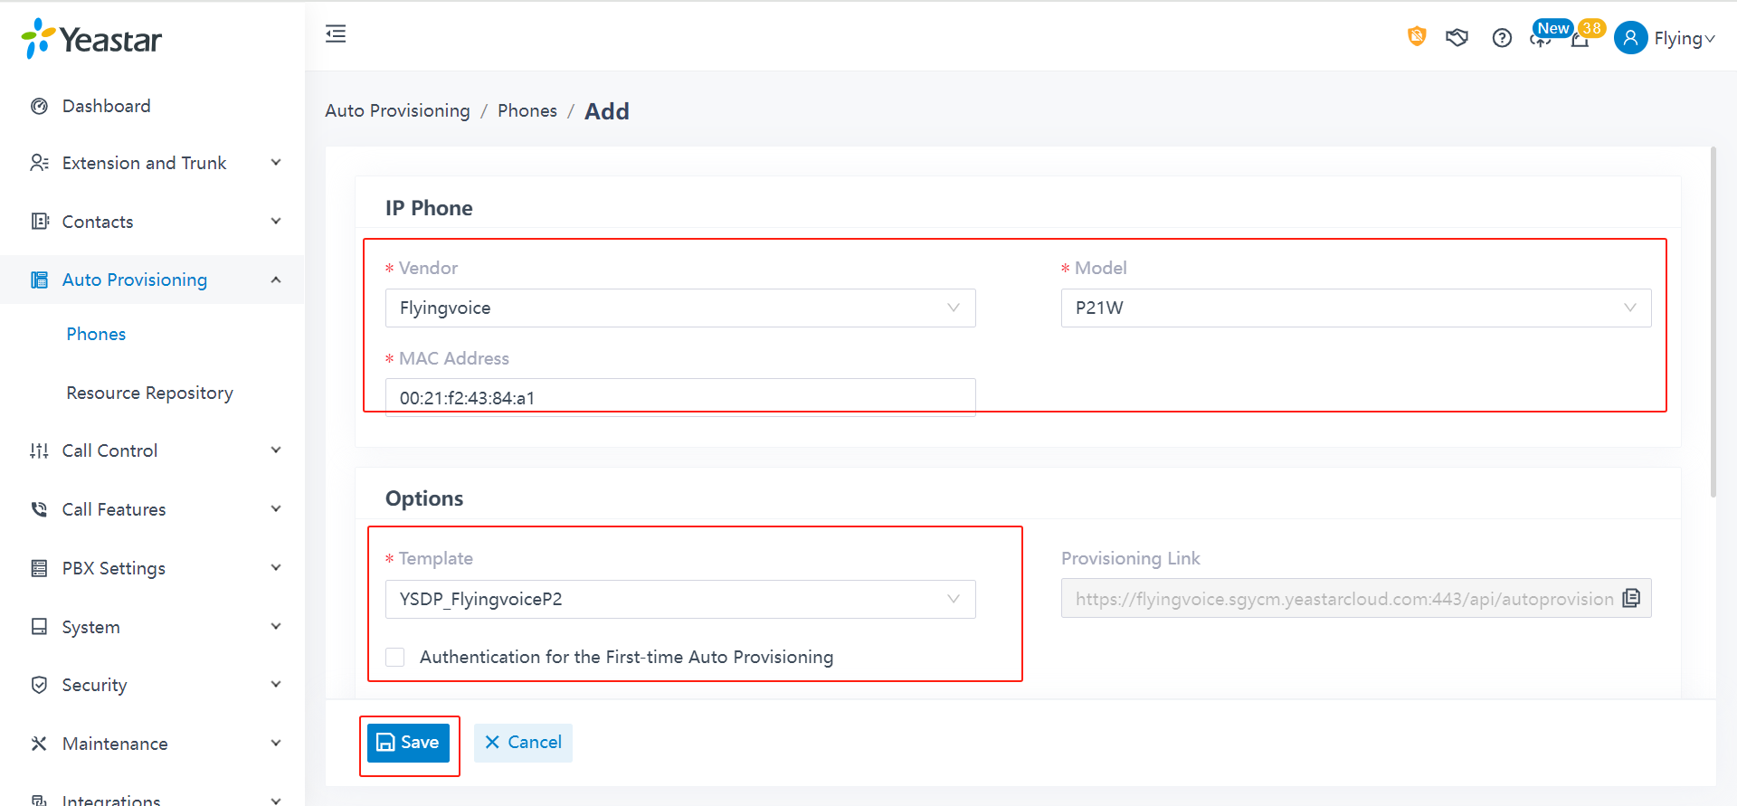

1. Click **Save**. The IPPBX automatically generates the profile of the phone and sends an event notification of a successful RPS request, indicating that the MAC address of the phone has been successfully added to FRPS.

(3)IP Phone get the profile

IP phone power on (or restart), so that the phone immediately obtain the acquired profile

(4) Check the result

You can check the registration status of the extension on the configured phone in A**uto Provisioning > Phones**.

* ：The assigned extension is registered on the phone.
* ：The assigned extension is unregistered on the phone.

