# Yeastar auto-provision with FLYINGVOICE IP phones(DHCP Option 66)

The auto-provisioning function helps you centrally manage and provision IP phones and ATA gateways on Yeastar P-series IPPBX. Using this function, the configuration and management process of IP phones and ATA gateways can be simplified, making the management and provisioning process of equipment more efficient and convenient.

## Ⅰ Premise

1. one or more FLYINGVOICE IP phone, an Yeastar P series PBX , a PC, a DHCP server(Using H3C’s layer 3 switch for DHCP server here).
2. All the devices can communicate with each other.
3. Available for all series FLYINGVOICE IP phones.

## Ⅱ Operation steps

1. Open remote extension registration in IP PBX web management page (if the phone and IP PBX are not in the same network segment, this operation is required)
2. Open the browser and enter the IP address of IP PBX, log in to the PBX management page, go to **Extension and Trunk > Extension**, and edit the extension to be allocated. (IP PBX ‘s address is 192.168.50.19 in this case)
3. Click the **Advanced** , and under **VoIP Settings**, check **NAT**.
4. Click the **Security** , and under **SIP Security**, check **Allow Remote Registration**.
5. Click **Save**.

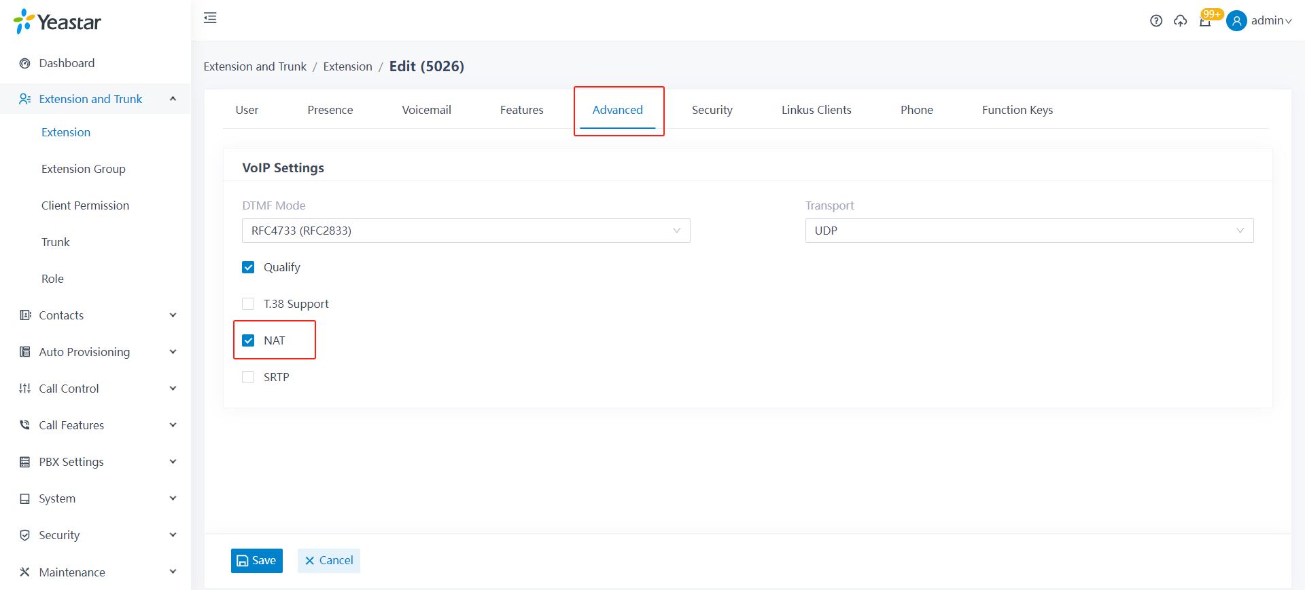

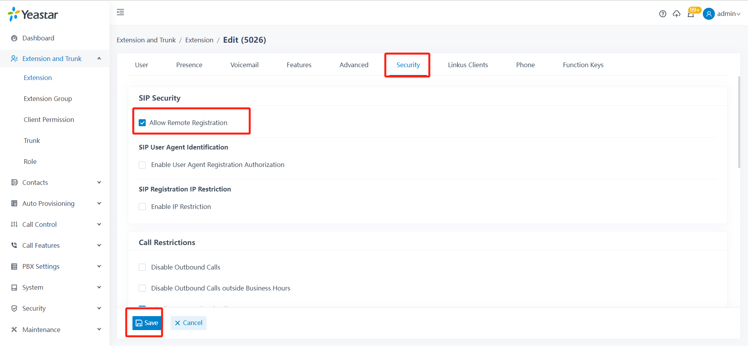

1. Generate phone configuration file
2. Set up the phone to **factory default setting**.
3. Log in IP PBX management page, enter **Auto Provisioning > Phones**, click **Add**, add a phone on IP PBX.
4. Fill in the parameters of vendor,MAC Address and model.
5. Select the **template** and **provisioning method**,copy the **provisioning link**.

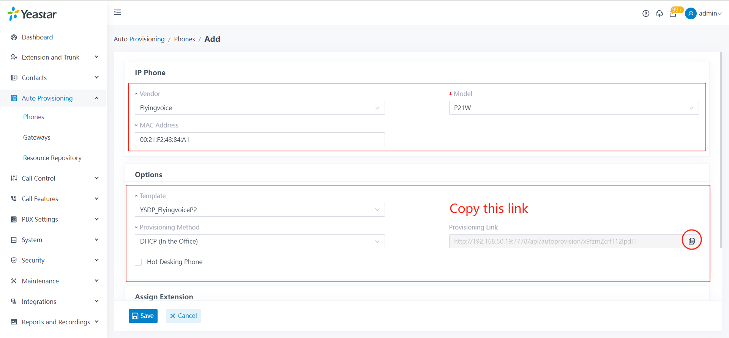

1. **Assign the extension** for this phone,then **save**.

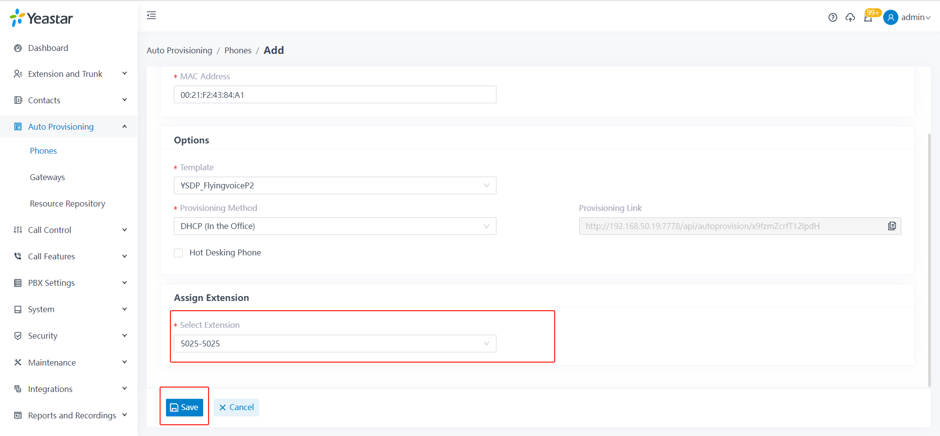

1. Configure option 66 on the DHCP server.
2. Connect the PC with the switch, and find the DHCP address pool which assign the address of the phone.
3. Enter the address pool and configure a command as: **option66 acsii + provisioning link**.
4. Save the configuration and restart the switch as needed.

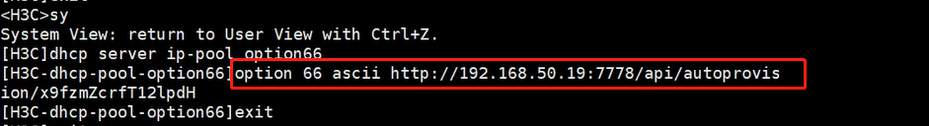

1. Check if the phone configuration is working.

After the DHCP server configuration takes effect, the phone will restart automatically, and the configuration file will be issued and effective.

