# Yeastar auto-provision with FLYINGVOICE IP phones(SIP PnP)

🎯 This article will introduce how to use the PnP method of Yeastar P series IP PBX to realize the remote batch deployment in the same LAN, to help you quickly initialize the device configuration

## Ⅰ Premise

1. All series of FLYINGVOICE IP phones support SIP PnP , Including FIP1X series , P1X series and P2X series.
2. PnP (plug and play) requires IP phoneS and IP PBX must be in the same IP network segment.

## Ⅱ Application Scenario

IP phone and IPPBX are in the same local area network.

Sample(all devices are in the subnet 192.168.6.0/24):

IP phone’s IP address :192.168.6.237

IP PBX’s IP address:192.168.6.19

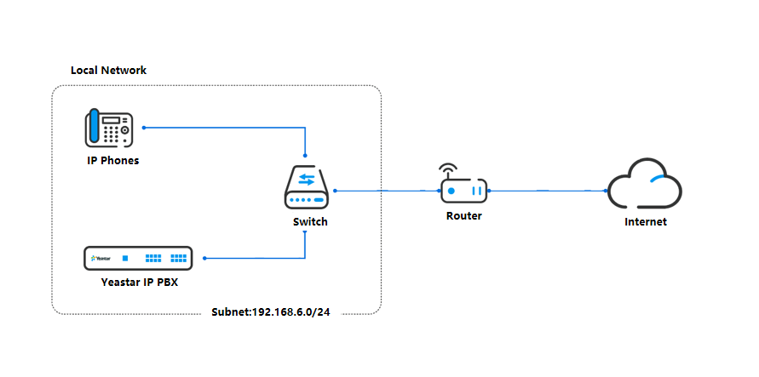

## Ⅲ Solutions

## 1.Solution 1:Pre-configuration

Add /batch add MAC informations and SIP accounts binding relationship in Yeastar IPPBX management web page in advance, and then the phones are powered on and connected to the Internet to realize plug-and-play. This solution is suitable for a large number of IP phones batch deployment.

## 2.Solution 2:Normal configuration

After the Yeastar IPPBX and IP phones are powered on and connected to the Internet, the PBX management Web page is used to manually select the online phone for SIP account binding, so that the configuration parameters obtained by the phone are restarted and effective.

## Ⅳ Operation steps

## Operation steps for solution1

1. Log in Yeastar IPPBX management page, go to **Auto Provisioning > Phones > Bulk add**,fill in the parameters marked in the figure below.

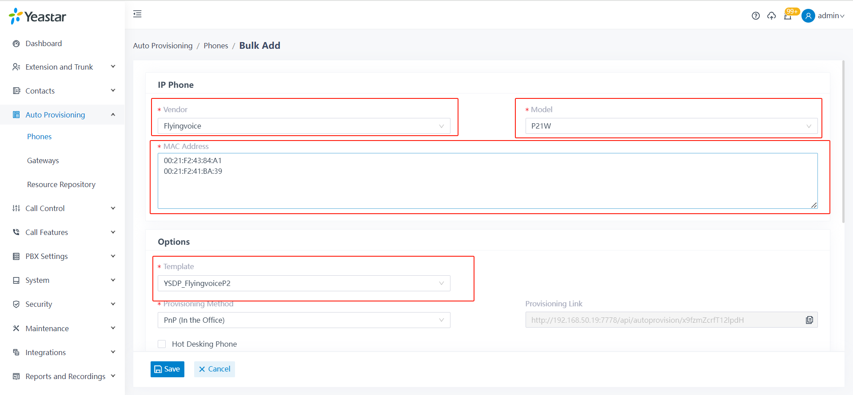

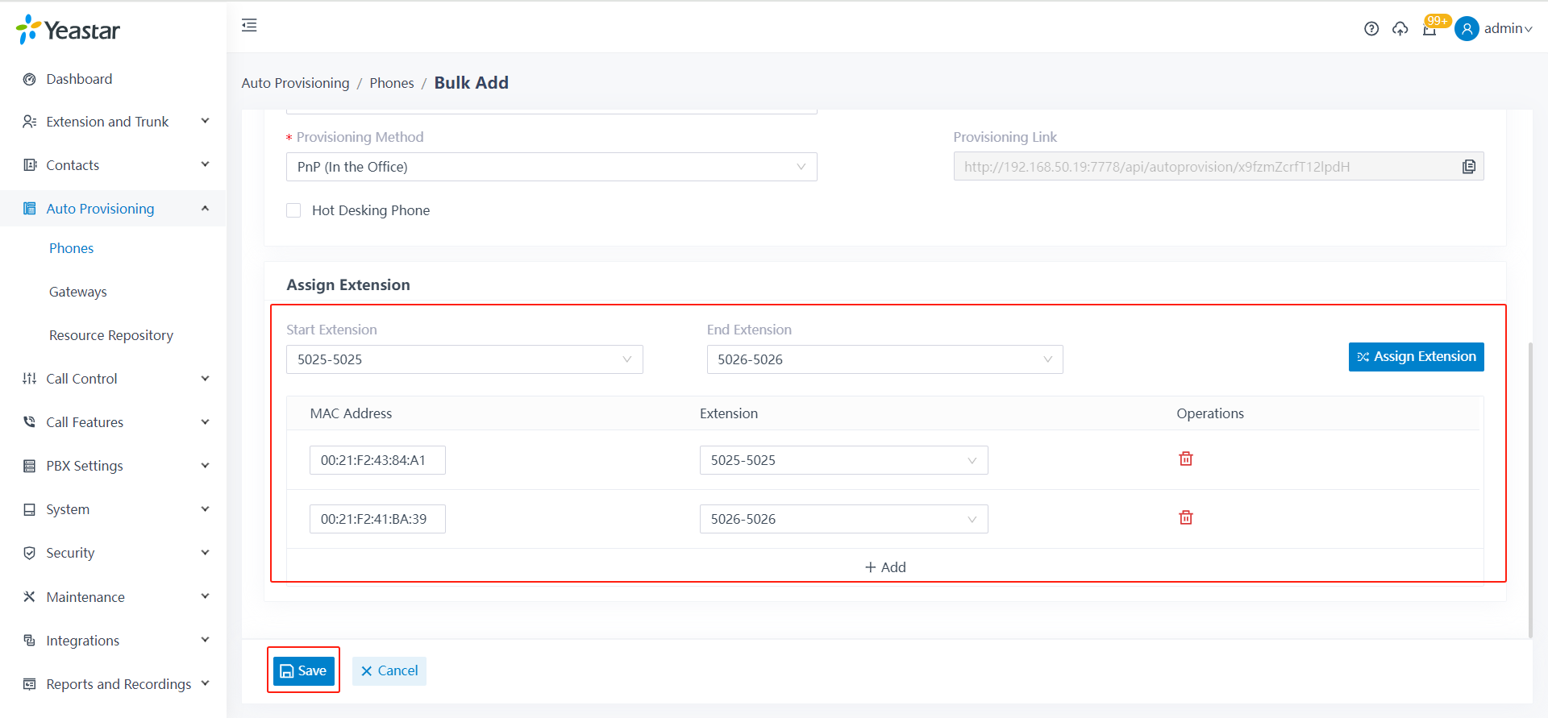

|  |  |
| --- | --- |
| **Description of Configuration Parameters** | |
| Vendor | Choose “Flyingvoice” |
| Model | Please choose according to the actual use of FLYINGVOICE IP phone model |
| MAC  Address | Enter the MAC address of FLYINGVOICE IP phone, separated by line, you can contact our sales manager in advance to get the MAC table list |
| Extensions | Please choose the binding relationship between the phone and SIP account according to the actual situation |
| Save | Configuration saved to work |

1. Power on the phones and network them,the phones will get the configurations atuomatically.
2. The phone reads the configuration information and restarts automatically to check the configuration results.

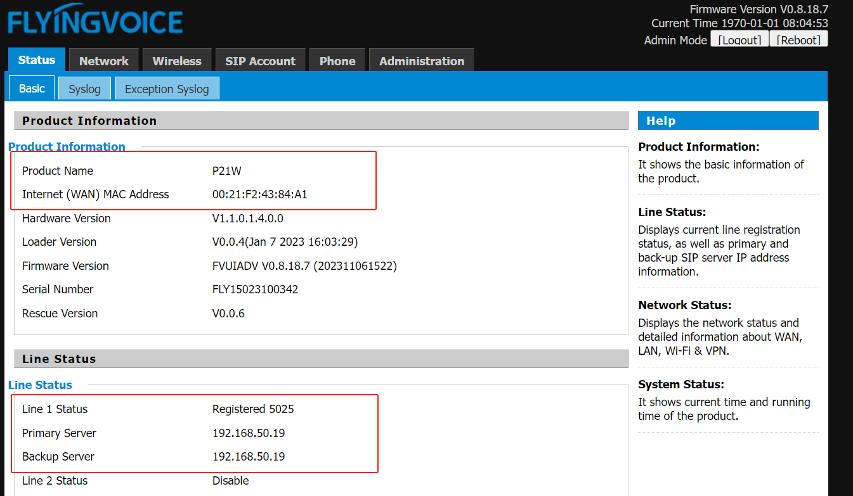

## Operation steps for solution2

1. Log in to the Yeastar IPPBX management page, choose **Auto Provisioning> Phones**, select the phone to be configured, and click **Edit**(pencil icon),then assign the extension for this phone.

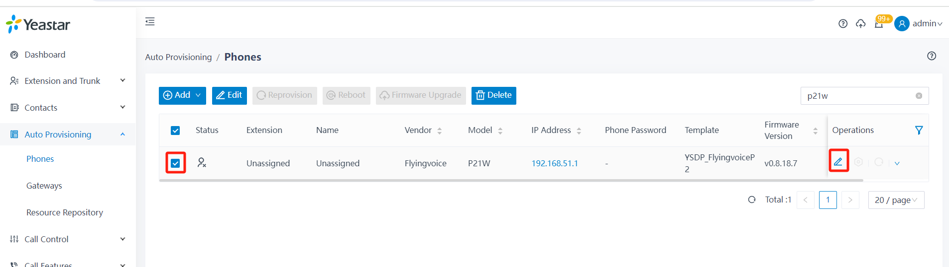

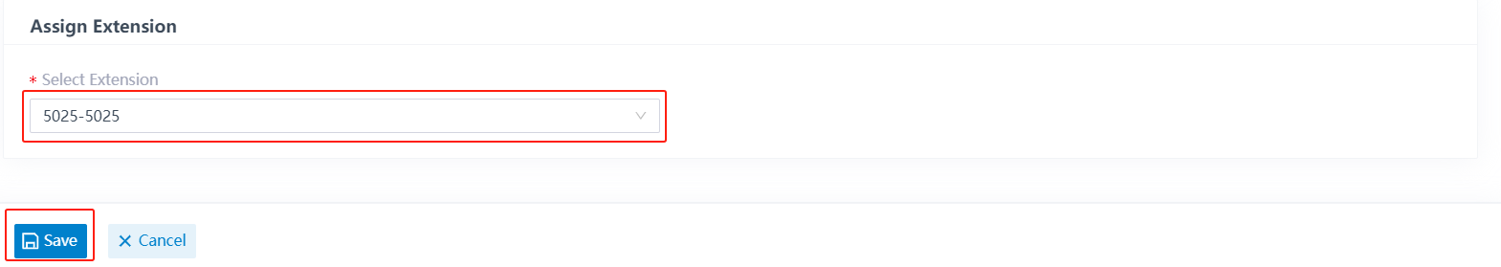

1. The IP phone reads the configuration information and automatically restarts. Check the configuration result.

