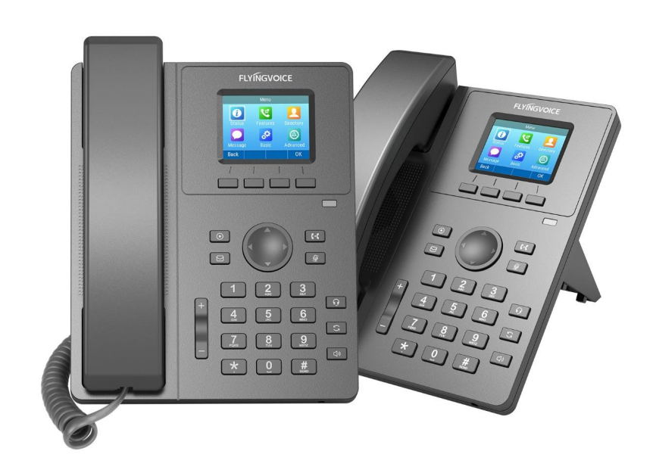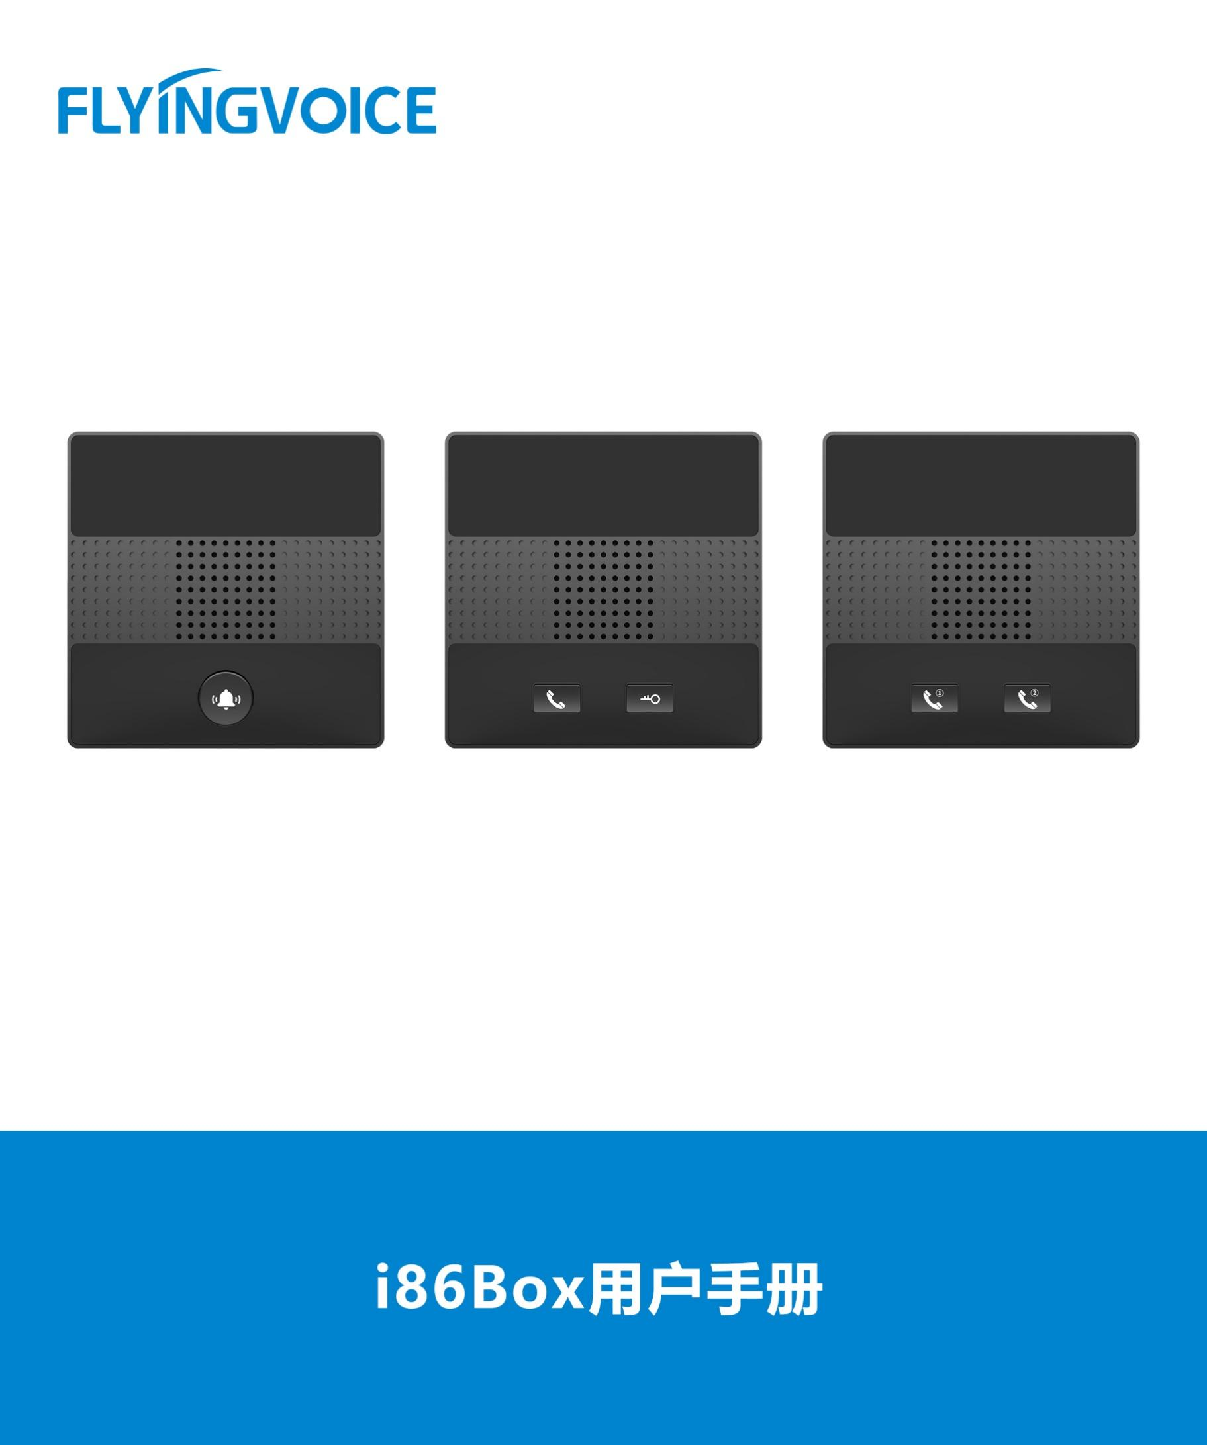

**FreePBX Docking Configuration Guide**

**Directory**

一、 Introduction 2

二、 Flow Configuration 2

1、 Configuring FreePBX 2

① Login to FreePBX administrator interface in browser 2

② Create an extension 2

2、 Configuring IP Phone 3

① Login to the web interface of the IP phone 3

② Register an account 3

三、 Verification of Results 4

1. **Introduction**

Register your phone with FreePBX and use it to make and receive calls.

1. **Flow Configuration**
2. **Configuring FreePBX**
3. **Login to FreePBX administrator interface in browser**

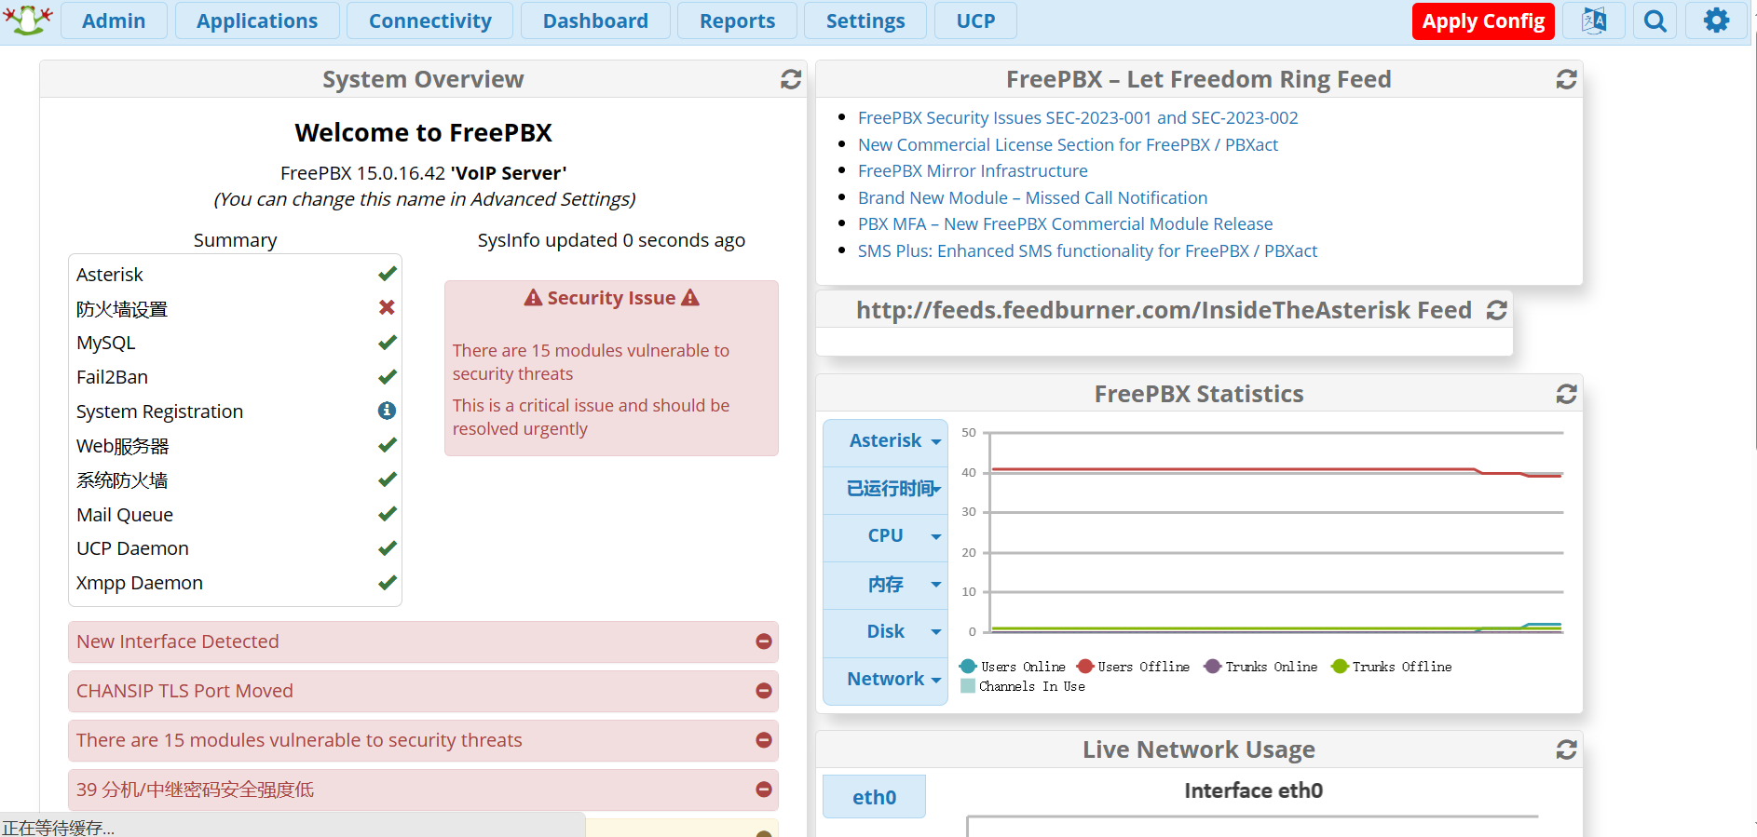

Figure 1 FreePBX login screen

1. **Create an extension**

Use PJSIP to create a SIP extension.

**operating steps：**

Applications--》Extensions--》Add Extensions--》Add New SIP [chan_pjsip]Extensions；

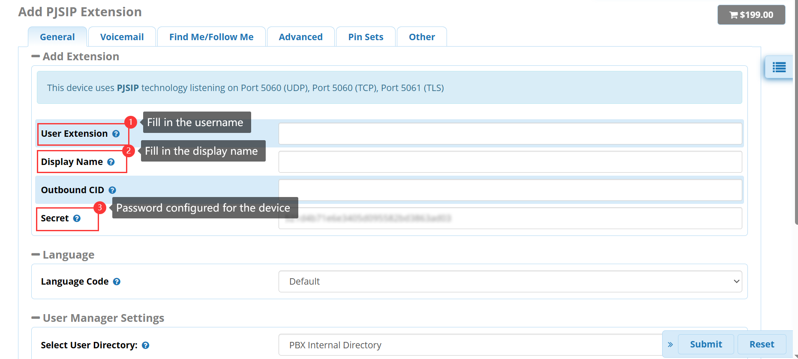

Figure 2 create an extension

Submit--》Apply Config；

1. Configuring IP Phone
2. **Login to the web interface of the IP phone**

Enter the IP address of the IP phone in the browser, and enter the web interface of the phone for relevant configuration.

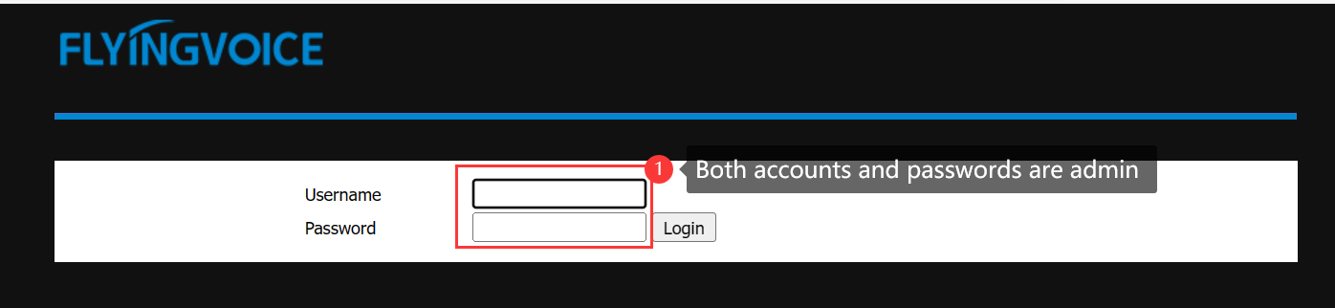

Figure 3 web interface

1. **Register an account**

Fill in the extension information.

**operating steps：**

Enter the web interface of the phone--》VoIP--》Account--》Fill in the extension information--》save and reply；

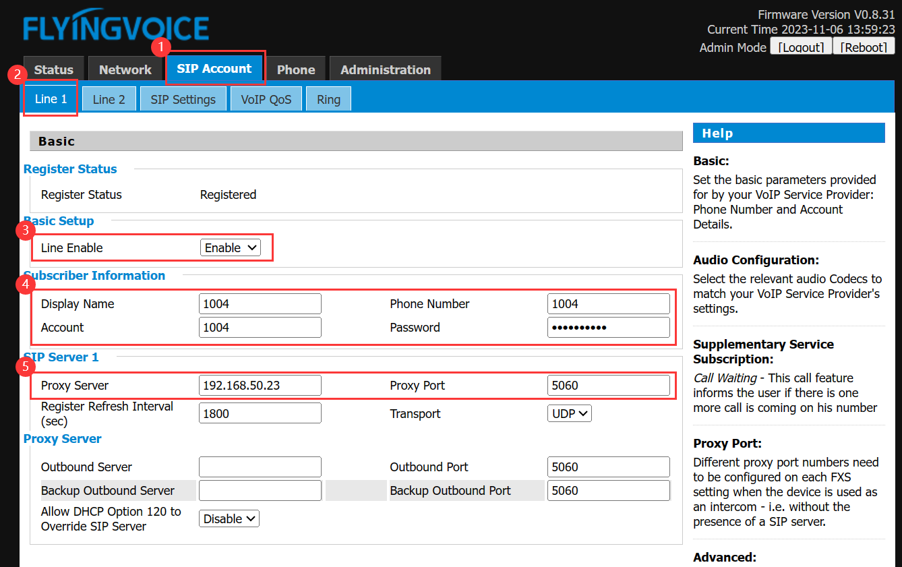

Figure 4 register accounts

|  |  |
| --- | --- |
| **Parameter** | **Description** |
| **Line Enable** | Enable |
| **Display Name** | Fill in the display name |
| **Phone Number** | Fill in the extension number |
| **Account** | Fill in the account |
| **Password** | Fill in the password |
| **Proxy Server** | Fill in the ip address of FreePBX |
| **Proxy Port** | 5060（Check the server configuration for the actual port number） |

1. **Verification of Results**

Register the extension numbers 1004 and 1122 on two phones respectively, use the extension 1004 to dial 1122, and the test is successful.

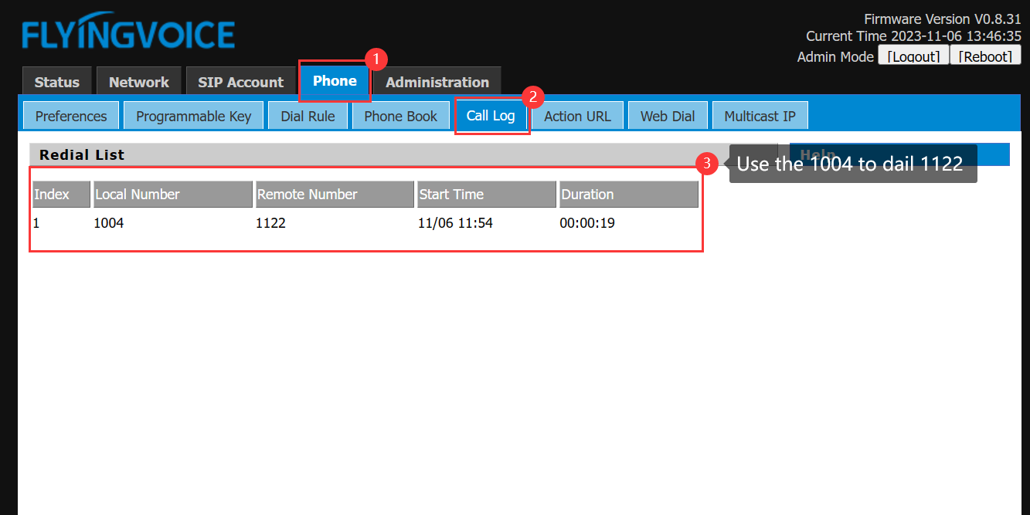

Figure 5 test result