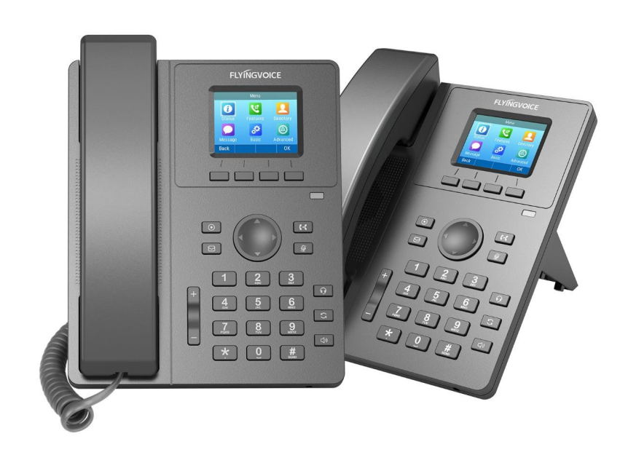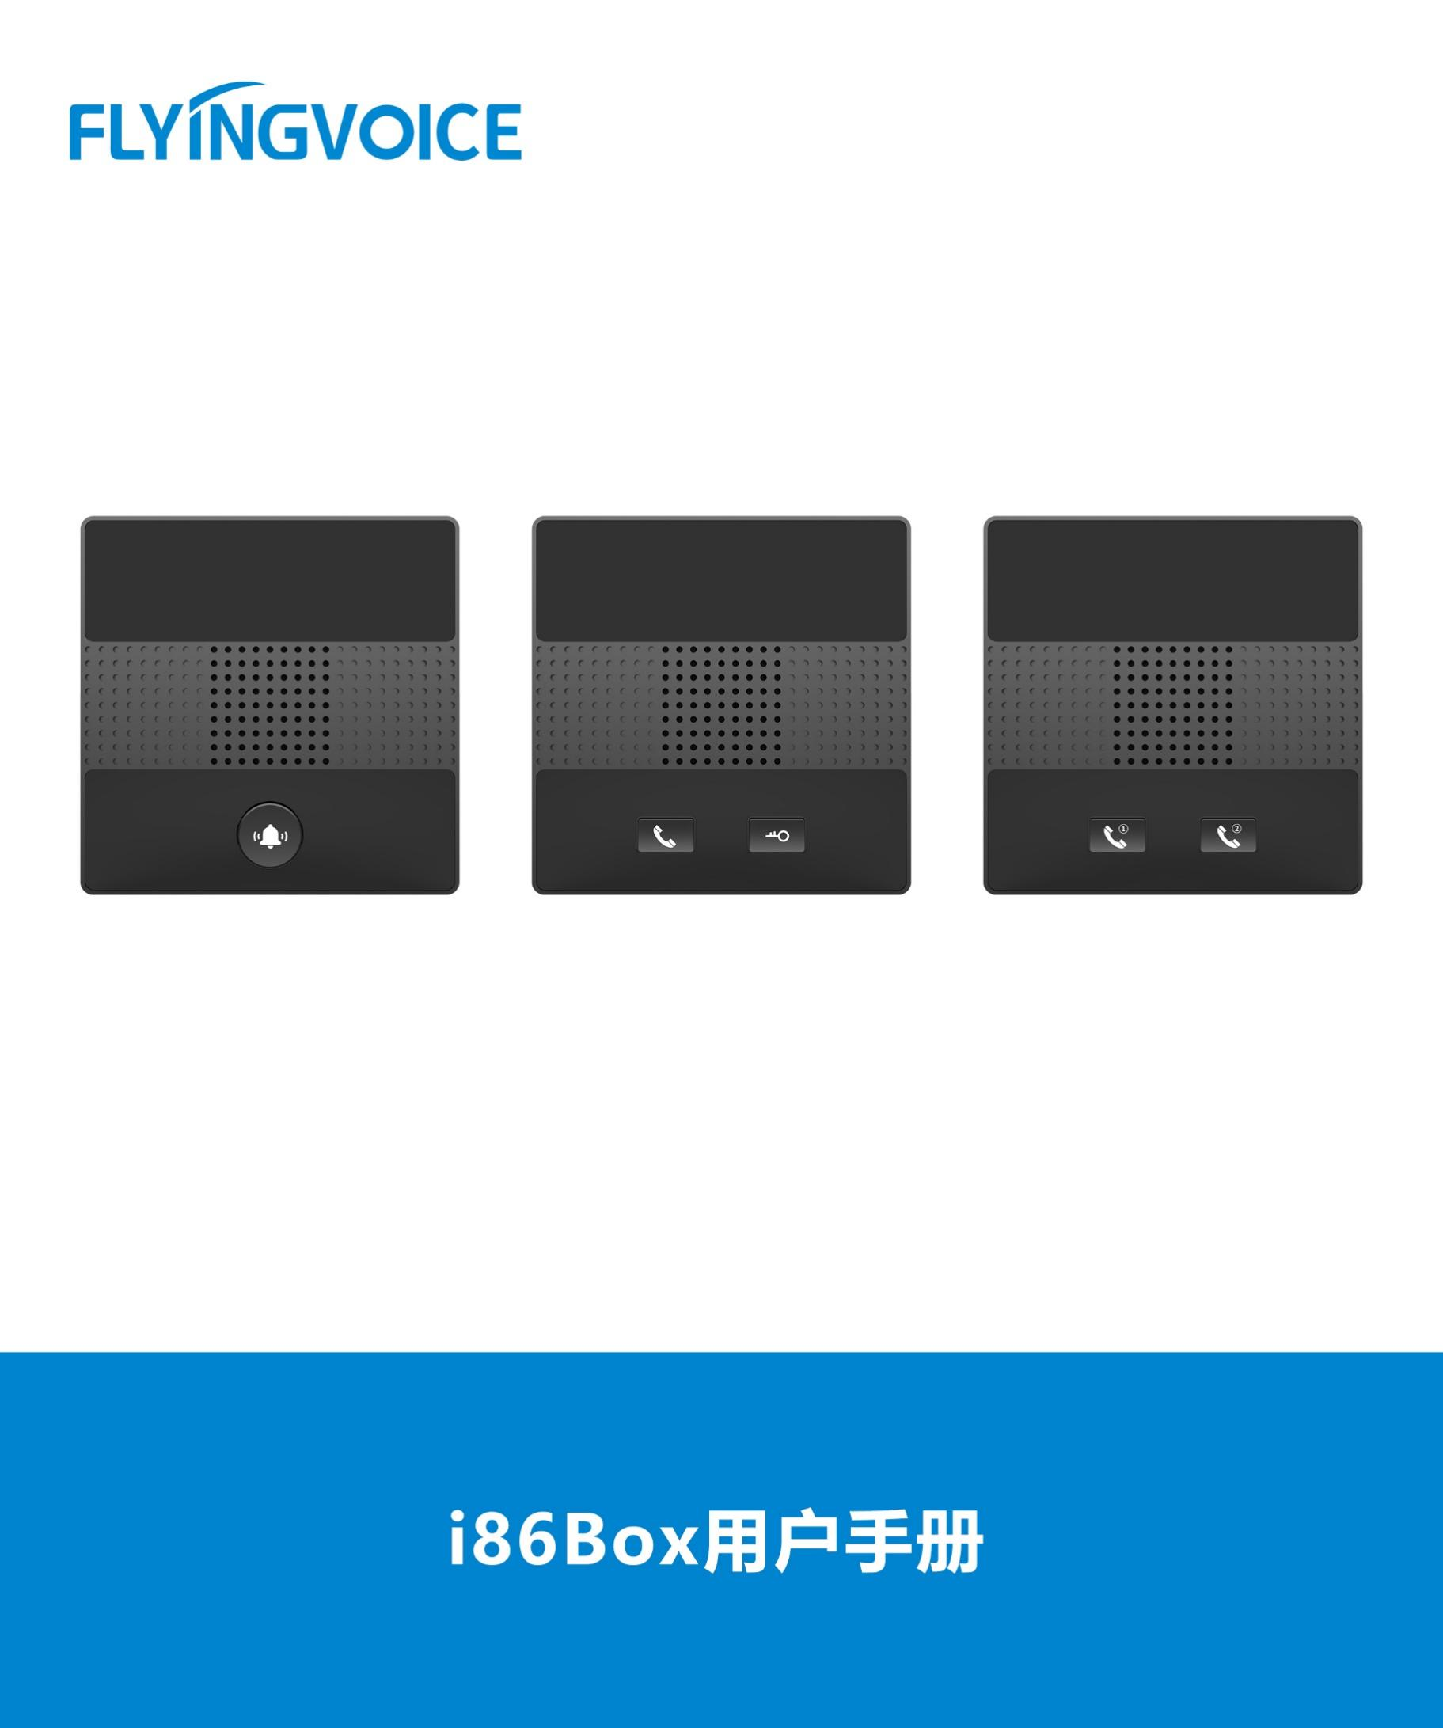

**Voicemail Configuration Guide**

**Directory**

一、 Introduction 2

二、 Flow Configuration 2

1、 Configuring FreePBX 2

① Login to FreePBX administrator interface in browser 2

② Create an extension 2

③ Set Voicemail 3

④ Set Call Forward 4

⑤ Check the Feature Codes of Voicemail 4

2、 Configuring IP Phone 5

① Login to the web interface of the IP phone 5

② Register an account 5

③ Set Voicemail 6

三、 Verification of Results 7

1. **Introduction**

FreePBX integrated free voicemail function,and this article introduces how to use voice mail function with FreePBX in Flyingvoice IP phone.

1. **Flow Configuration**
2. **Configuring FreePBX**
3. **Login to FreePBX administrator interface in browser**

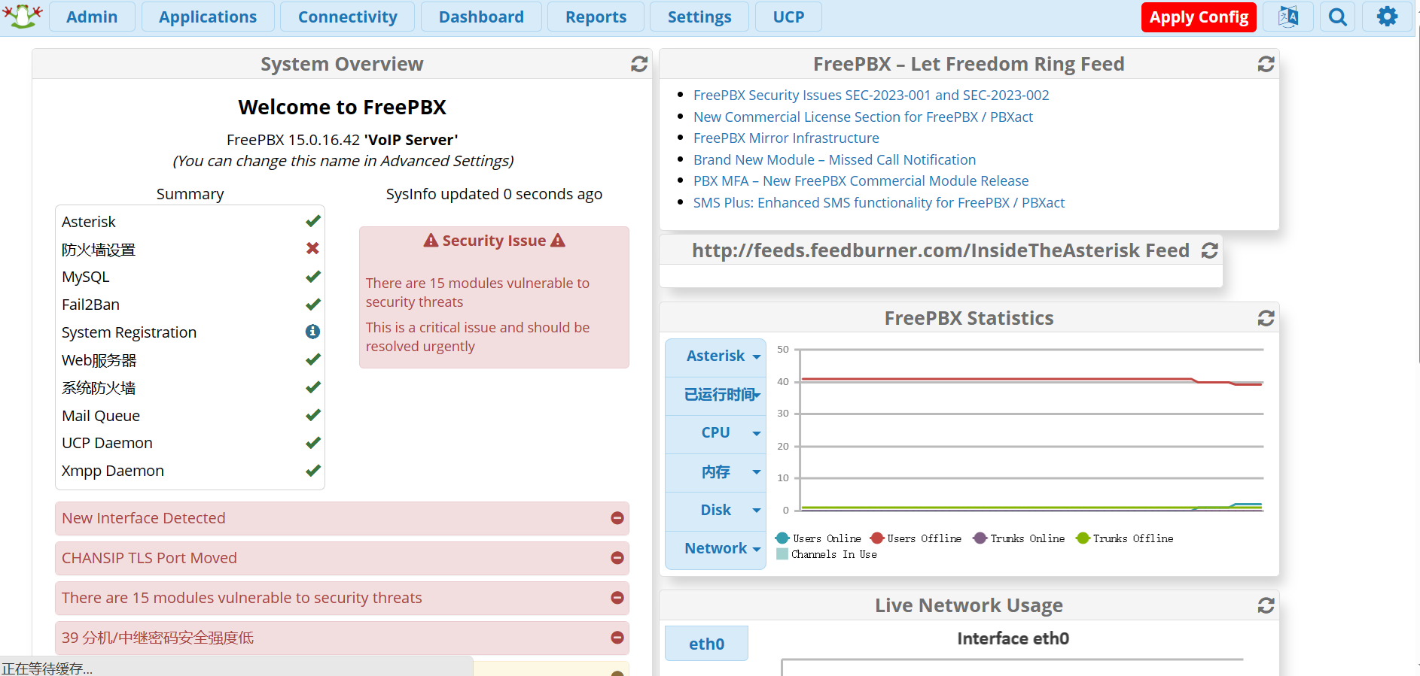

Figure 1 FreePBX login screen

1. **Create an extension**

Use PJSIP to create a SIP extension.

**operating steps：**

Applications--》Extensions--》Add Extensions--》Add New SIP [chan_pjsip]Extensions；

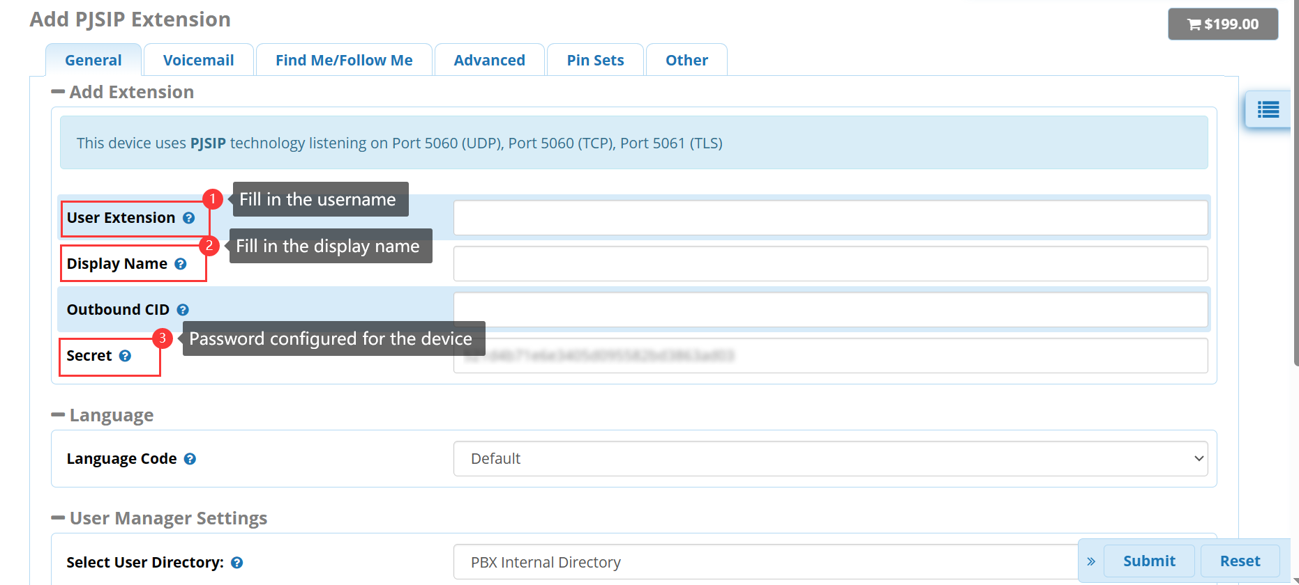

Figure 2 create an extension

Submit--》Apply Config；

1. **Set Voicemail**

Enable the Voicemail function,and set it as the destination of the no answer.

**operating steps：**

Applications--》Extensions--》Add Extensions--》Add New SIP [chan_pjsip]Extensions--》 Voicemail；

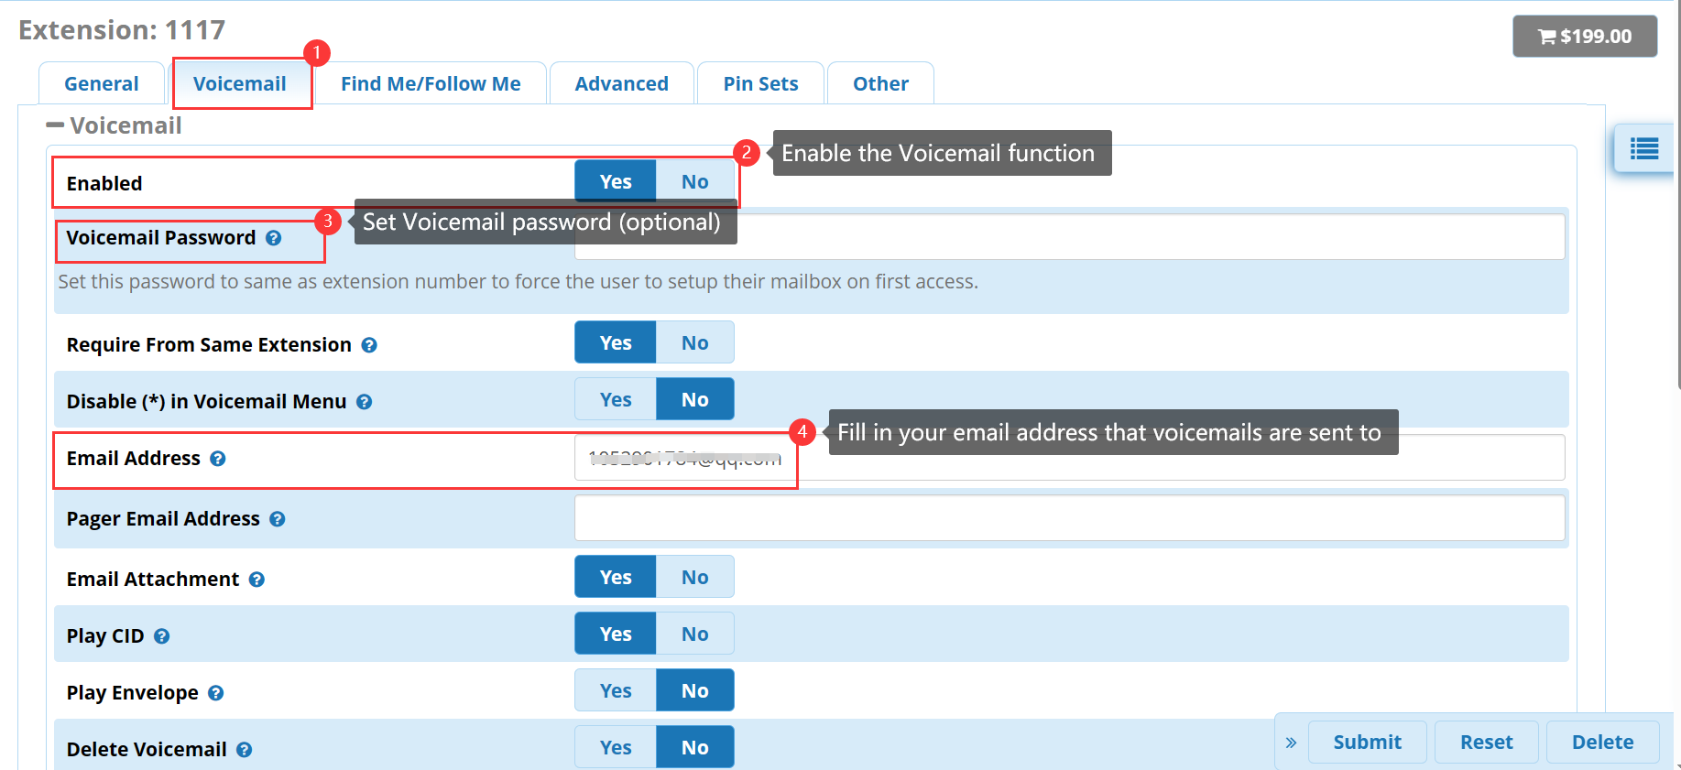

Figure 3 set Voicemail function

1. **Set Call Forward**

Set the destination when the call is not answered on an otherwise idle phone is Voicemail.

**operating steps：**

Applications--》Extensions--》Add Extensions--》Add New SIP [chan_pjsip]Extensions--》 Advanced--》Optional Destinations；

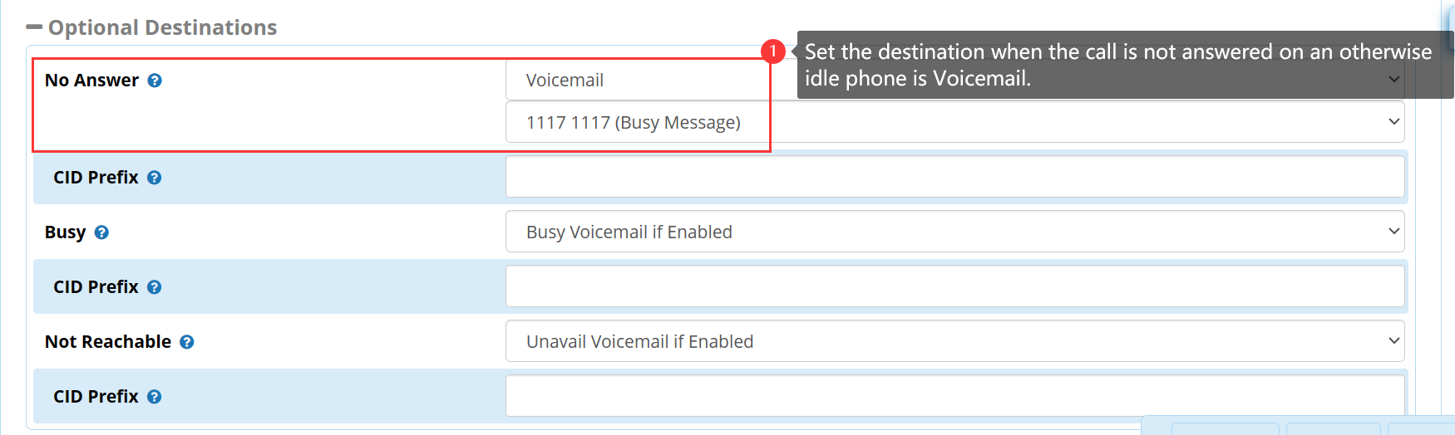

Figure 4 set call forward

1. **Check the Feature Codes of Voicemail**

Check the feature codes of voicemail，and dail the feature codes to listen to voicemails。

**operating steps：**

Admin--》Feature Codes--》Voicemail；

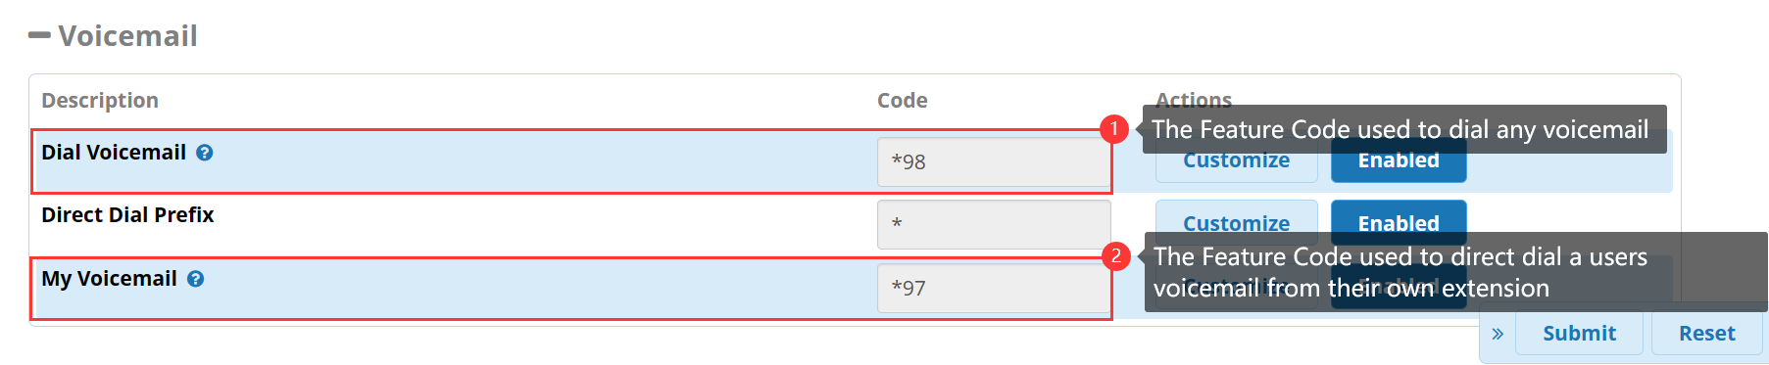

Figure 5 check feature codes

1. Configuring IP Phone
2. **Login to the web interface of the IP phone**

Enter the IP address of the IP phone in the browser, and enter the web interface of the phone for relevant configuration.

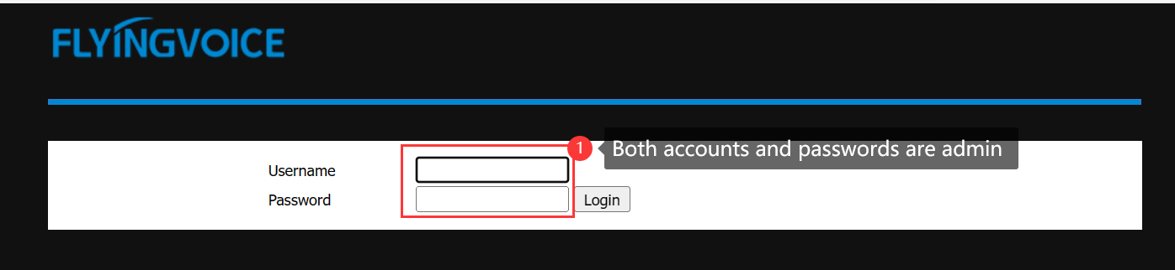

Figure 6 web interface

1. **Register an account**

Fill in the extension information.

**operating steps：**

Enter the web interface of the phone--》VoIP--》Account--》Fill in the extension information--》save and reply；

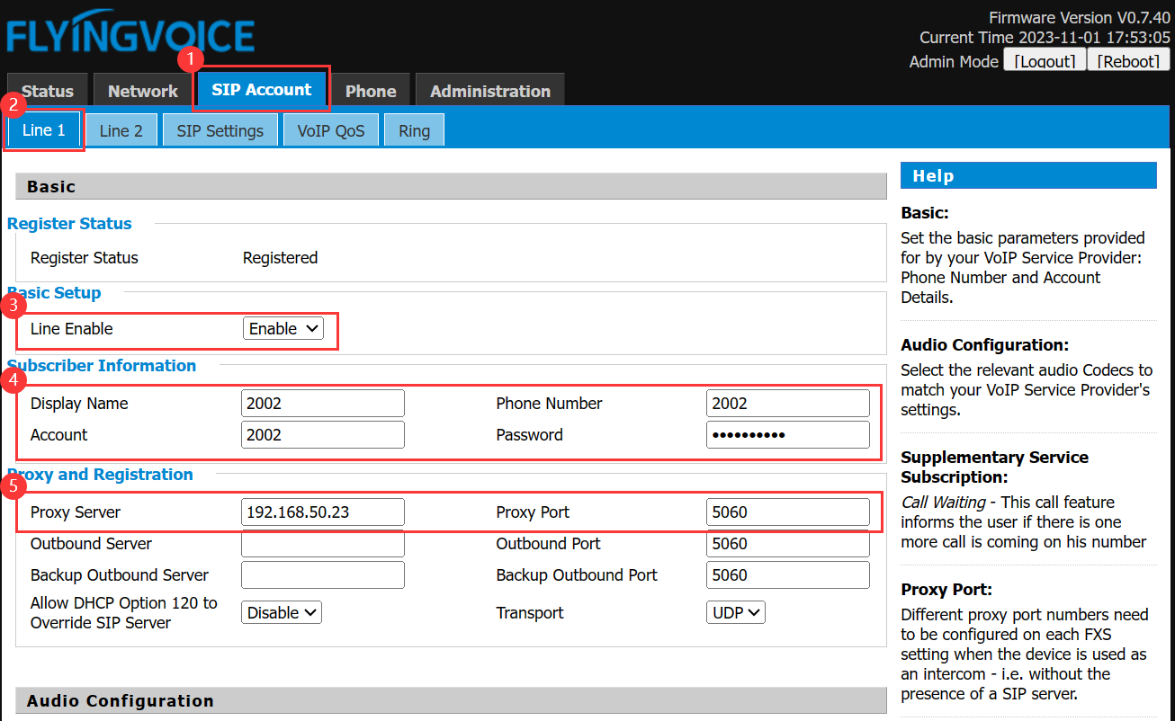

Figure 7 register accounts

|  |  |
| --- | --- |
| **Parameter** | **Description** |
| **Line Enable** | Enable |
| **Display Name** | Fill in the display name |
| **Phone Number** | Fill in the extension number |
| **Account** | Fill in the account |
| **Password** | Fill in the password |
| **Proxy Server** | Fill in the ip address of FreePBX |
| **Proxy Port** | 5060（Check the server configuration for the actual port number） |

1. **Set Voicemail**

Enable the voicemail function of ip phone，and fill in the feature codes。

**操作步骤：**

VoIP--》Account--》Supplementary Services；

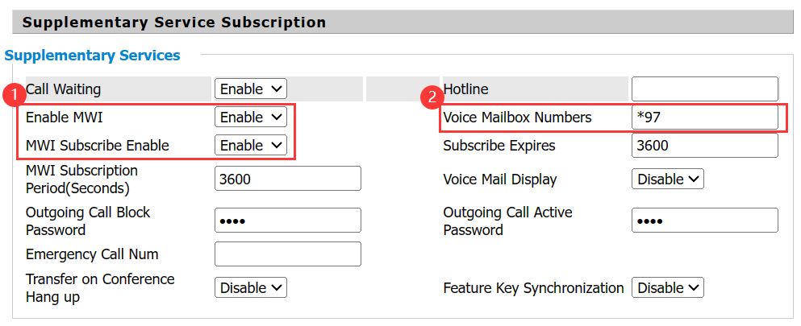

Figure 8 enable voicemail function

|  |  |
| --- | --- |
| **Parameter** | **Description** |
| **Enable MWI** | Enable |
| **MWI Subscribe Enable** | Enable |
| **Voice Mailbox Numbers** | Fill in the feature codes of voicemail |

1. **Verification of Results**

When the user dials extension 2002 and there is no answer, it will be automatically transferred to voicemail, and the system will prompt for voice message.

In extension 2002, you can dial *97 directly to view the voice message, or you can enter the mailbox of the phone to view. The specific steps are: Menu -- 》Message --》Voice Mail -- 》Connection.