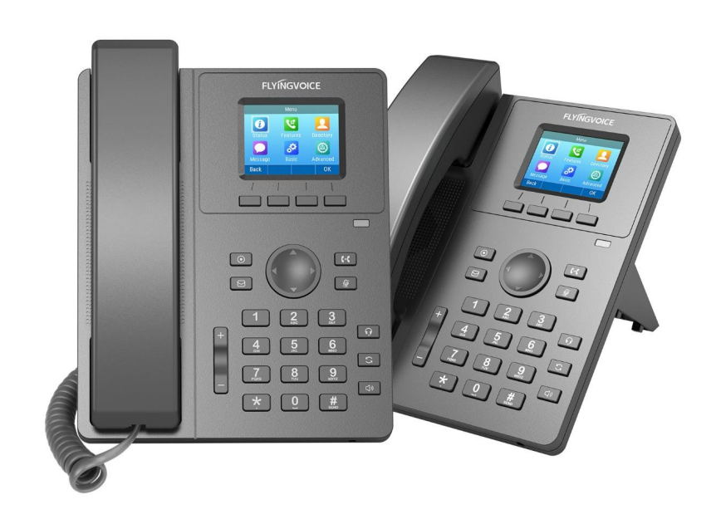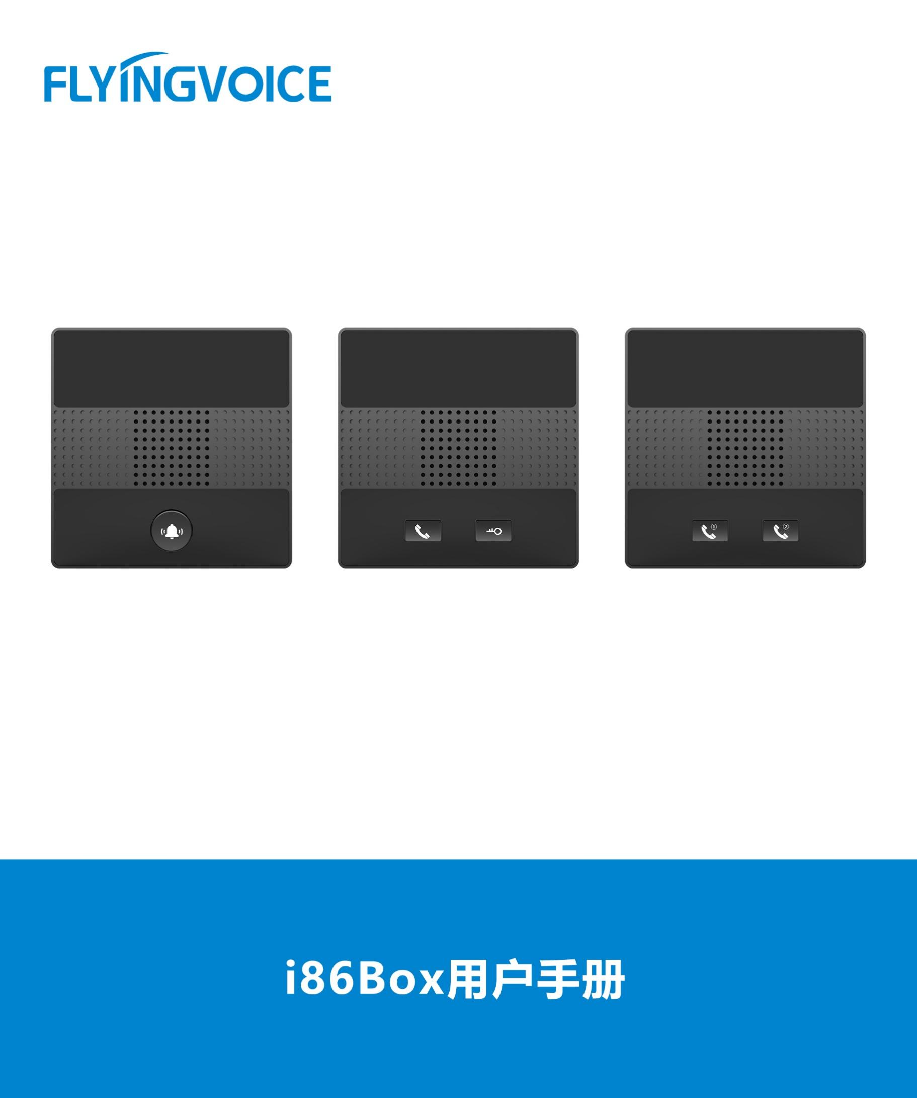

**Voicemail Blasting Configuration Guide**

**Directory**

一、 Introduction 2

二、 Flow Configuration 2

1、 Configuring FreePBX 2

① Login to FreePBX administrator interface in browser 2

② Create an extension 2

③ Set Voicemail 3

④ Create a Voicemail Blasting Group 4

⑤ Check the Feature Codes of Voicemail 4

2、 Configuring IP Phone 4

① Login to the web interface of the IP phone 4

② Register an account 5

③ Set Voicemail 6

三、 Verification of Results 7

1. **Introduction**

Voicemail blasting lets you send a voicemail message to multiple users at the same time. The Voicemail Blasting module is used to create a group of users and assign a number to the group. A user can dial this number to leave a voicemail message for the group. All members of the group will receive the message in their voicemail boxes.

1. **Flow Configuration**
2. **Configuring FreePBX**
3. **Login to FreePBX administrator interface in browser**

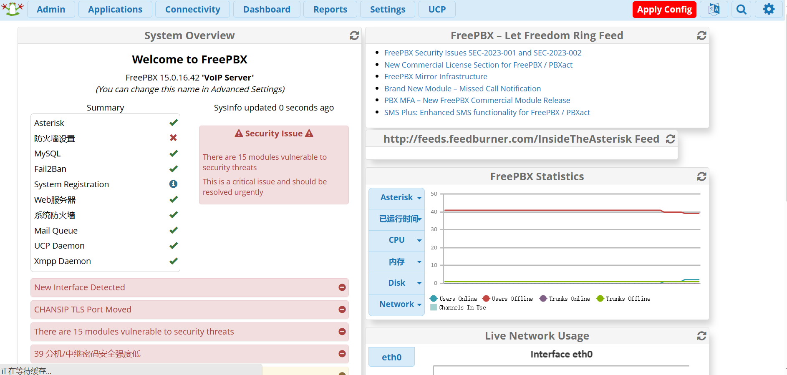

Figure 1 FreePBX login screen

1. **Create an extension**

Use PJSIP to create a SIP extension.

**operating steps：**

Applications--》Extensions--》Add Extensions--》Add New SIP [chan_pjsip]Extensions；

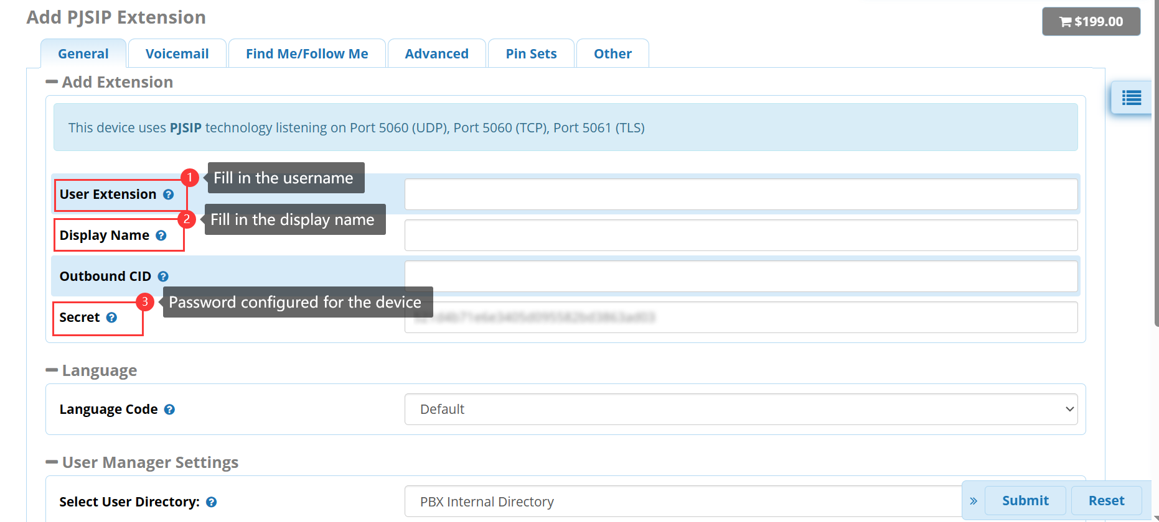

Figure 2 create an extension

Submit--》Apply Config；

1. **Set Voicemail**

Enable the Voicemail function,and set it as the destination of the no answer.

**operating steps：**

Applications--》Extensions--》Add Extensions--》Add New SIP [chan_pjsip]Extensions--》 Voicemail；

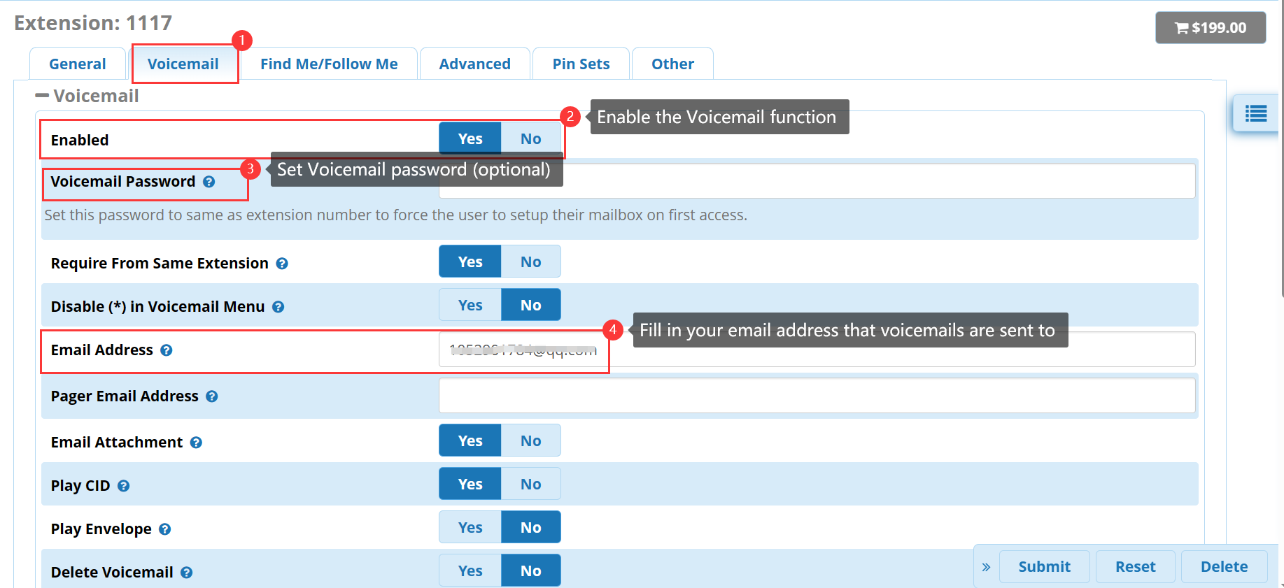

Figure 3 set Voicemail function

1. **Create a Voicemail Blasting Group**

Set VMBlast Number.

**operating steps：**

Applications--》Voicemail Blasting--》Add VM Blast Group；

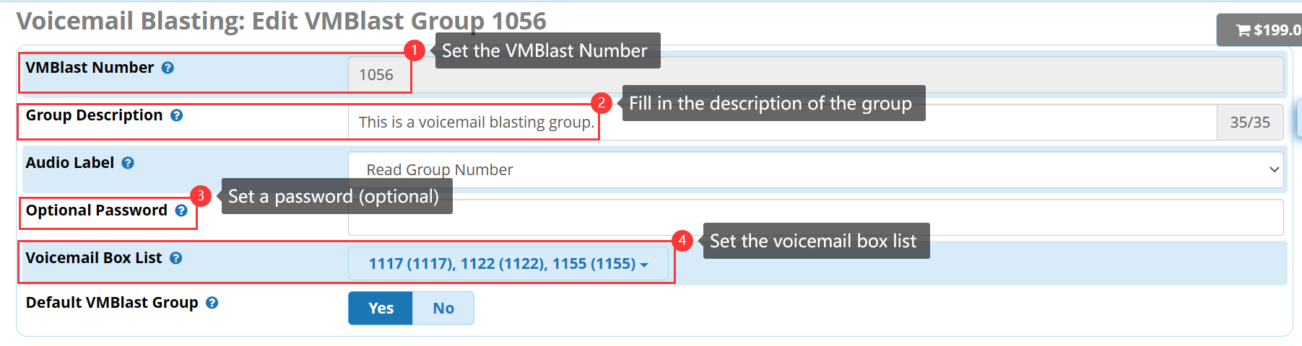

Figure 4 set VMBlast

1. **Check the Feature Codes of Voicemail**

Check the feature codes of voicemail，and dail the feature codes to listen to voicemails。

**operating steps：**

Admin--》Feature Codes--》Voicemail；

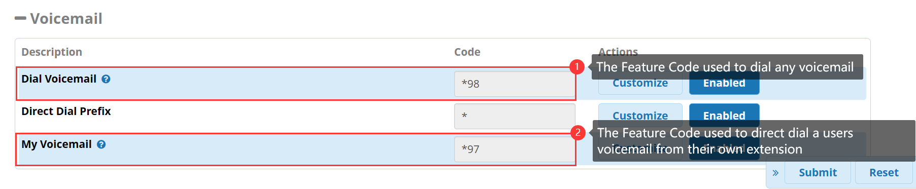

Figure 5 check feature codes

1. Configuring IP Phone
2. **Login to the web interface of the IP phone**

Enter the IP address of the IP phone in the browser, and enter the web interface of the phone for relevant configuration.

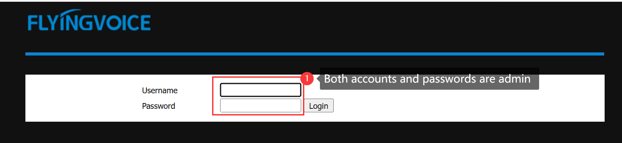

Figure 6 web interface

1. **Register an account**

Fill in the extension information.

**operating steps：**

Enter the web interface of the phone--》VoIP--》Account--》Fill in the extension information--》save and reply；

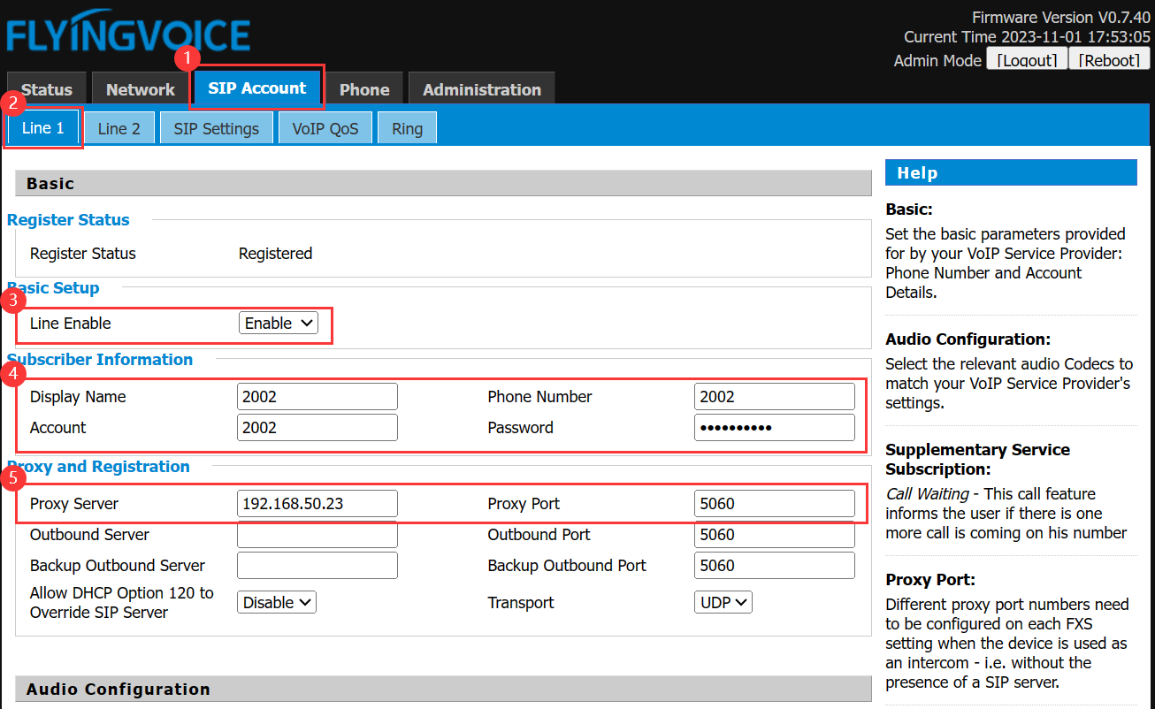

Figure 7 register accounts

|  |  |
| --- | --- |
| **Parameter** | **Description** |
| **Line Enable** | Enable |
| **Display Name** | Fill in the display name |
| **Phone Number** | Fill in the extension number |
| **Account** | Fill in the account |
| **Password** | Fill in the password |
| **Proxy Server** | Fill in the ip address of FreePBX |
| **Proxy Port** | 5060（Check the server configuration for the actual port number） |

1. **Set Voicemail**

Enable the voicemail function of ip phone，and fill in the feature codes。

**操作步骤：**

VoIP--》Account--》Supplementary Services；

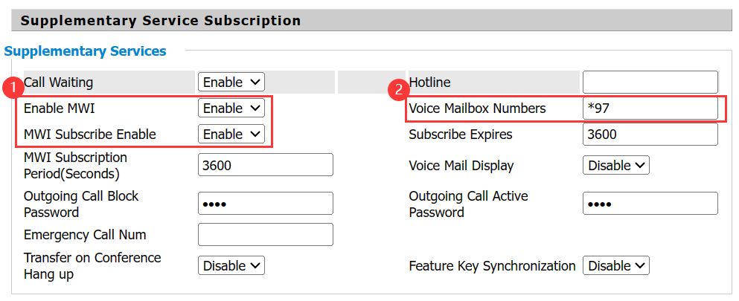

Figure 8 enable voicemail function

|  |  |
| --- | --- |
| **Parameter** | **Description** |
| **Enable MWI** | Enable |
| **MWI Subscribe Enable** | Enable |
| **Voice Mailbox Numbers** | Fill in the feature codes of voicemail |

1. **Verification of Results**

Users can dail the voicemail blasting group number: 1056 to send message to the voicemail box list.