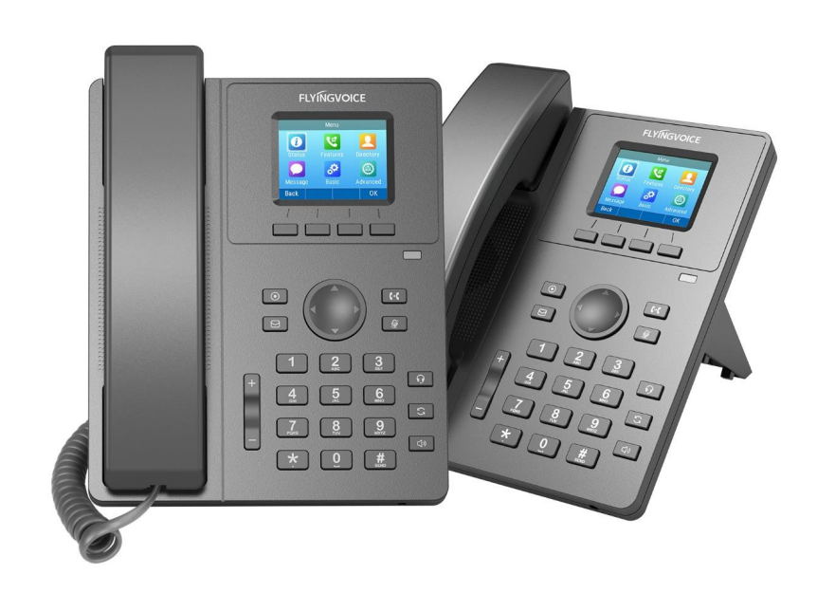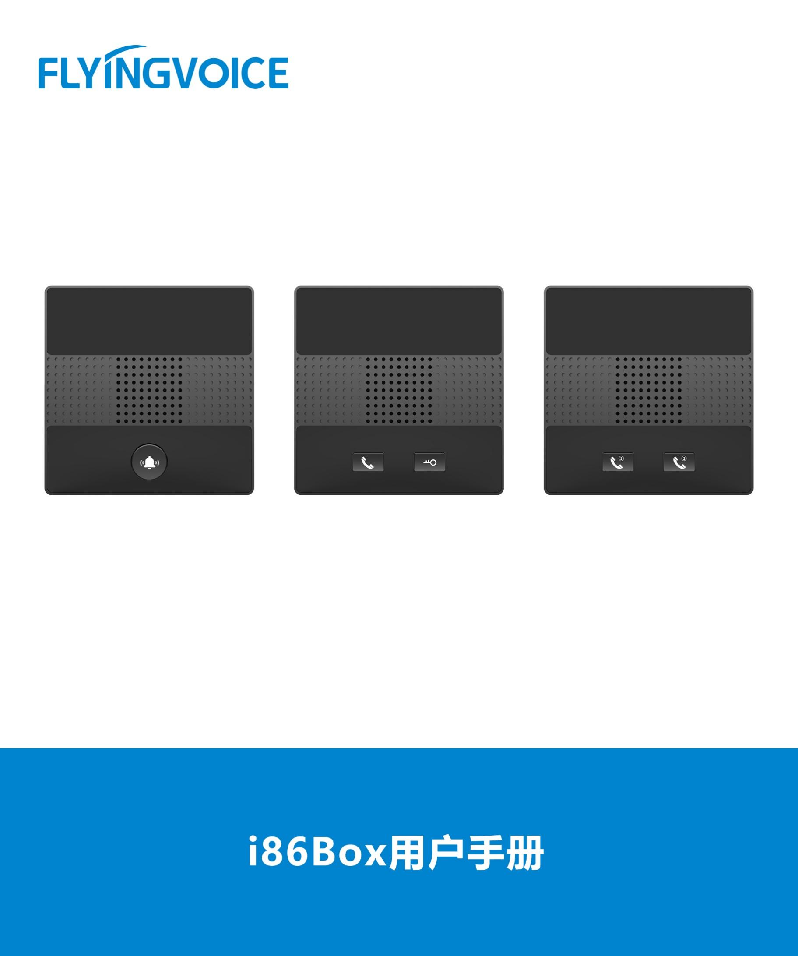

**Paging and Intercom Configuration Guide**

**Directory**

一、 Introduction 2

二、 Flow Configuration 2

1、 Configuring FreePBX 2

① Set Page Groups 2

三、 Verification of Results 2

1. **Introduction**

In the Paging and Intercom module, you can configure groups of phones that will auto-answer and play the page over their speakers when called from the page group. This module will work with most SIP phones that are supported by the PBX.

1. **Flow Configuration**
2. **Configuring FreePBX**
3. **Set Page Groups**

Create a paging-group number.

**operating steps：**

Applications--》Paging and Intercom--》Add Page Group；

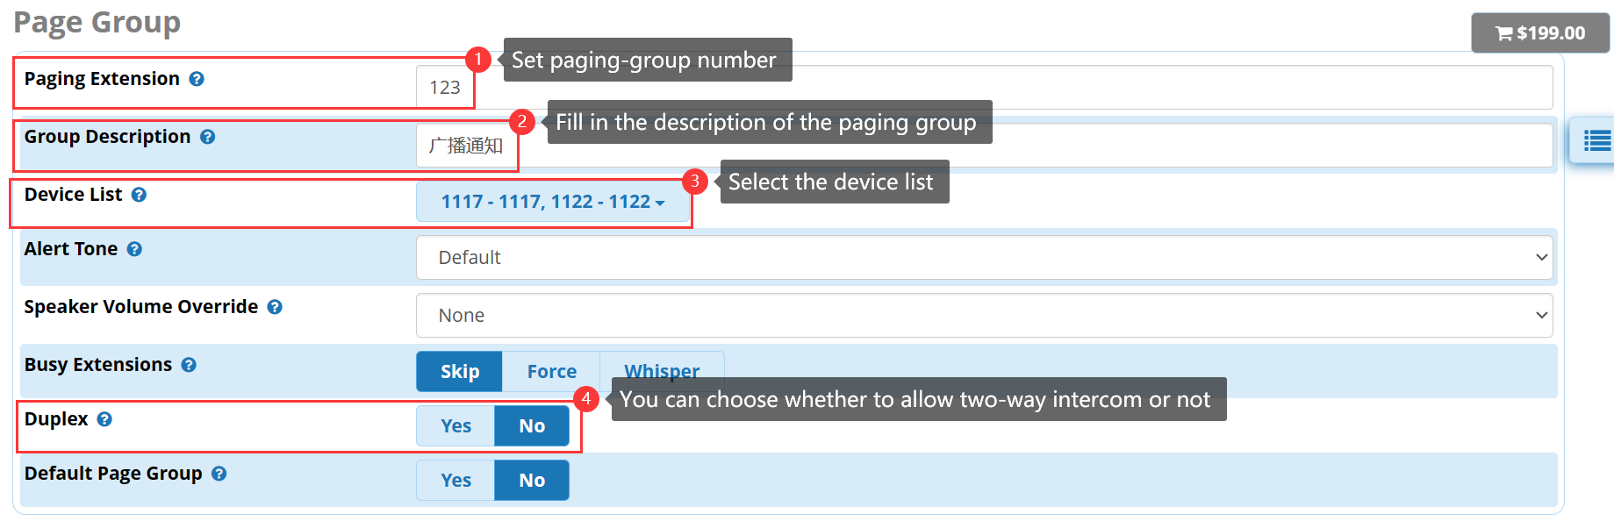

Figure 1 set page groups

1. **Verification of Results**

When users dial 123, extension 1117 and 1122 automatically answer, can hear the broadcast content.