**Paging and Intercom**

**Introduction and Configuration**

1. **Introduction**

Using this function, users can send voice notifications to members through the phone.

* **One way Paging：**One-way announcement to users with extensions registered.
* **One way Multicast Paging：**Paging feature is used to make a one-way announcement to users via a phone speaker.
* **Two-way Intercom：**Intercom feature is used to establish two-way communication with users via a phone speaker.
* **Scheduled paging call and intercom call:**Using the reservation broadcast group function, the system will play the broadcast regularly, or call the user's extension regularly to prompt the user to play the broadcast.

1. **Configuration Flow**

2.1 One way Paging

**Scenarios：**

A company has different departments on different floors in a building. Each department is deployed with a phone for communication. The boss has an urgent case that needs to confirm with marketers. In this case, you can set up a One-way paging group for Marketing Department. The boss can make a paging call to the department and ask marketers concerned to go to the office.

**Configurtion:**

Call Feature → Paging and Intercom → Fill in parameters → Click Save and apply

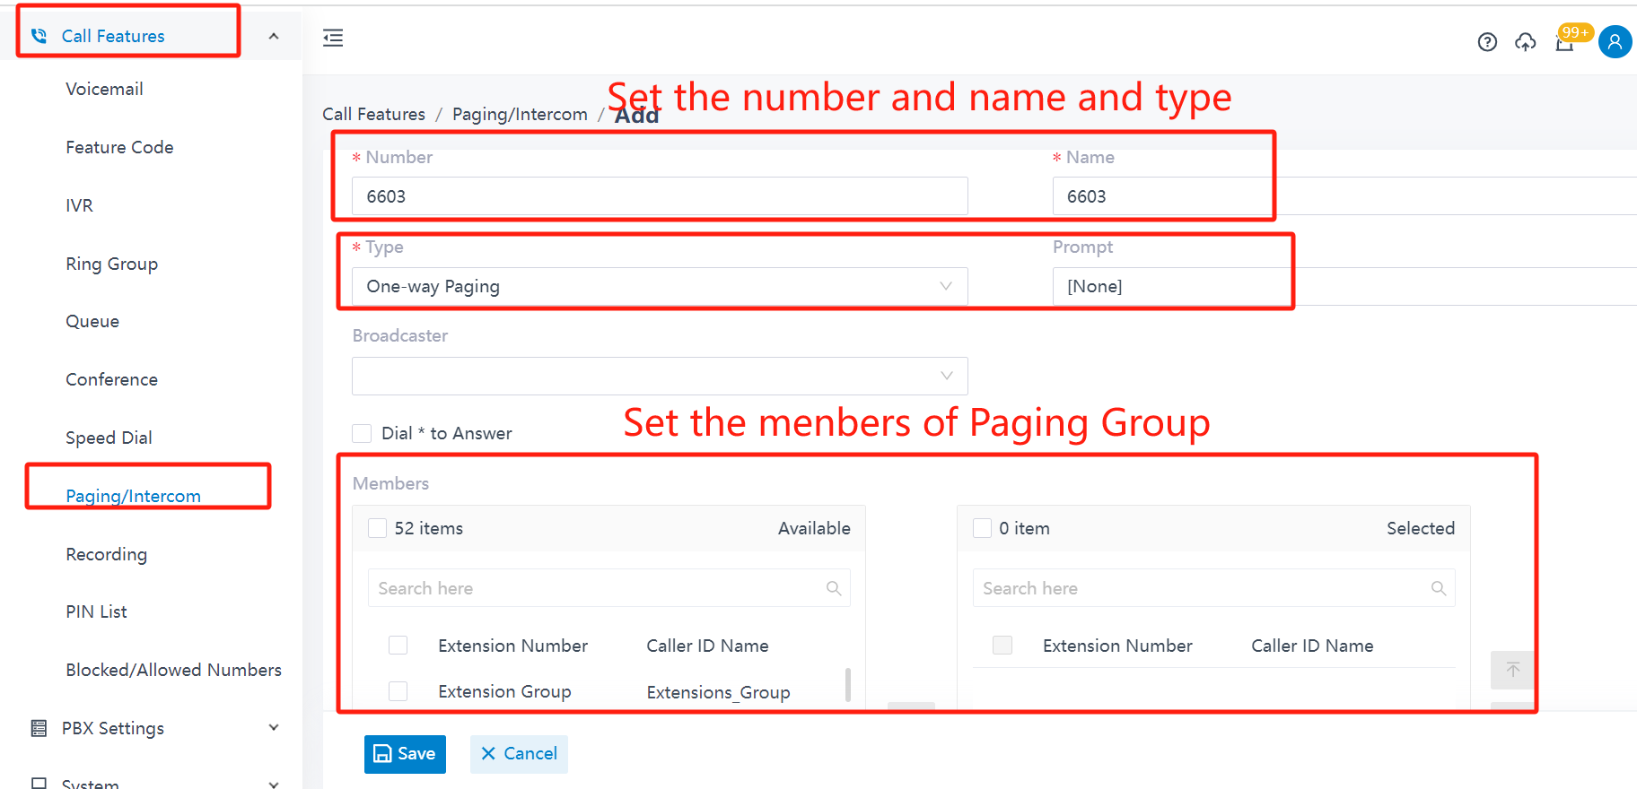

Parameter Description:

Number:Paging/Intercom gourp’s extension number.(A new extension number that has not been created before)

Name:Name the Paging/Intercom group,such as 6602.

Type:Paging/Intercom group’s type,such as One way Paging.

Prompt(Optional):If you want to play a notification tone before the intercom, select a custom notification tone here.

Broadcaster(Optional):If you want to restrict extension broadcast rights, you can select the rights granted by the broadcaster.

2.2 One way Multicast Paging

**Scenarios：**

For a warehouse, the work flow in product line is closely connected and tends to be complex. For example, one zone is responsible for packaging goods, another zone is for dispatching goods. To facilitate supervisors in coordinating daily warehouse activities, you can set up paging groups for each zone.

**Configurtion:**

①Call Feature → Paging and Intercom → Add → Fill in parameters

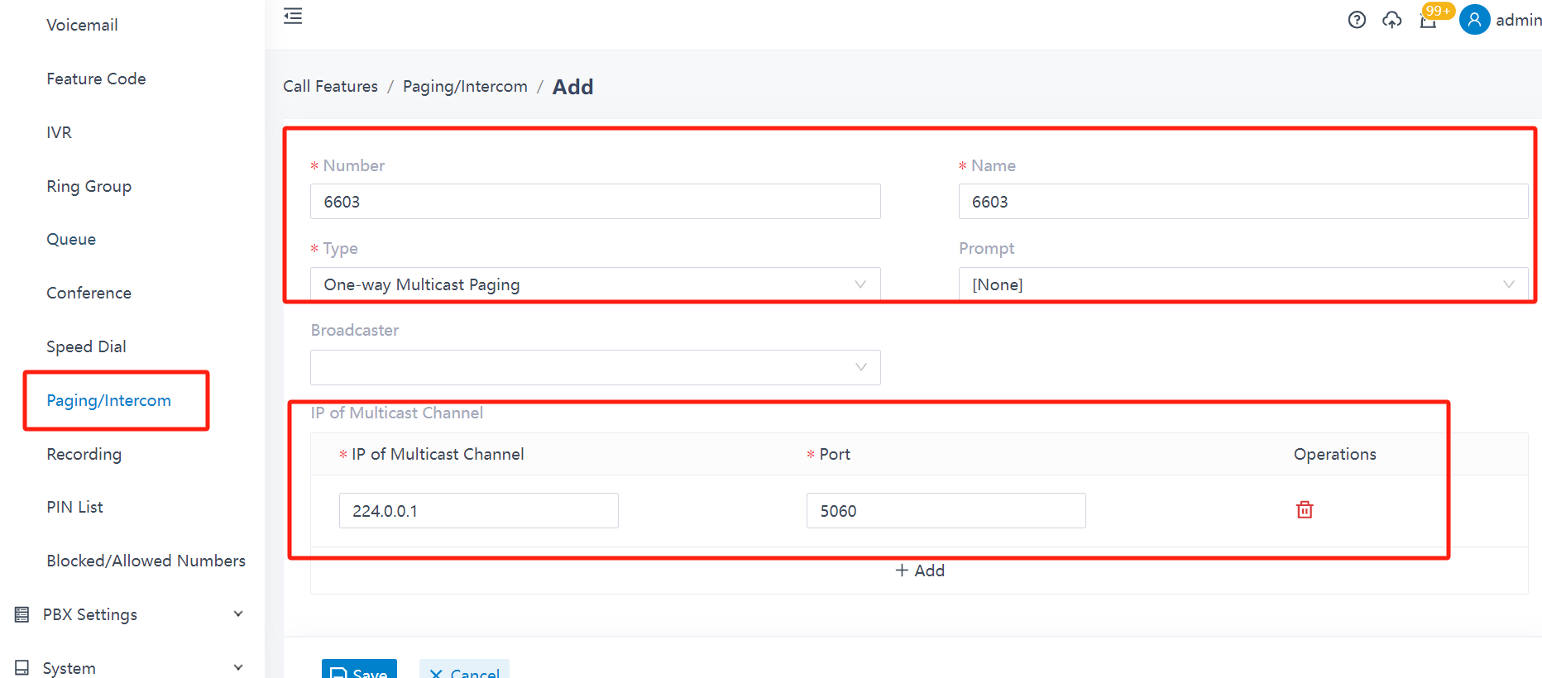

Parameter Description:

Number:Paging/Intercom gourp’s extension number.(A new extension number that has not been created before)

Name:Name the Paging/Intercom group,such as Control Room.

Type:choose One-way Multicast Paging here.

IP of Multicast Channel:Fill in the IP of Multicast Channel and Port.

②Configurate the IP Phone:Login the web of the phone→Phone→Multicast IP→Fill in parameters

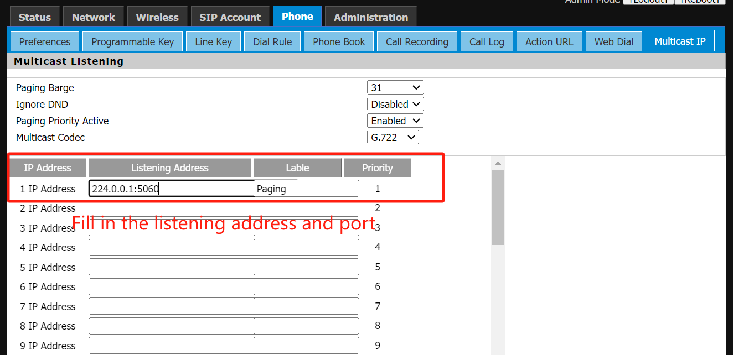

2.3 Two-way Intercom

**Scenarios：**

For a warehouse, the work flow in product line is closely connected and tends to be complex. For example, one zone is responsible for packaging goods, another zone is for dispatching goods. To facilitate supervisors in coordinating daily warehouse activities, you can set up paging groups for each zone.

**Configurtion:**

②Call Feature → Paging and Intercom → Add → Fill in parameters

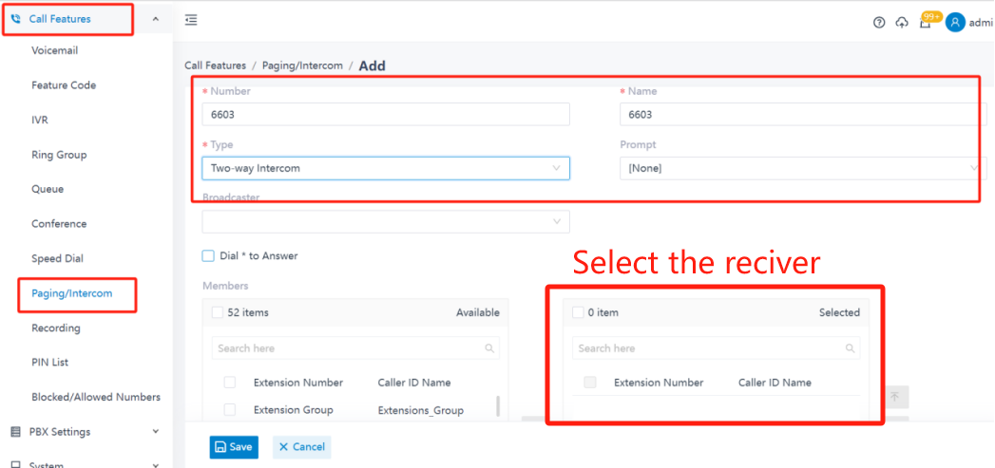

Parameter Description:

Number:Paging/Intercom gourp’s extension number.(A new extension number that has not been created before)

Name:Name the Paging/Intercom group,such as 6603.

Type:Paging/Intercom group’s type.

Prompt(Optional):If you want to play a notification tone before the intercom, select a custom notification tone here.

Broadcaster(Optional):If you want to restrict extension broadcast rights, you can select the rights granted by the broadcaster.

2.4 Scheduled paging call and intercom call

**Scenarios：**

Besides real-time paging calls or intercom calls, you can set a time schedule to automatically start your broadcast. The Scheduled Paging/Intercom feature is perfect for schools, churches, or other facilities that require routine notifications set in advance.

**Prerequisite:**

A Paging/Intercom group has been added.

**Configurtion:**

②Call Feature → Paging and Intercom → Scheduled Paging/Intercom → Add → Fill in parameters

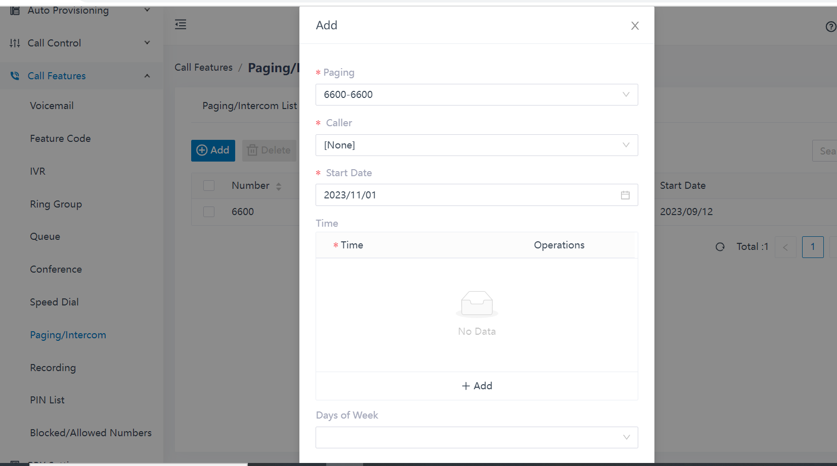

Paging：Select a paging group or a intercom group.

Caller:Select the broadcaster.

* Users：The system calls the user at the specified time. After the user picks up the phone, the call of the group member will be answered automatically.
* None：The PBX initiates the broadcast. The PBX calls the group personnel at the specified time and plays the specified beep. When the beep finishes playing, PBX hangs up. This setting is suitable for scenes such as school bell ringing and church bell ringing.

Start Date:Sets the effective date for this reserved Paging group.

Time:Sets the effective time for this reserved Paging group.

Days of Week:Set to launch the broadcast on the day of the week.

1. **How to initiate a broadcast**

Set the speed-dial key of the broadcast number to realize one-key broadcast function

Login web of the Phone → Phone → Programmable Key → Edit parameters

