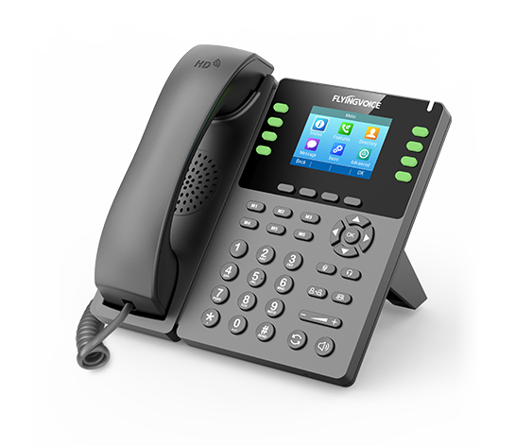

**Fusion PBX Auto-provisioning Configuration Guide(By RPS Mode)**

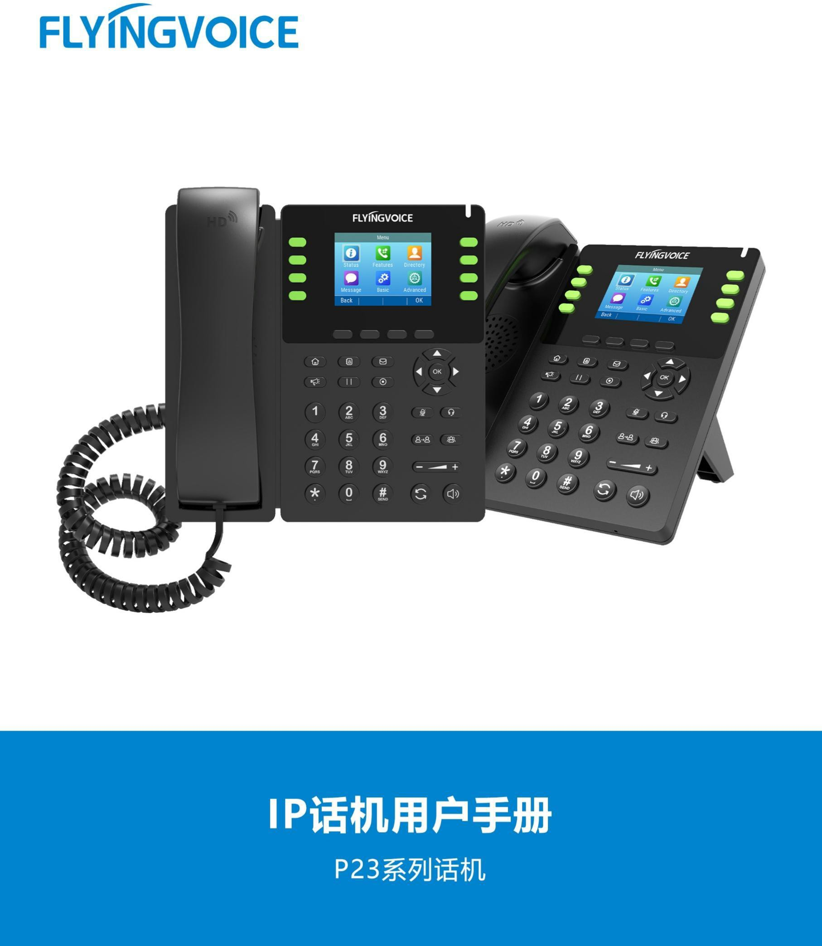

# Catalogue

Ⅰ Introduction 2

1.Fusion PBX Introduction 2

2.Description Of Solution 2

3.Explain 2

Ⅱ Configuration Flow 3

Ⅱ Configuration Operation 3

1.Set up a deployment environment 3

1.1 Required platforms and products 3

1.2 Premise 3

2.Configure the Fusion PBX 4

2.1 Login the PBX management web 4

2.2 Add Devices 4

2.3 Fill in the specific parameters 5

2.4 Save the Configuration 6

Ⅲ Configure the FRPS System 7

1. Devices init SN/MAC 7

2.Add Profile for Fusion PBX 8

3.Device manage 10

4.Auto-provisioning on IP Phones 11

Ⅳ Test result verification 11

1.Determine Auto-provisioning 11

2.Dial test 12

# Ⅰ Introduction

## 1.Fusion PBX Introduction

Fusion PBX is a free software PBX. It is an open source PBX developed with freeswitch as the underlying framework.Fusion PBX adapts to a variety of deployment environments and can be deployed on either Linux or Windows.

It also has a rich set of features, Fusion PBX provides for QR code softphone configuration, unlimited extension, voice mail to email, waiting for music, call park, analog lines, and many other features. FusionPBX can provide the functions required by enterprises and provide enterprise-class softphone switching system performance to small, medium and large enterprises.

## 2.Description Of Solution

This solution is designed to help you quickly deploy a large number of flying Voice IP phones across the network on the Fusion PBX in RPS mode, and initialize the device configuration to save you a lot of time and tedious operation of manual deployment.

## 3.Explain

Some configurations described in this article need to be pre-configured by the administrator. Please contact FLYINGVOICE support for assistance.

# Ⅱ Configuration Flow

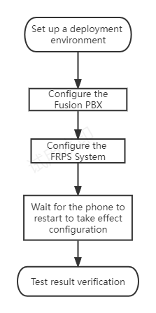

# Ⅱ Configuration Operation

## 1.Set up a deployment environment

### **1.1 Required platforms and products**

FLYINGVOICE FRPS Device Management System、FUsion PBX(Ready to use)、Many FLYINGVOICE IP Phones

### **1.2 Premise**

1.2.1 The phones must be in factory Settings. If your phones have been configured, restore them to factory Settings.

1.2.2 The phones and PBX must be connected to the network. They may not be in the same network segment, but they must be able to communicate with each other.

## 2.Configure the Fusion PBX

### 2.1 Login the PBX management web

Contact the network administrator to obtain PBX domain name, user name and password information, login PBX web page management page.

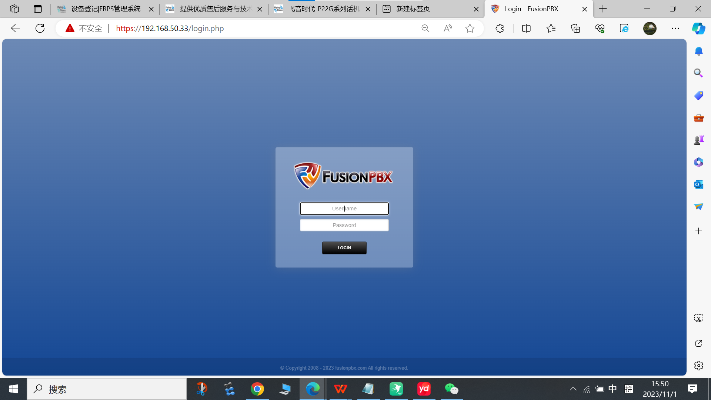

### 2.2 Add Devices

Steps：Accounts--》Devices--》ADD

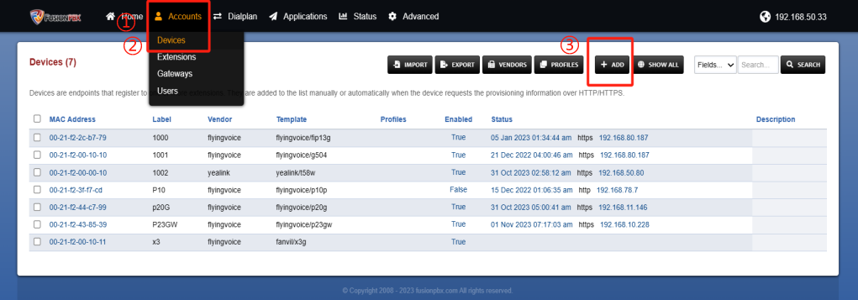

### **2.3 Fill in the specific parameters**

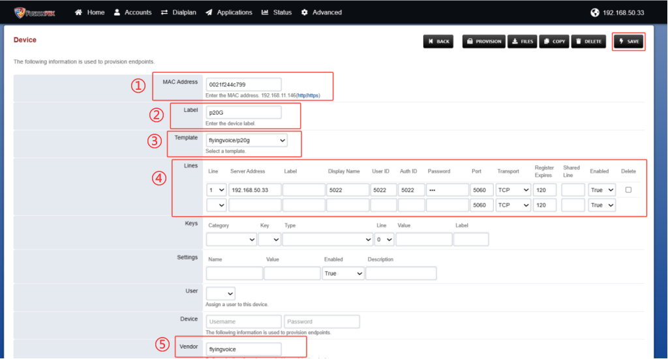

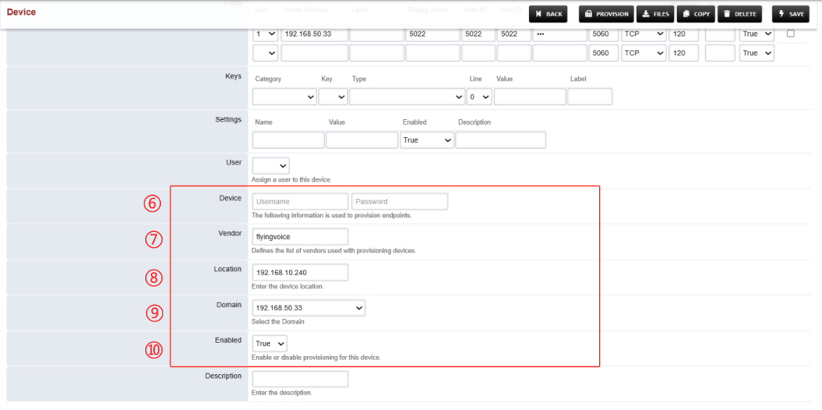

Table1 Parameters Description

|  |  |  |
| --- | --- | --- |
| Parameters | | Description |
| MAC Address | | Enter the MAC address. |
| Label | | Enter the device label. |
| Template | | Select a template. |
| Lines | Line | Select the line registered to the phone; |
| Server Address | The IP address of the SIP server, or the PBX domain name if the PBX is deployed in the cloud. |
| Display Name | Fill in the name of the call that will be displayed on the phone |
| User ID | The Extension number, contact the network administrator for extension number related information; |
| Auth ID | Authentication ID, fill in the extension number here; |
| Password | Extension’s password; |
| Transport | Protocol transmission mode, there are UDP/TCP/TLS/DNS SRV four ways to choose, according to the actual needs of choice; |
| Register Expires | Valid registration time, fill in according to the actual needs, the default is 120; |
| Enabled | select True to enable; |
| Vendor（optional） | | For device manufacturers, choose flyingvoice. |
| Enabled | | select to ture; |
| Device（Username/Password) | | Login device user and password, FFLYINGVOICE default to admin/admin; |
| Location | | IP address where the phone is located; |
| Domain | | Select the Domain |
| Enabled | | Select to True； |

### 2.4 Save the Configuration

After filling in the parameters to save, save success will prompt configuration has been updated.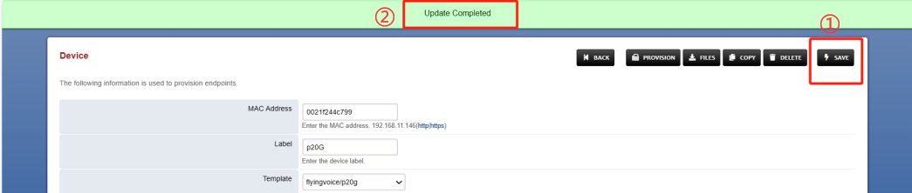

# Ⅲ Configure the FRPS System

1. Devices init SN/MAC

Considering the safety of the device, it is necessary to make the device init SN/MAC on the FRPS Device Management System . You can contact FLYINGVOICE support in advance to apply for account or apply for equipment registration.

First login the FRPS Device Management System.

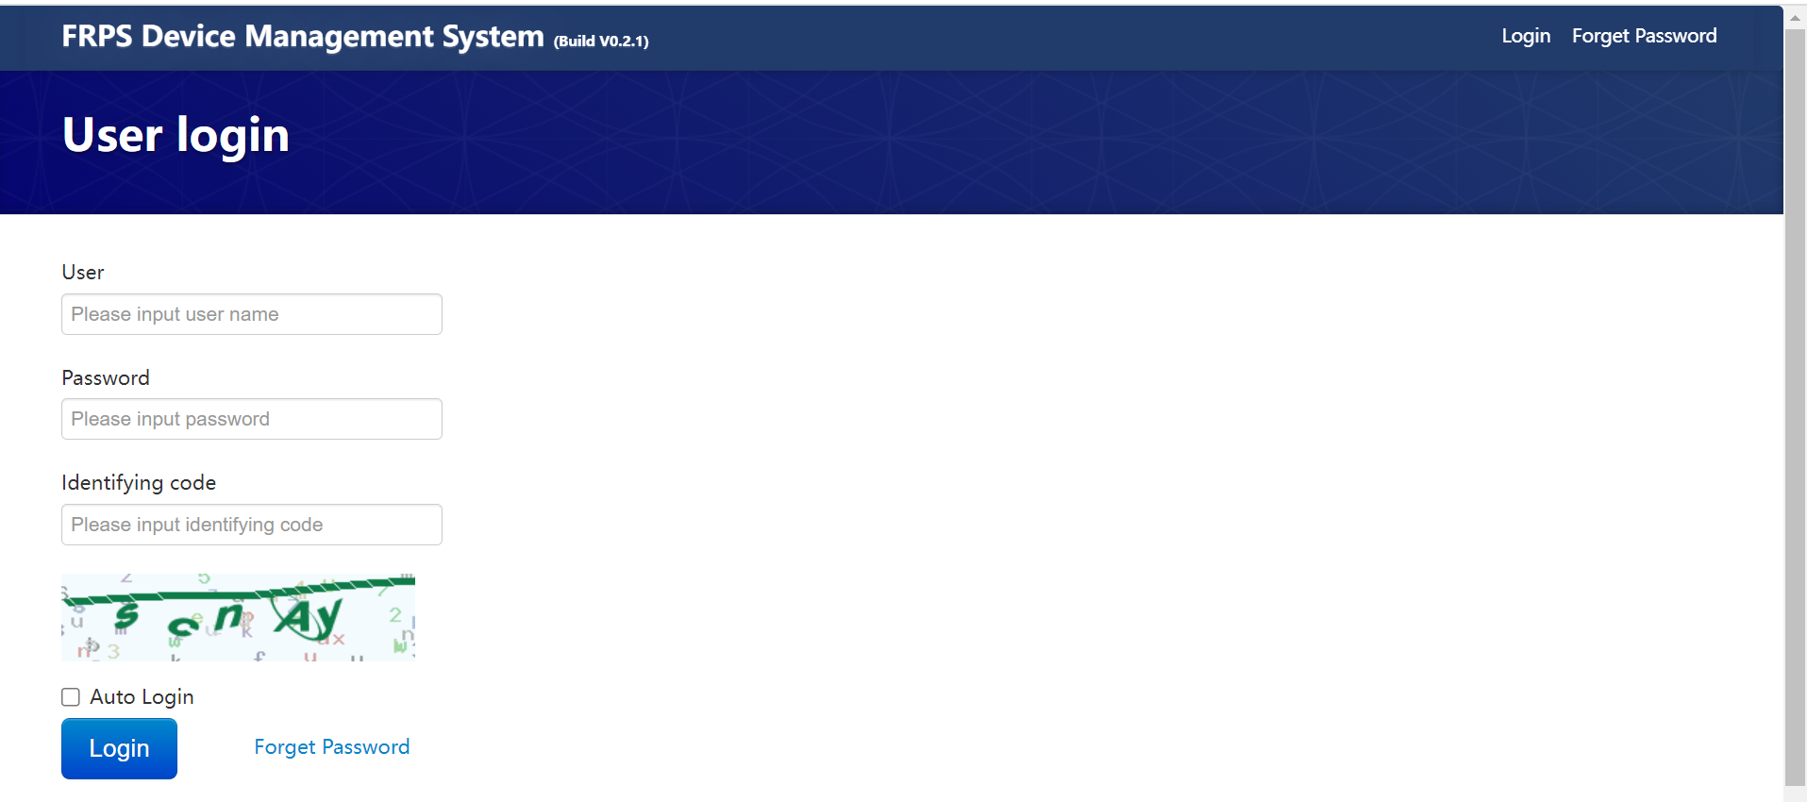

Then make the Devices init SN/MAC.

Stps: Devices init SN/MAC --》import.

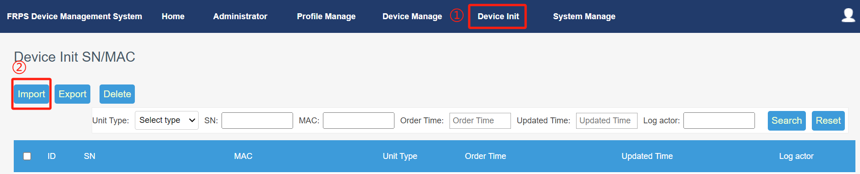

Download the template.

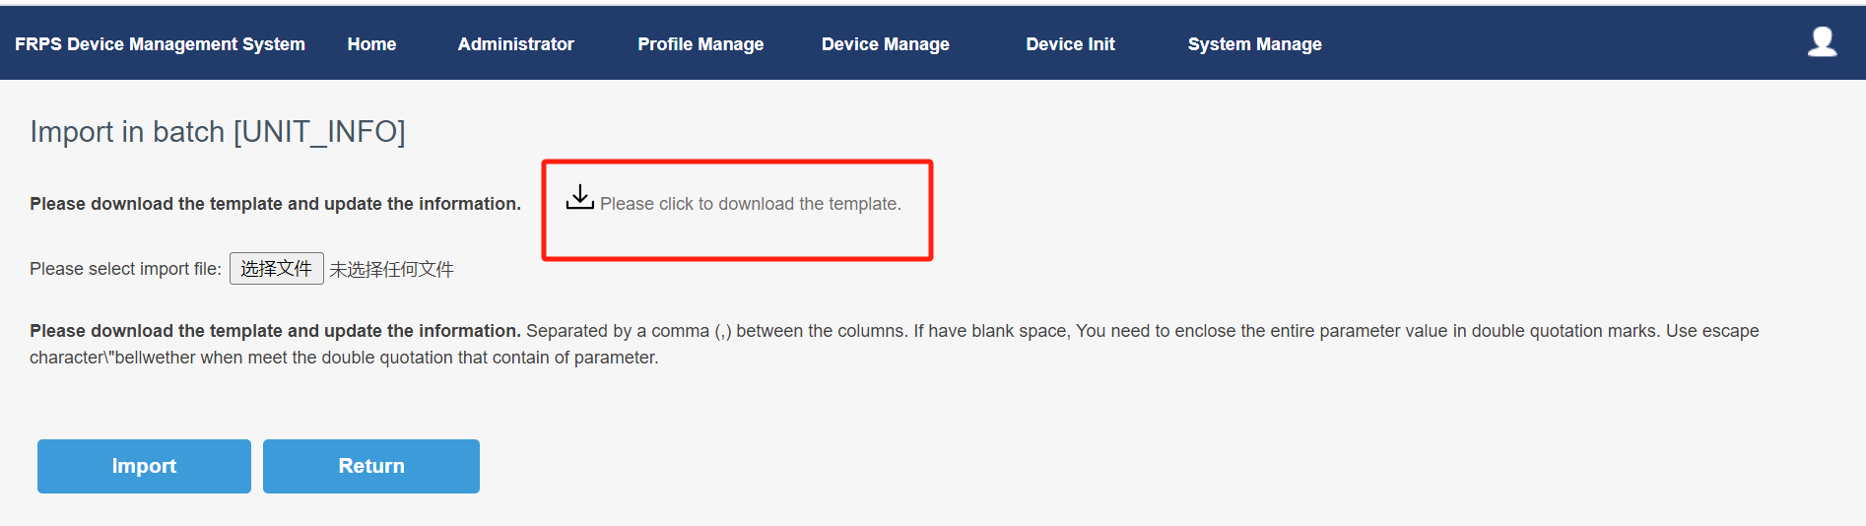

Fill in the device type, SN, MAC and other parameters in the downloaded format template file and save the file.

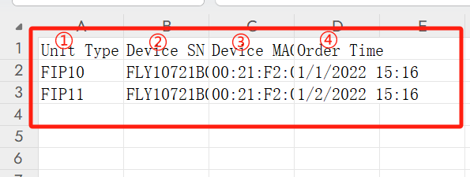

Import the format template file that has been filled in, the page will jump to the prompt after the import is successful.

Steps: Select import file --》import

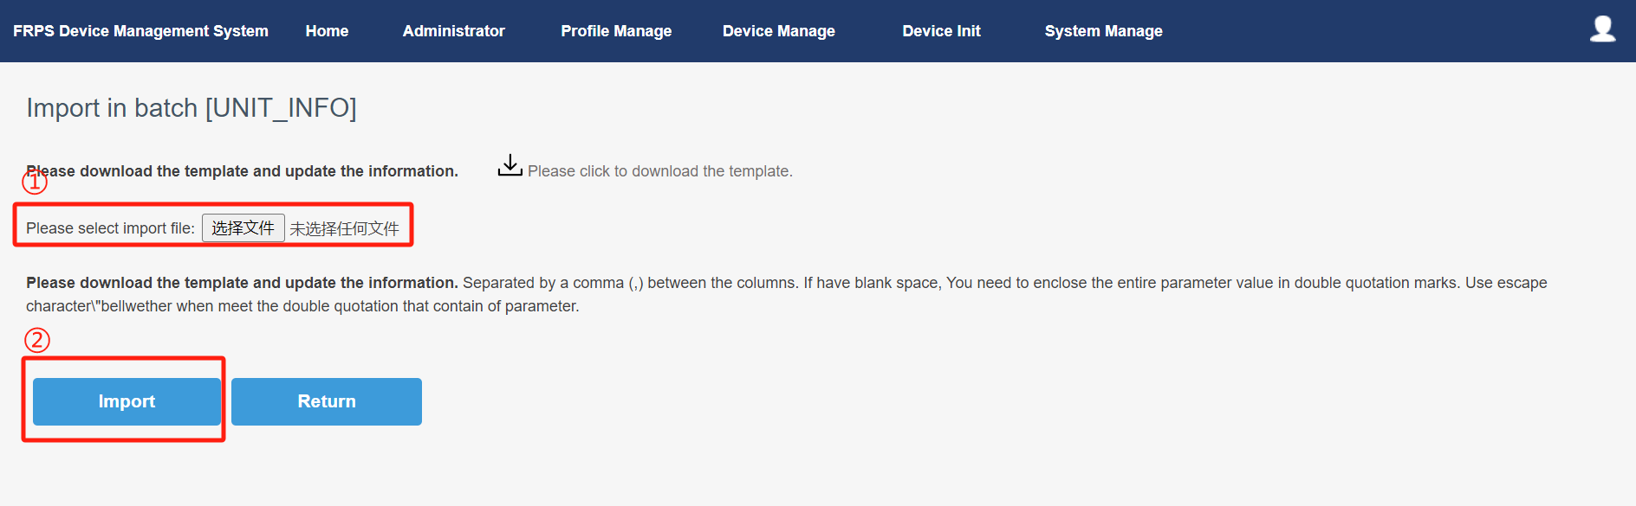

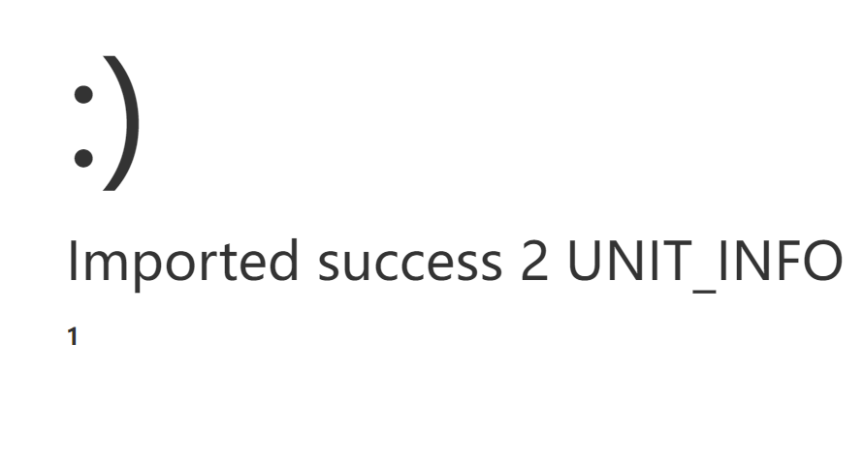

## 2.Add Profile for Fusion PBX

Step：Profile Manage --》Add

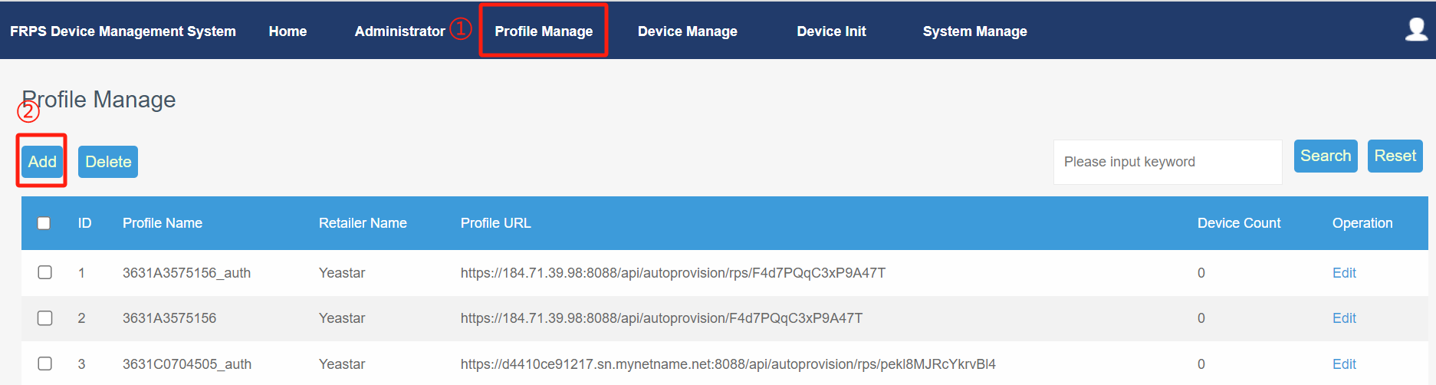

Fill in the required parameters in the figure. The username and password should refer to the PBX parameter setting. If the parameter is globally enabled in PBX, it is required, and if the parameter is globally closed, it is not necessary.

Step：Profile URL--》username--》password

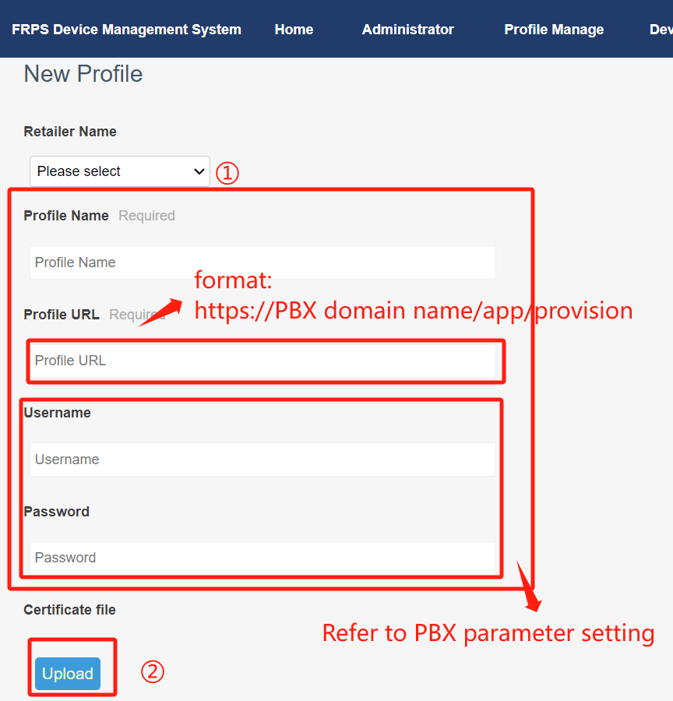

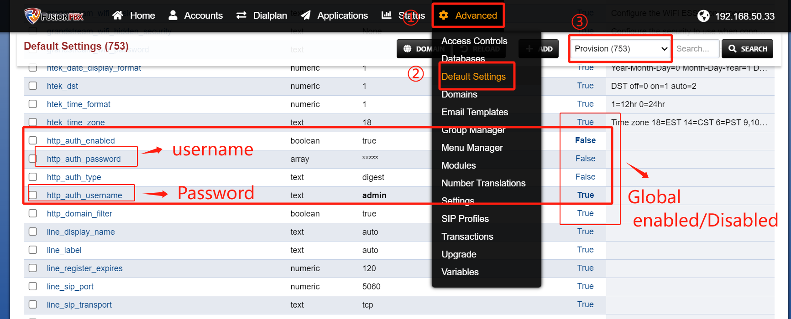

## 3.Device manage

Import batch of device informations.

Step:Device Manage --》Import

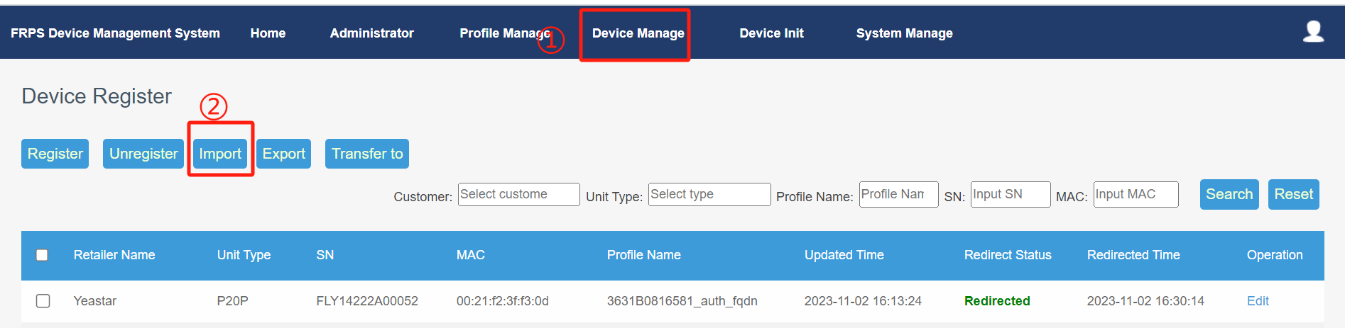

Download the template and fill in the parameters in the template file.

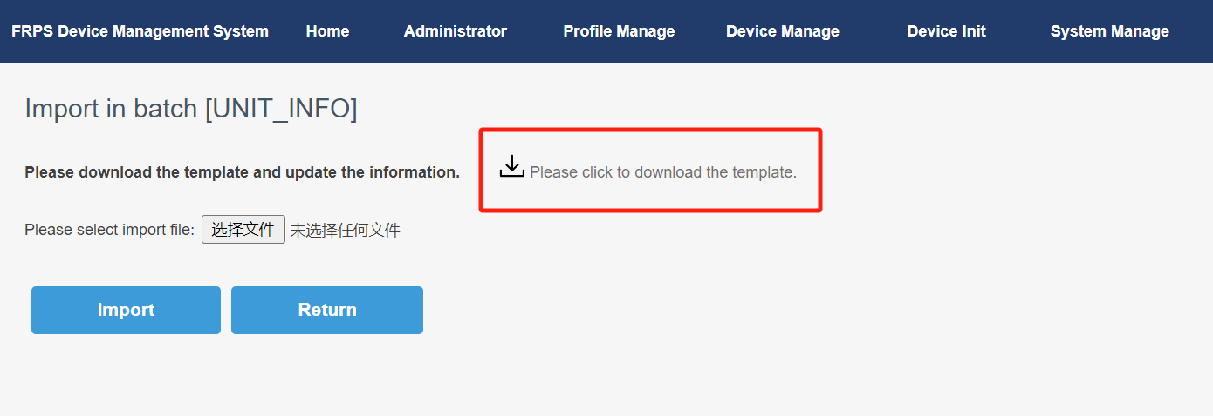

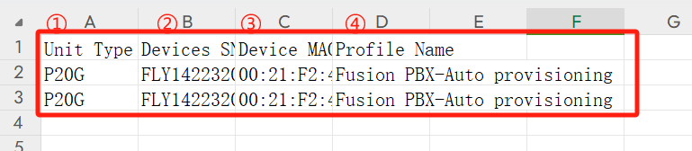

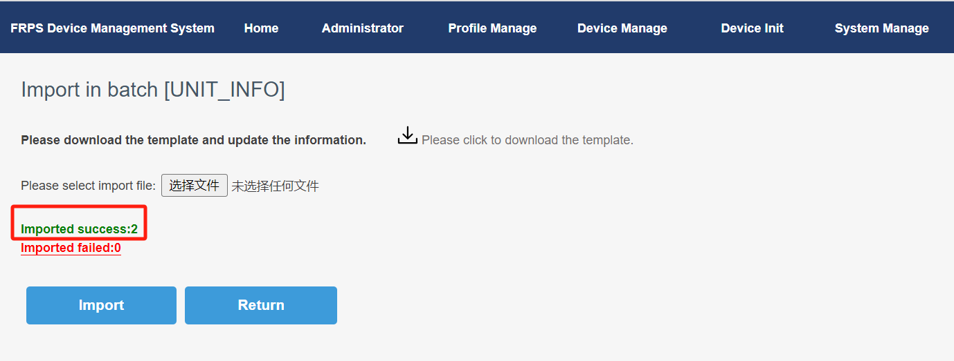

## 4.Auto-provisioning on IP Phones

Wait for the phone to restart and take effect the configurations.

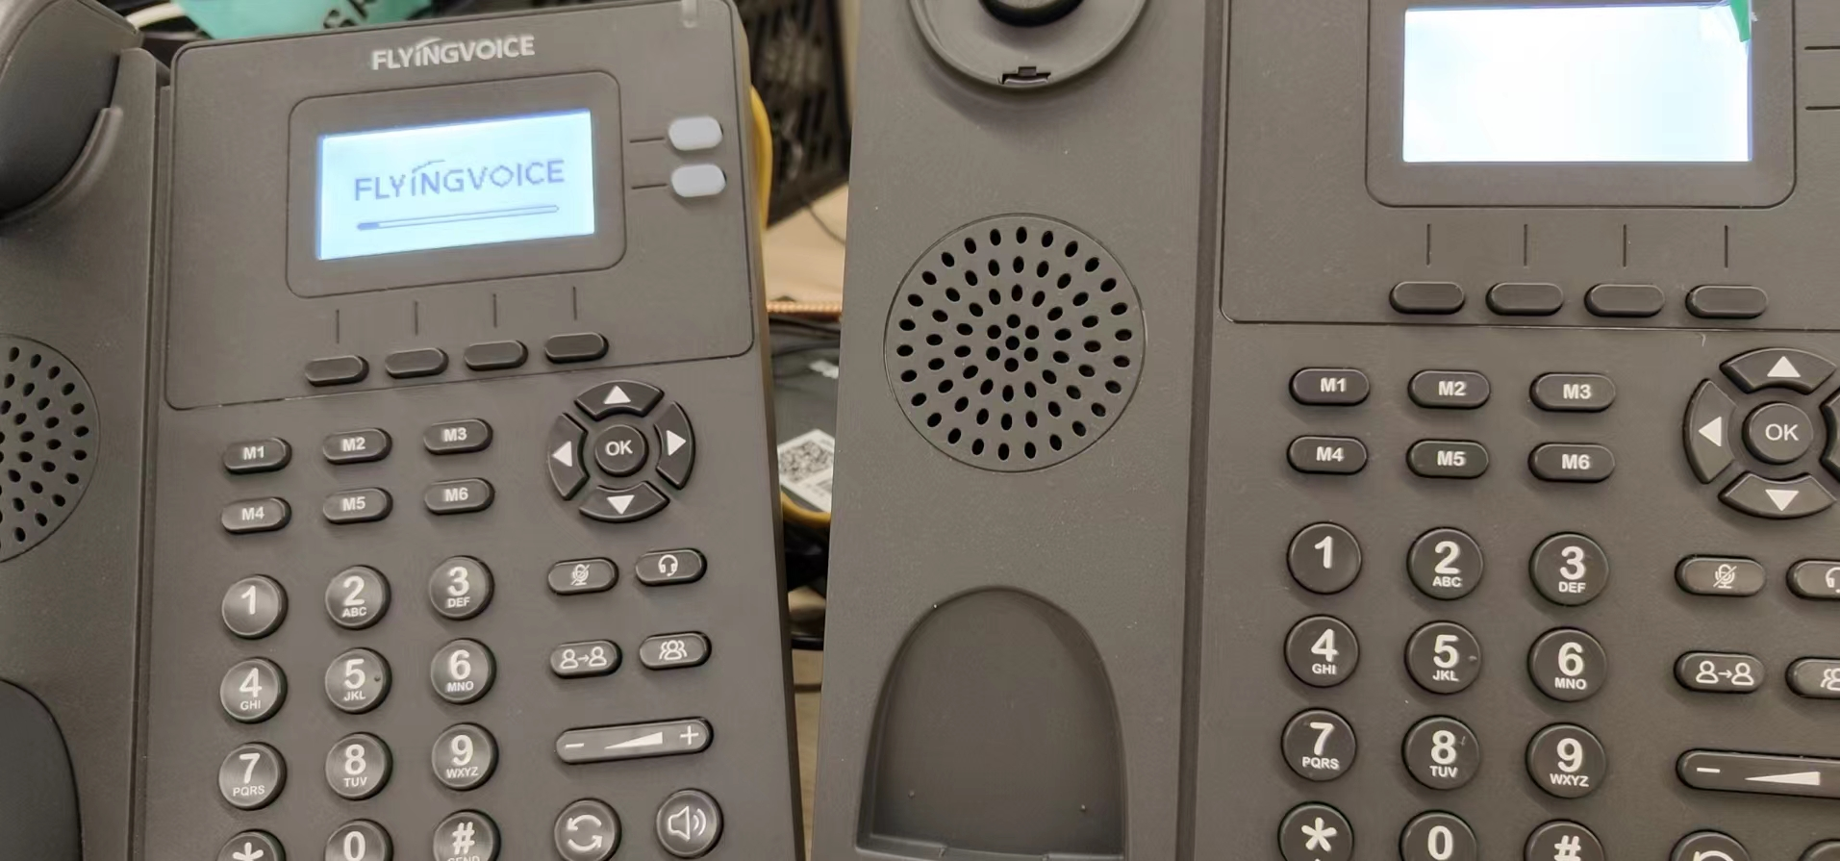

# Ⅳ Test result verification

## 1.Determine Auto-provisioning

After the phone is successfully provisioned, you can check whether the phone is successfully provisioned on the FRPS system, check whether the account key turns green on the phone, or check the registration status on the phone Web page to check whether the phone is successfully provisioned.

Checking route:Device Manage --》Redirect Status

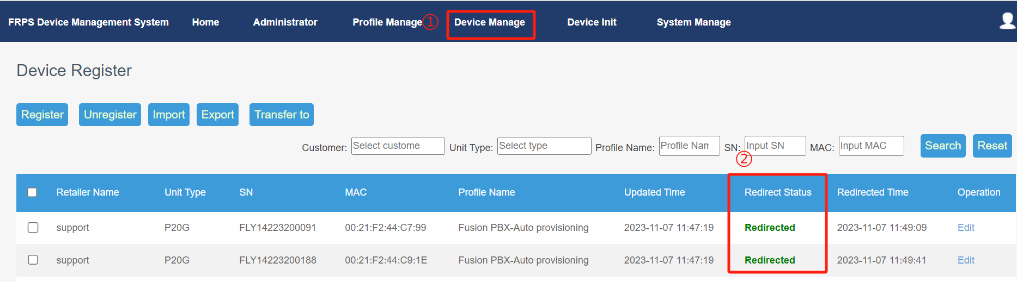

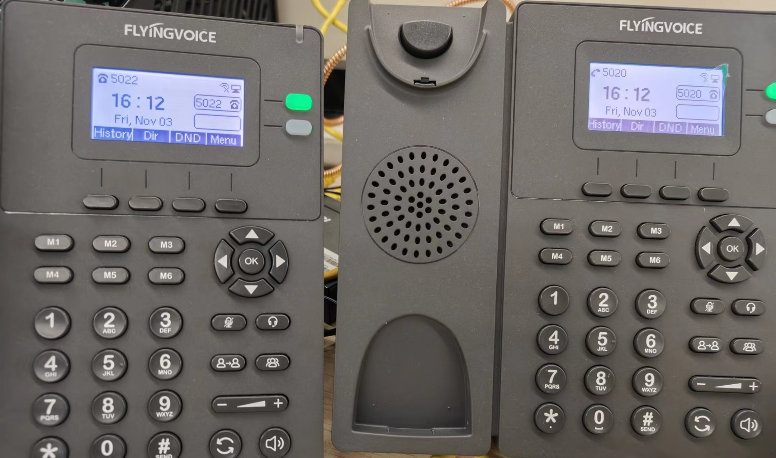

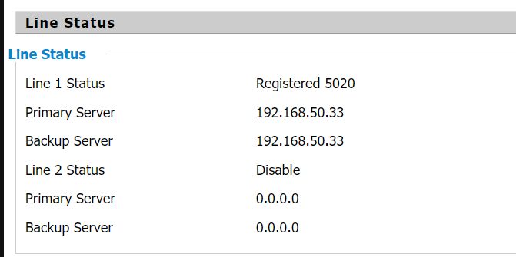

## 2.Dial test

5020 Dial 5022.Test successful.

