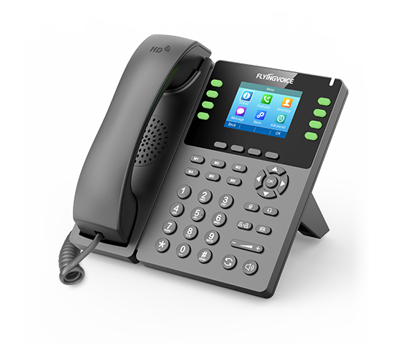

**Fusion PBX Conferences**

**Configuration Guide**

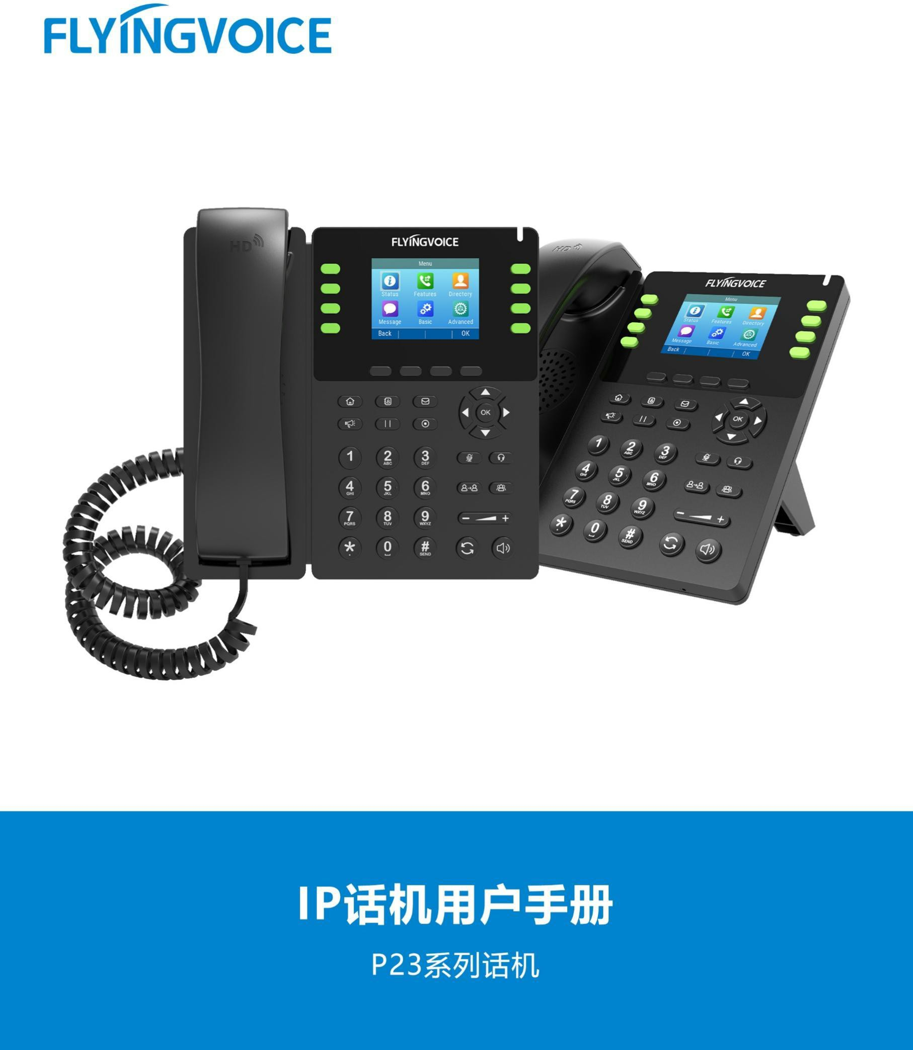

# Catalogue

Ⅰ Conference Introduction 1

Ⅱ Configuration Flow 2

Ⅲ Configuration Operation 2

1.Login the PBX management web 2

2. Add Conference 3

3. Fill in the specific parameters 4

4. Save the Configuration 5

Ⅳ Test result verification 5

1.Enter Conference 5

2.Conference status check 6

2.1 Check the conference status 6

2.2 Active Conference check 6

2.3 Conference management and status details view 6

# Ⅰ Conferences Introduction

The conferences function is a very practical function. Compared with the traditional conferences, it has the characteristics of rapid conference arrangement, no time and regional restrictions, and low cost. Compared with the traditional point-to-point telephone service, from the function, breaking the limit that the call can only be limited to two-parties can meet the simultaneous call of more than three-parties.

# Ⅱ Configuration Flow

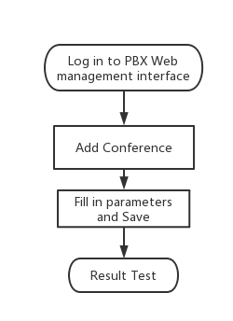

# Ⅲ Configuration Operation

## 1.Login the PBX management web

Contact the network administrator to obtain PBX domain name, user name and password information, login PBX web page management page.

Steps:input the domain name of pbx--》input the username and password --》Click Login

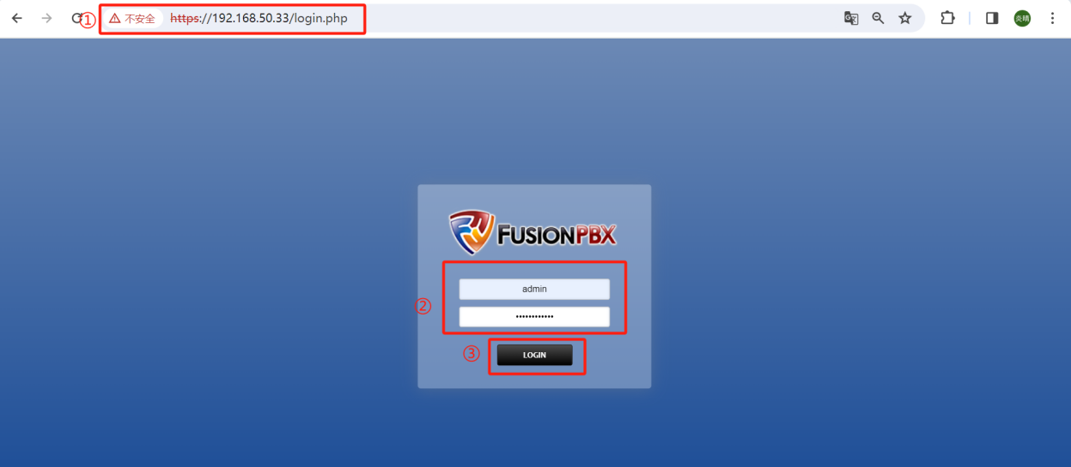

## Add a Conference

Steps：Applications--》Conferences--》+ADD

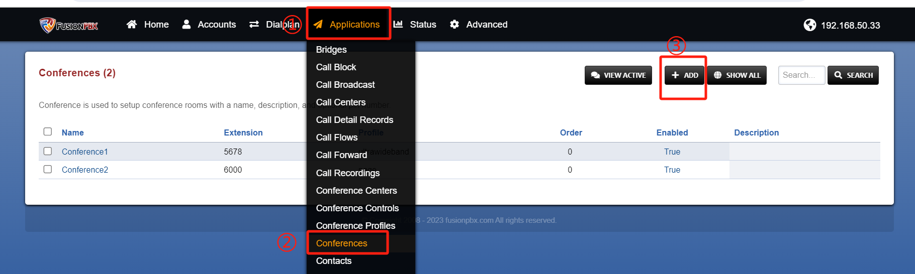

## 3. Fill in the specific parameters

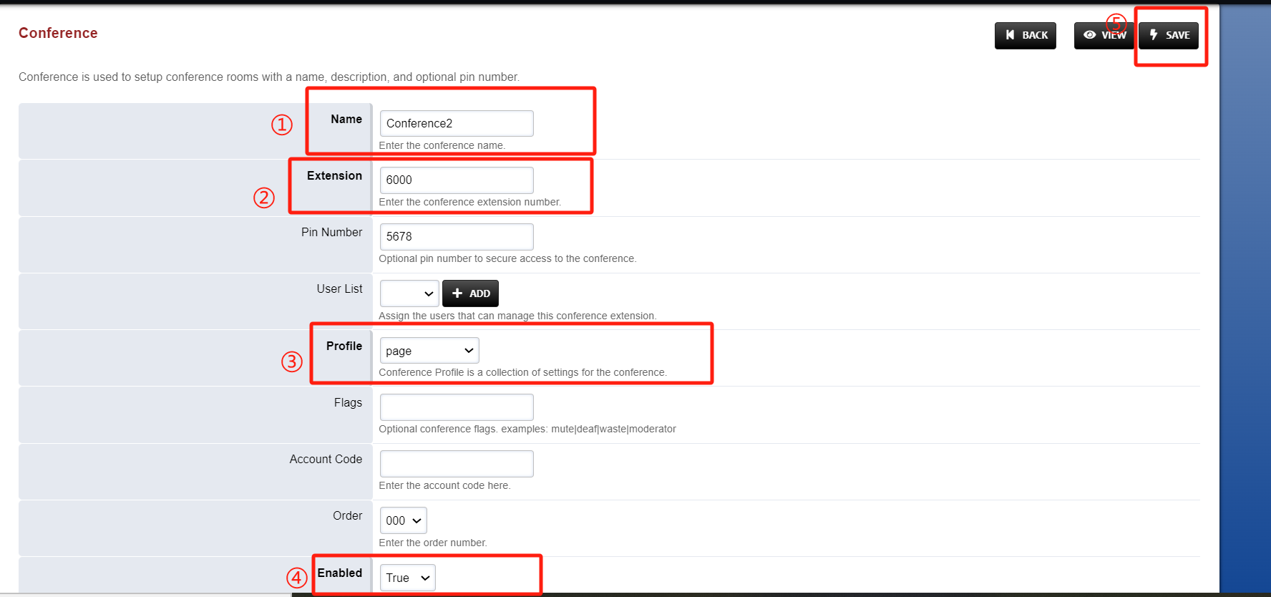

Table1 Parameters Description

|  |  |
| --- | --- |
| Parameters | Description |
| Name | Enter the conference room name; |
| Extension | Enter the extension number of the conference room. It needs to be a new number that has not appeared before. |
| Pin Number | Enter the password required for joining a meeting. Ignore this parameter if it is not required. |
| Profile | Meeting room configuration file template, optional system default or custom template; |
| Flags | The meeting marker, the value can be gag/moderator/mute, etc.; |
| Account Code | Conference room account code. You can dial this code to enable or disable the conference. |
| Order | Order of meeting rooms; |
| Description | Description of meeting rooms; |
| Enabled | Select to True； |

## 4. Save the Configuration

After the file is saved, the system automatically returns to the previous page with an update complete message.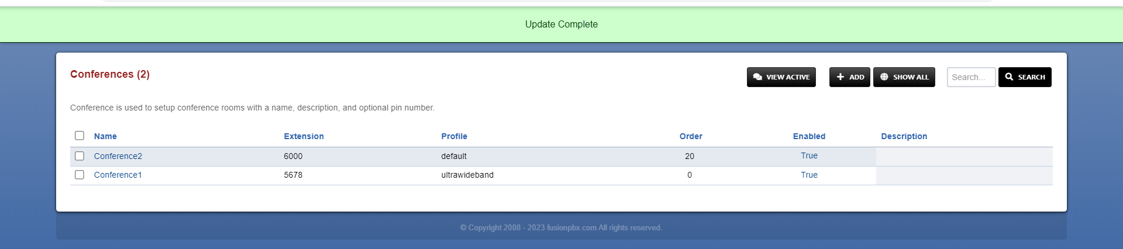

# Ⅳ Test result verification

## 1.Enter Conference

Now that the configuration is complete, we can go into the conference room and test that it works.

Steps:Extension 5020, 5022 Dial the conference extension 6000 -- 》Enter the PIN code --》 After successful input, you hear a short "beep" tone -- 》You have entered the conference；

Tip: If you are the first participant to enter the meeting room, you will hear the "You are currently the only person in the conference" tone, and the waiting music will play until the second participant enters the conference and the conference officially begins.

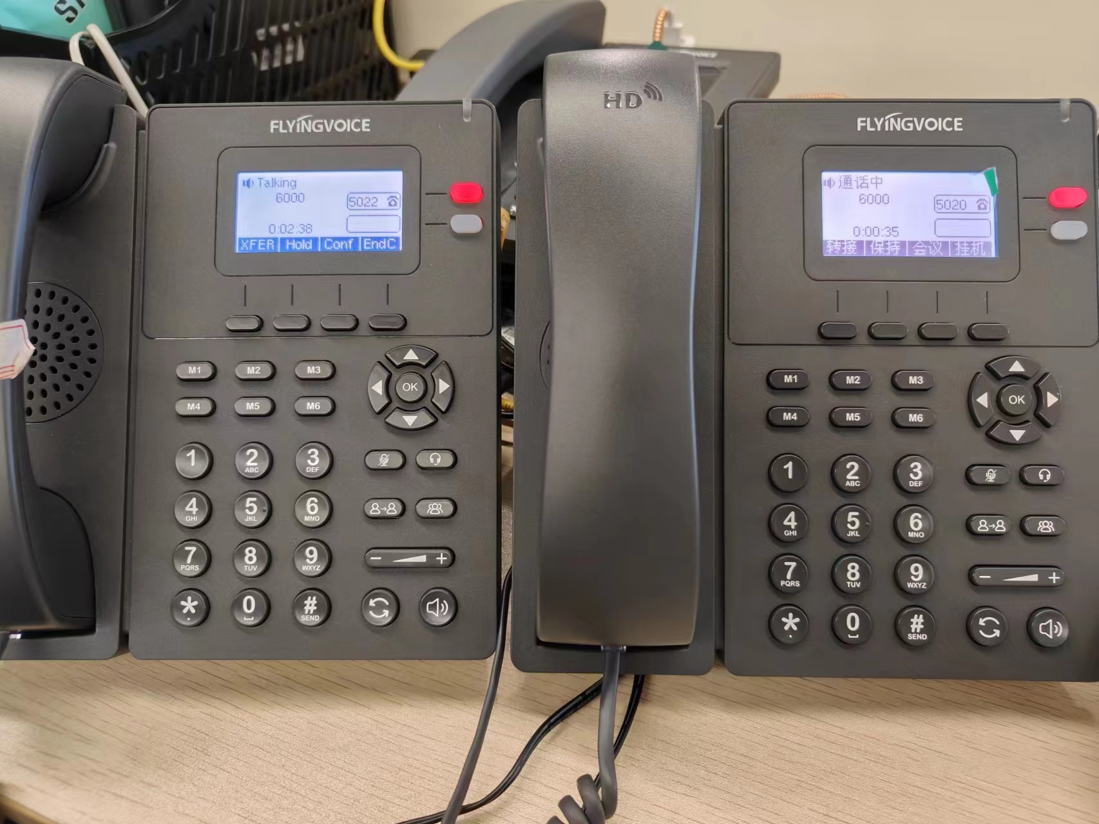

## 2.Conference status check

### 2.1 Check the conferences status

Steps:Click the VIEW ACTIVE

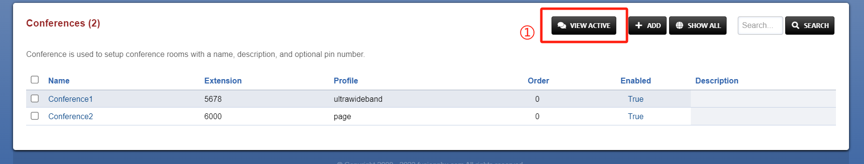

### 2.2 Active Conferences check

You can see that the conference 6000 has been activated and the number of participants is 2.Click the item 6000 to configure.

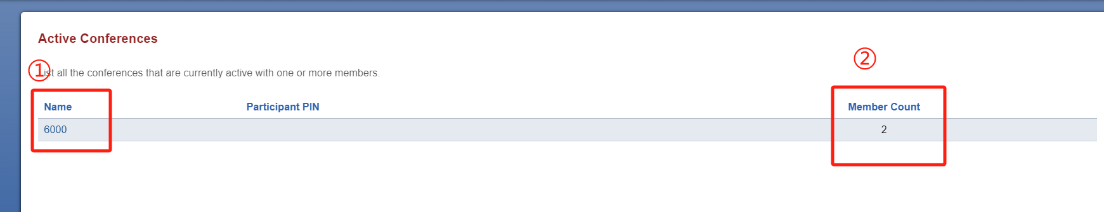

### 2.3 Conferences management and status details view

Steps:1)Enter the item 6000 to check the status details.

2)Click the buttons to Control attendee’s behavior.(mute/Lock/Kick...)

