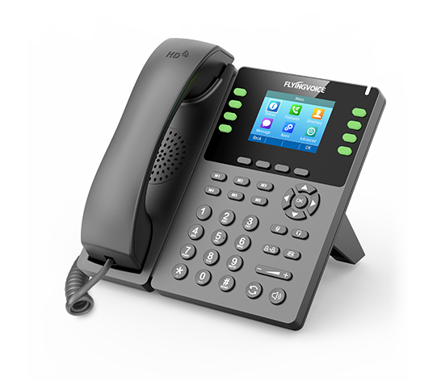

**Fusion PBX Conference Controls**

**Configuration Guide**

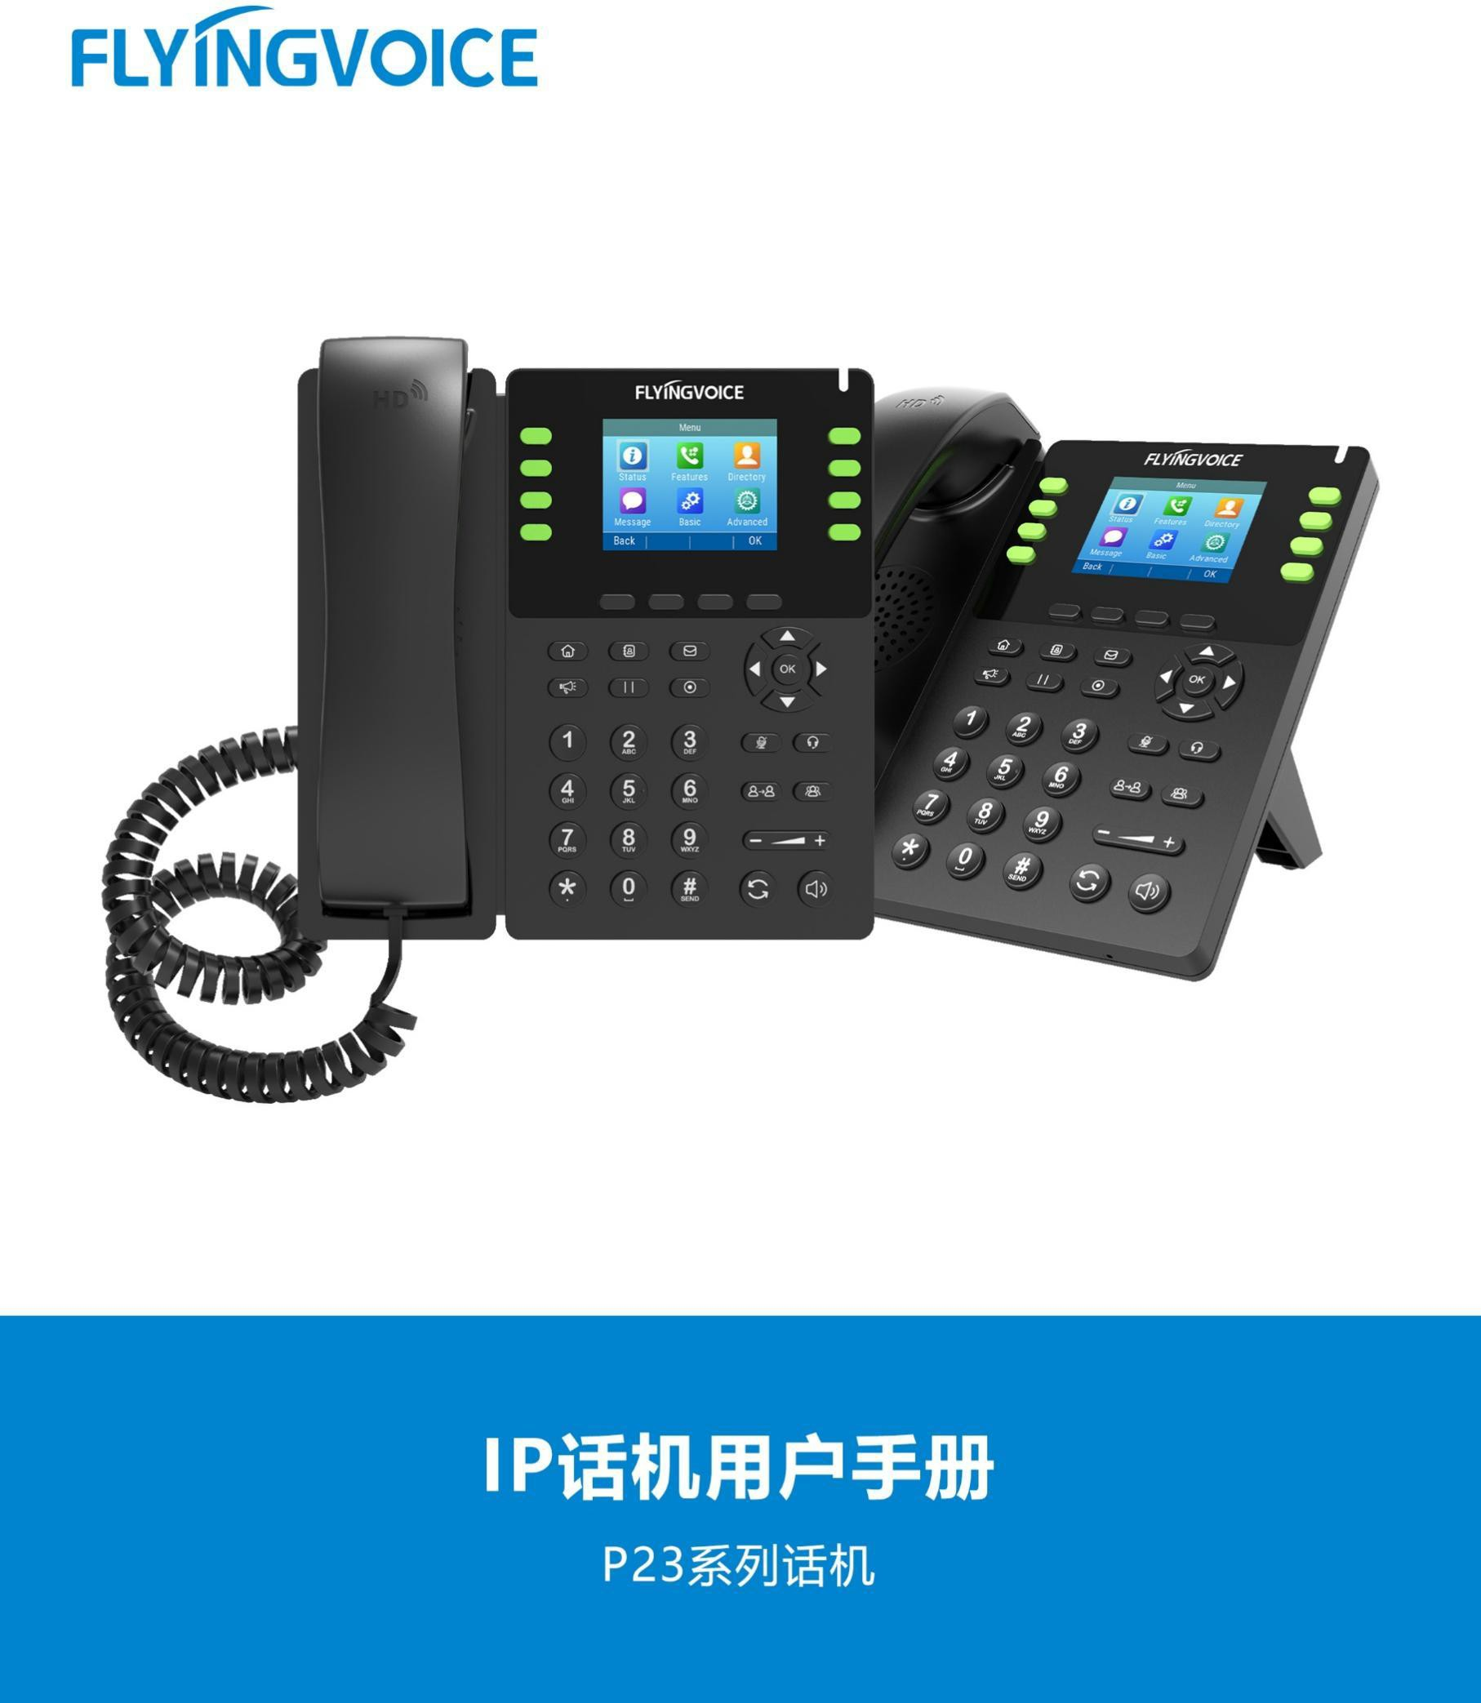

# Catalogue

Ⅰ Conference Controls Introduction 1

Ⅱ Configuration Flow 1

Ⅲ Configuration Operation 2

1.Login the PBX management web 2

2. Configure the Conference Control 2

2.1 Add a new control 2

2.2 Fill in the sepecific parameters 3

2.3 Editing an existing control 5

3. Write the controls in the conference profiles 5

3.1 Find the conference profile you want 5

3.2 Write the control in the conference profile 6

Ⅳ Test result verification 7

1.Enter Conference 7

2.Test the control wheter works 8

# Ⅰ Conference Controls Introduction

Fusion PBX's conference controls are actually a set of rule templates that you can edit by yourself for all the specific items, or you can use the PBX's default rules to fill in the control rules in the conference room Profile. The control rules take effect when you select the appropriate profile when you set up the meeting room.

The conference control function is a necessary function for the conference. The conference control function helps maintain the order of the conference and makes the conference run smoothly. It can also enable participants to adjust the volume appropriately and improve the quality of conference calls.

# Ⅱ Configuration Flow

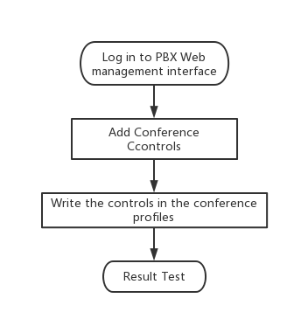

# Ⅲ Configuration Operation

## 1.Login the PBX management web

Contact the network administrator to obtain PBX domain name, user name and password information, login PBX web page management page.

Steps:input the domain name of pbx--》input the username and password --》Click Login

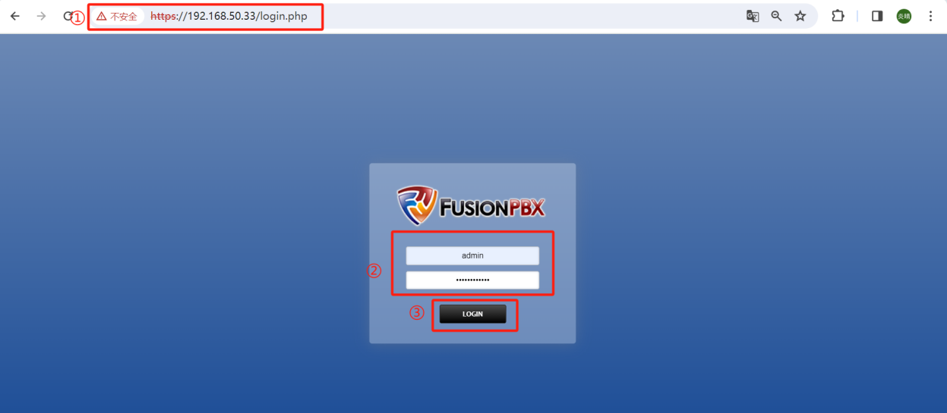

## Configure the Conference Control

### 2.1 Add a new control

If you want to customize your own rules, you can choose to add a new control. First you need to add a blank control.

Steps:Applications--》Conference Controls--》+ ADD--》Fill in the parameters(which is framed in red)--》Save

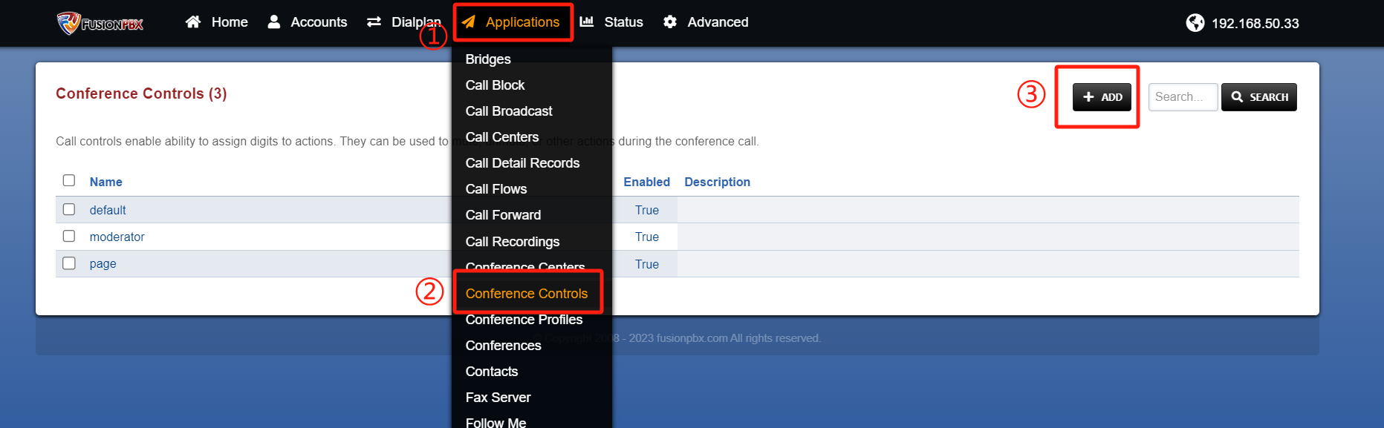

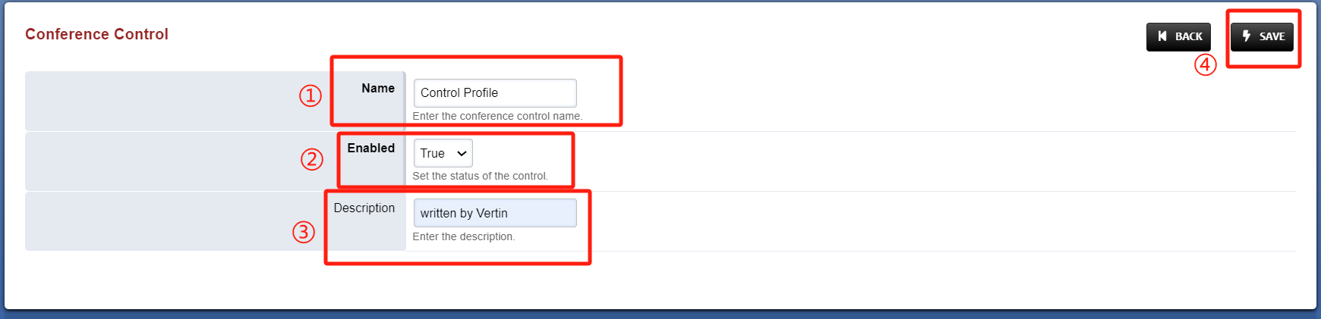

### 2.2 Fill in the sepecific parameters

After the successful saving, it will return to the previous interface. At this time, click the new control again to edit the rule items in the control. For details about rule parameters, see Table 1.

Steps: Click the control bar item --》+ADD --》fill in the sepecific parameters --》Save parameters --》Add successfully

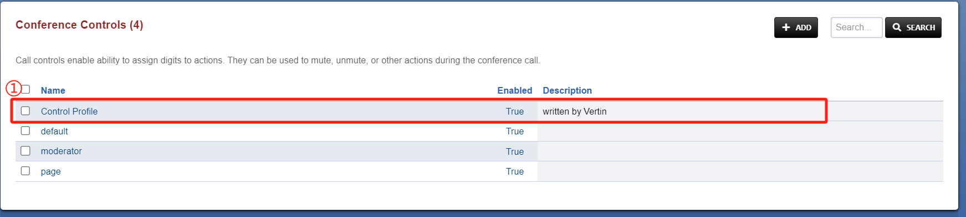

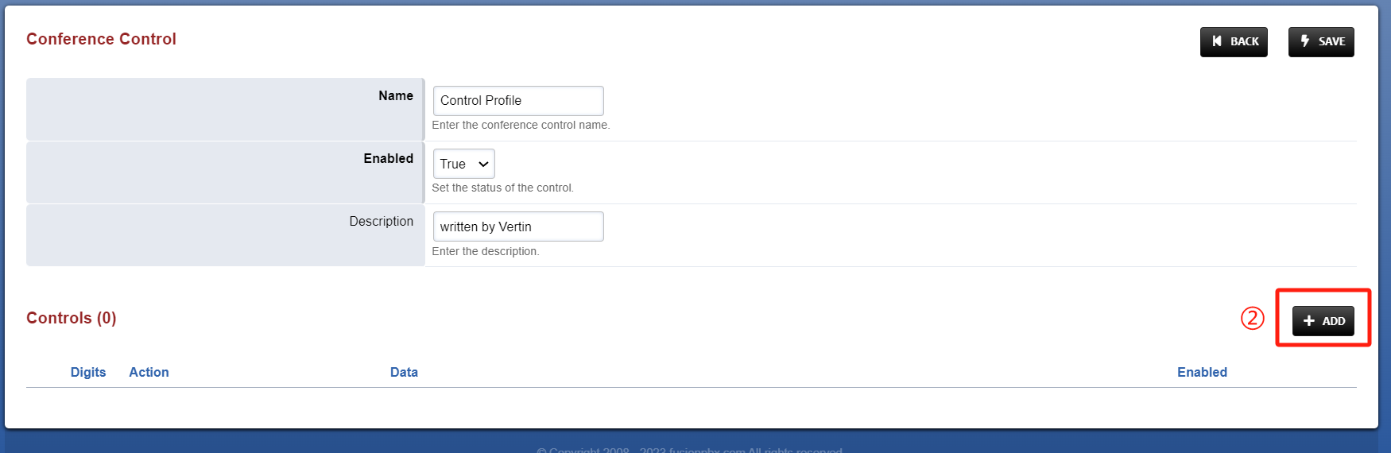

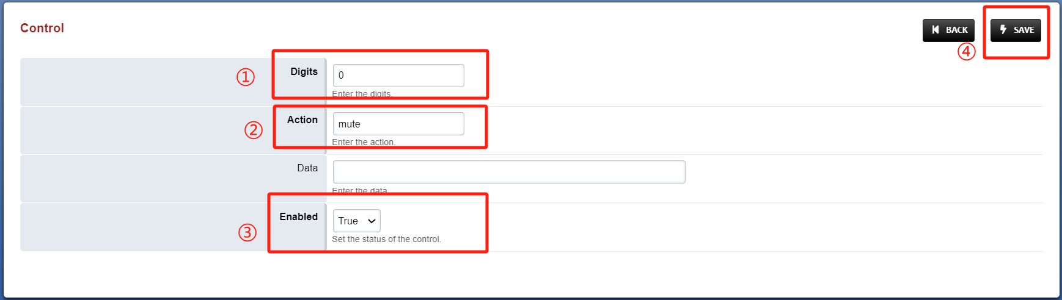

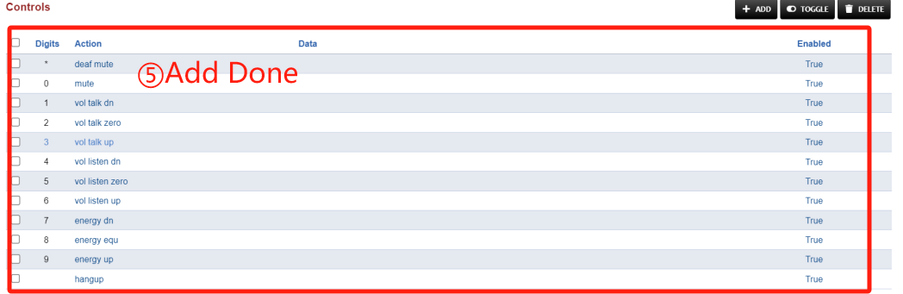

Table 1 Parameters Description

|  |  |  |
| --- | --- | --- |
| Parameters | | Description |
| Digits | | The number dialed during control can usually be set to 0-9 and *, # |
| Actions | mute | Act of control, which means banning one's microphone. |
| deaf Mute | The act of control, which means banning one's microphone and receiver. |
| vol talk dn/zero/up | Control behavior, this item represents the control of speaking volume increase, the scale is 1-4;  Each time the number represented by the behavior is clicked, the volume overflow decreases by one level/cancels the overflow/increases by one level; |
| vol listen dn/zero/up | Control behavior, this item represents the control of the handset volume increase, the level is 1-4;  Each time the number represented by the line is clicked, the volume of the handset decreases/cancels the overflow/increases by one level; |
| energy dn/equ/energy/up | Control behavior, this item represents the control noise threshold to reduce/restore the default value/increase;  When the voice is louder than the noise threshold, your voice will be transmitted to the other member's receiver;  Each time the number represented by the line is clicked, the noise threshold is increased/decreased by 200, with a minimum of 0 and a maximum of 1800; |
| hang up | Control behavior, this represents hanging; |
| Data | | When a special rule needs to be added, it should be used to fill in the URL that points to the path of the rule's data. |
| Enabled | | Select to true. |

### 2.3 Editing an existing control

If you only need to modify the rules on an existing control, you can choose to edit the control, as described above.

Steps:Applications --》Conference Controls --》item --》+ADD

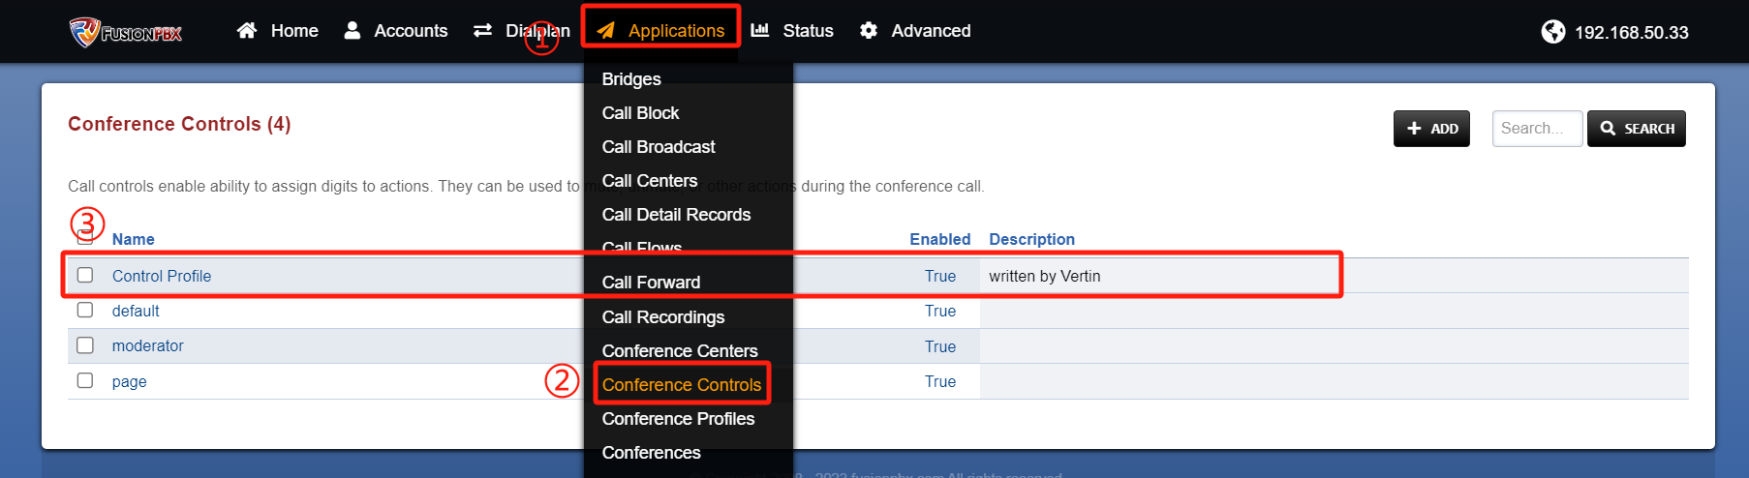

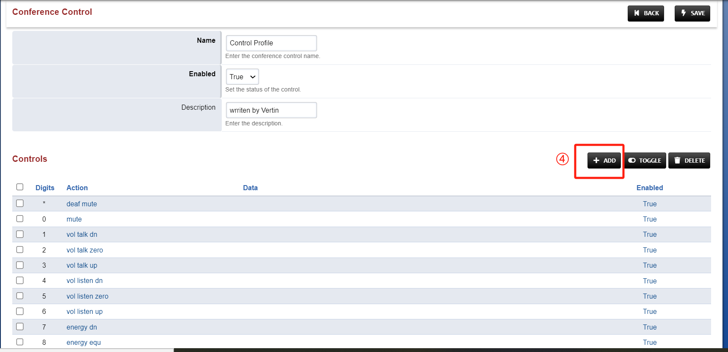

## Write the controls in the conference profiles

### 3.1 Find the conference profile you want

Steps:Applicaitons--》Conference Profiles--》Find the item

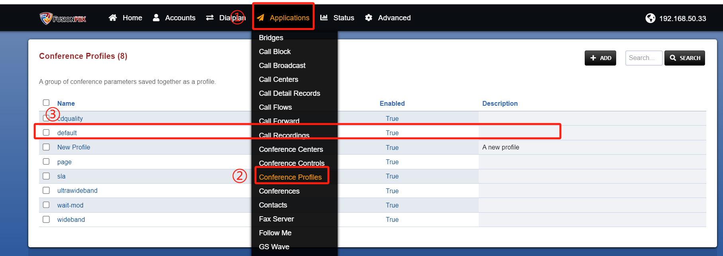

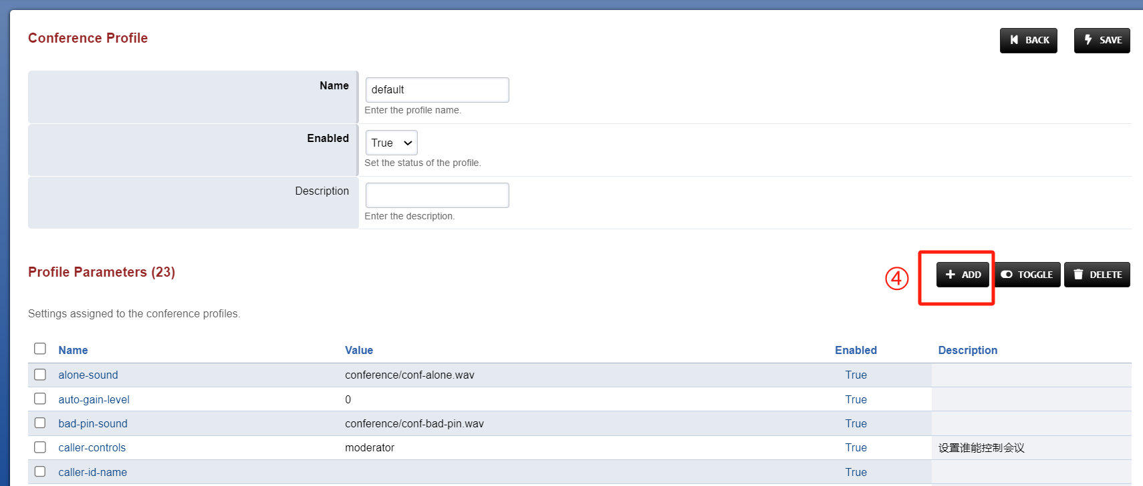

### 3.2 Write the control in the conference profile

Steps:Fill in name--》Fill in value--》Enabled select to true--》Save --》Return to the previous interface to save changes to the conference profile

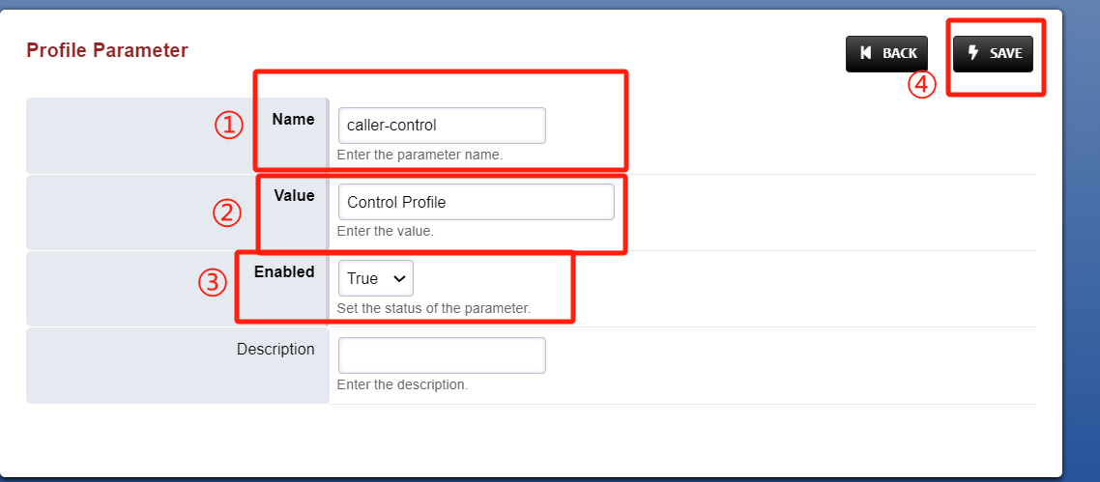

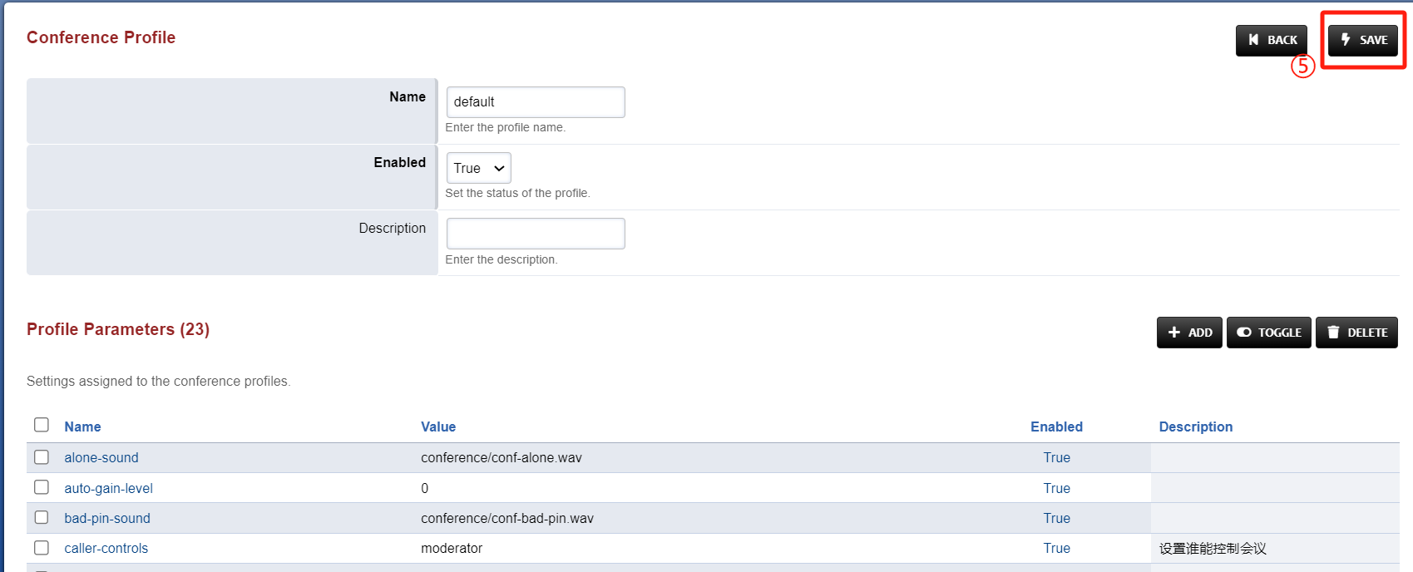

# Ⅳ Test result verification

## 1.Enter Conference

Now that the configuration is complete, we can go into the conference to test the control wheter works.

Steps:Extension 5020, 5022 Dial Conference extenion 6000 -- 》Enter the PIN code of the conference --》After successful input, you hear a short "beep" tone -- 》You have entered the conference;

Tip: If you're the first person to enter the conference, you'll hear a tone that says, "You're currently the only person in the conference." and then MOH will play until the second person enters the room and the meeting begins.

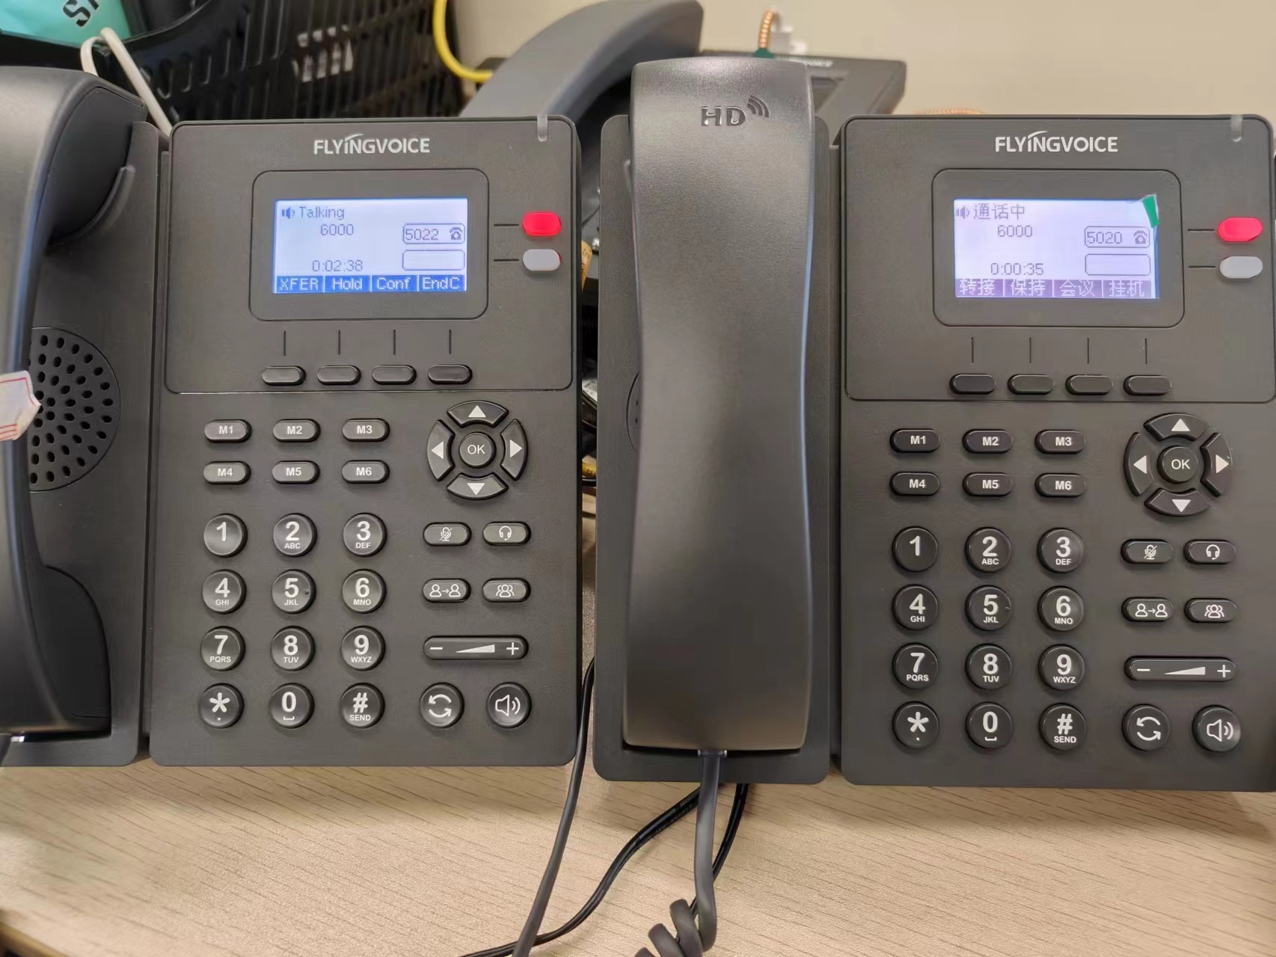

## 2.Test the control wheter works

Test steps: Participants 5020 dial the number "*" -- 》5020 hear the prompt sound" you are now muted ", other participants' handset can not hear 5020 speaking -- 》judgment configuration is effective