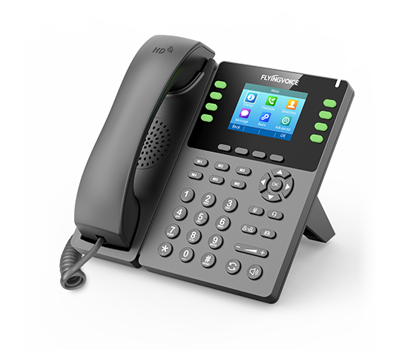

**Fusion PBX Conference Profiles**

**Configuration Guide**

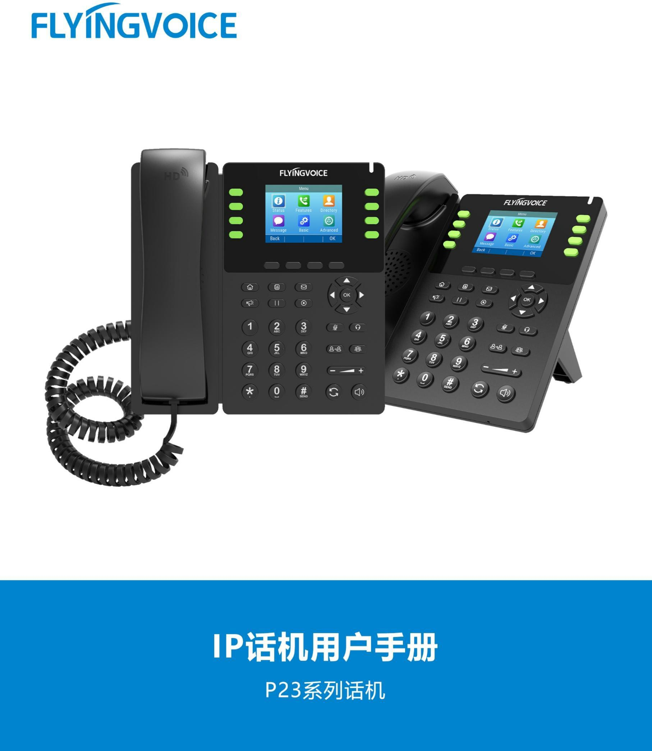

# Catalogue

Ⅰ Conference Profiles Introduction 1

Ⅱ Configuration Flow 1

Ⅲ Configuration Operation 1

1.Login the PBX management web 1

2. Add/Edit the conference profiles 2

2.1 Add a new conference profile 2

2.2 Fill in the sepecific parameters 3

2.3 Editing an existing profile 5

3. Save and Apply 6

3.1 Save 6

3.2 Apply 6

Ⅳ Test result verification 7

1.Enter Conference 7

2.Test the profile wheter works 7

# Ⅰ Conference Profiles Introduction

A conference profile is essentially a set of conference parameters that you can customize to create your own conference.

# Ⅱ Configuration Flow

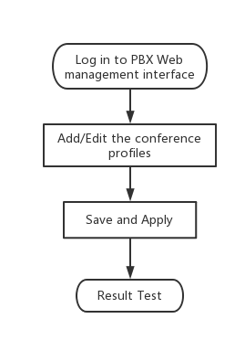

# Ⅲ Configuration Operation

## 1.Login the PBX management web

Contact the network administrator to obtain PBX domain name, user name and password information, login PBX web page management page.

Steps:input the domain name of pbx--》input the username and password --》Click Login

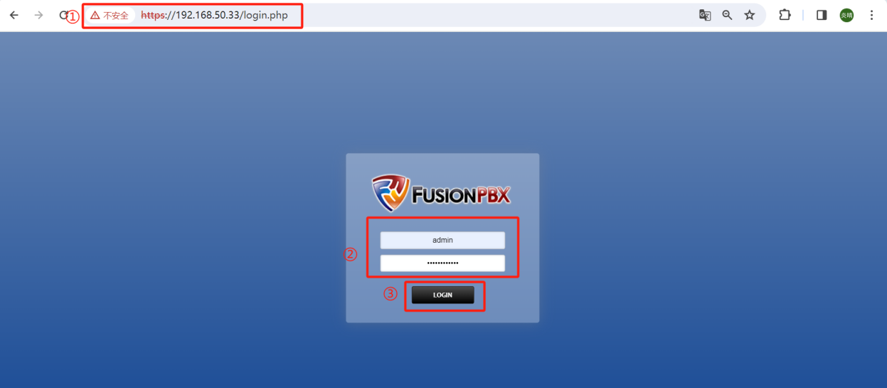

## Add/Edit the conference profiles

### 2.1 Add a new conference profile

If you want to customize your own conferencr, you can choose to add a new conference profile. First you need to add a blank profile.

Steps:Applications--》Conference Profiles--》+ ADD--》Fill in the parameters(which is framed in red)--》Save

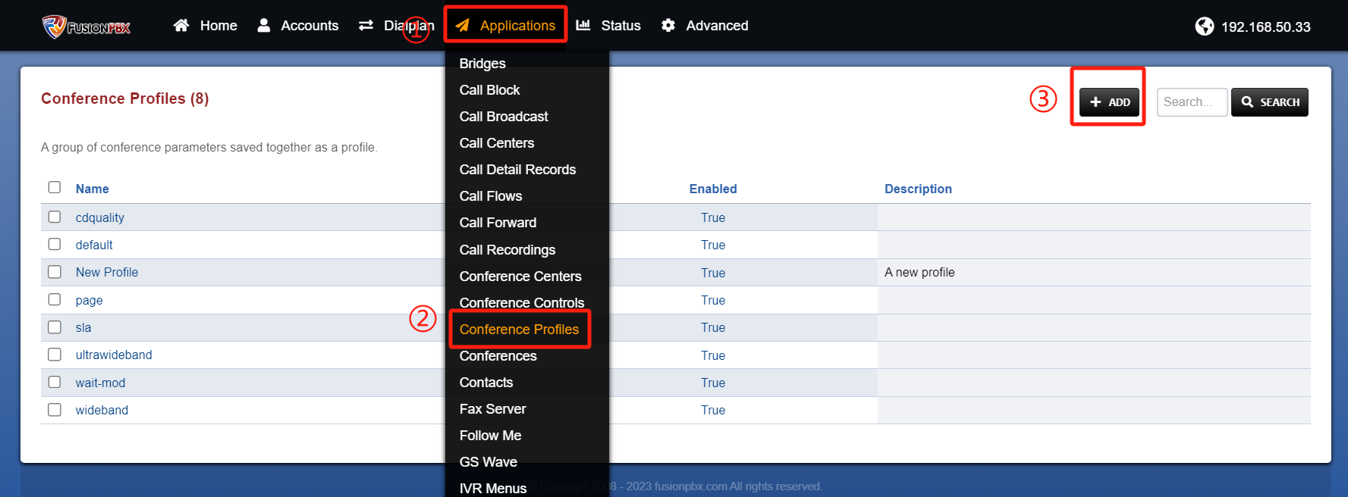

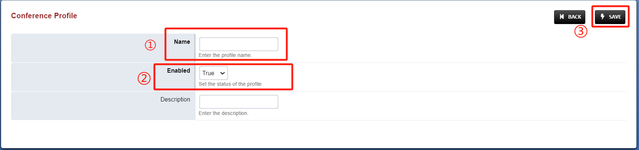

### 2.2 Fill in the sepecific parameters

After the successful saving, it will return to the previous interface. At this time, click the new profile again to edit the rule items in the profile. For details about rule parameters, see Table 1.

Steps: Click the control bar item --》+ADD --》fill in the sepecific parameters --》Save parameters --》Add successfully

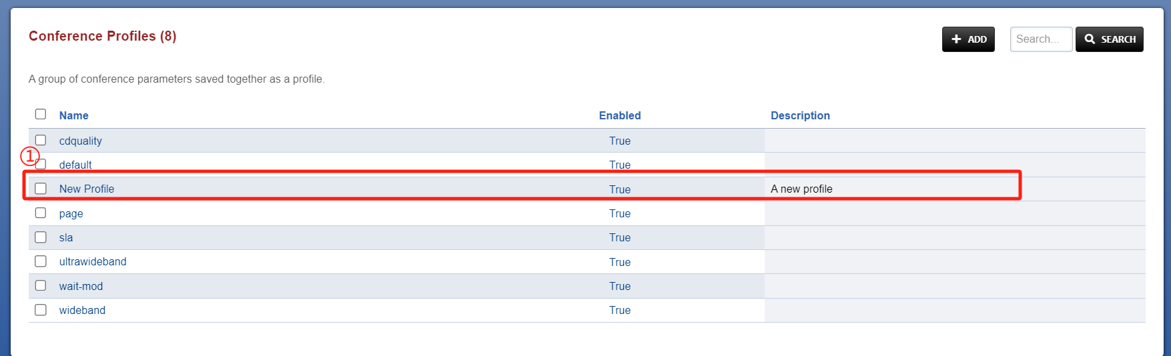

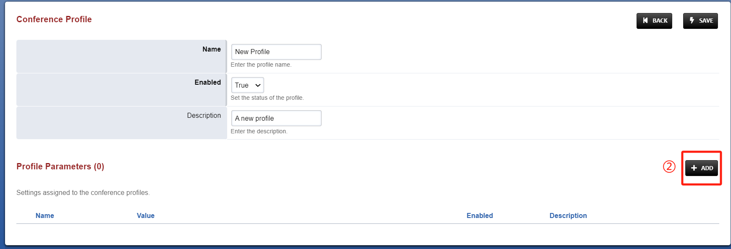

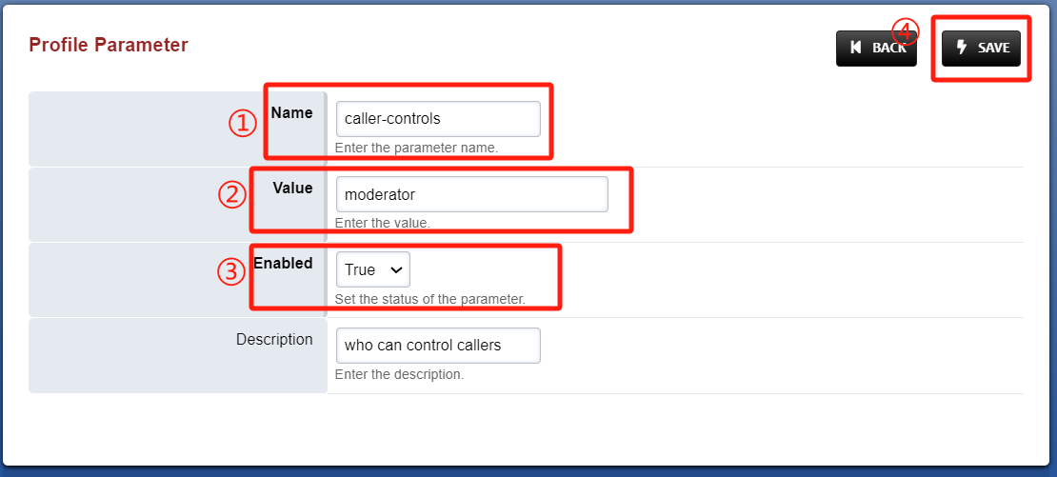

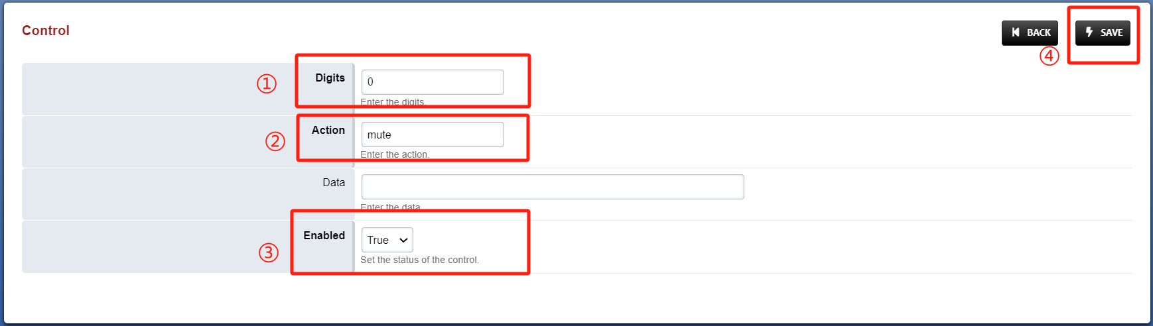

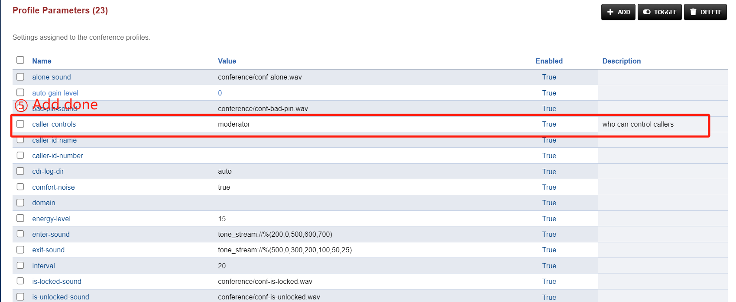

Table 1 Parameters Description

|  |  |
| --- | --- |
| Parameters | Description |
| cdr-log-dir | Set as auto. Could be set manually and is enabled. |
| Domain | enabled. |
| rate | The rate in kHz. 8000kHz and is enabled. |
| interval | 20 is the default. |
| energy-level | 15 is the default. |
| auto-gain-level | 0 is the default. |
| caller-controls | default is the default. |
| moderator-controls | moderator is the default. |
| muted-sound | conference/conf-muted.wav is the default. |

### 2.3 Editing an existing profile

If you only need to modify the rules on an existing profile, you can choose to edit the profile, the method of fill in parameters as described above.

Steps:Applications --》Conference Profiles --》item --》+ADD

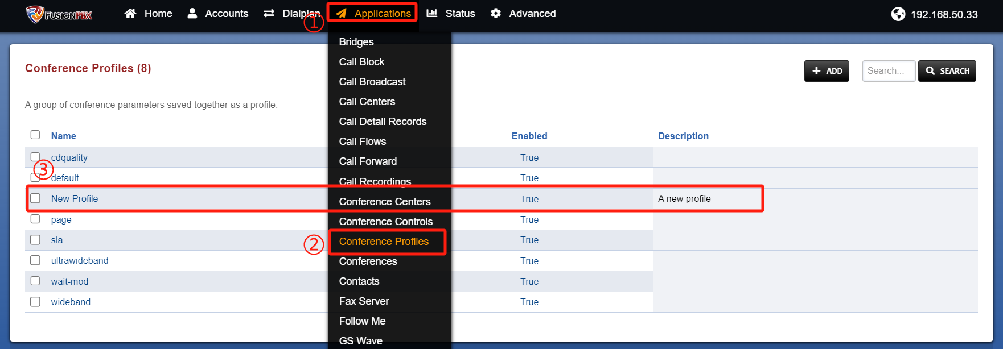

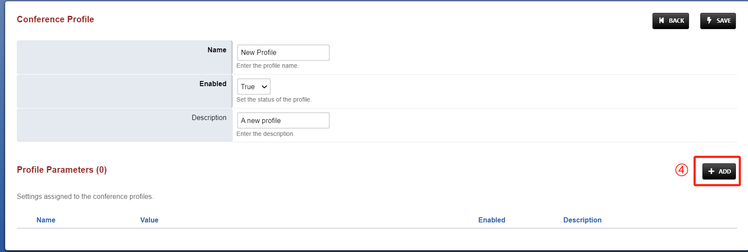

## Save and Apply

### Save

* 1. When the parameter entry is added successfully, it will return to the previous interface and need to save the entire profile.

Steps:Save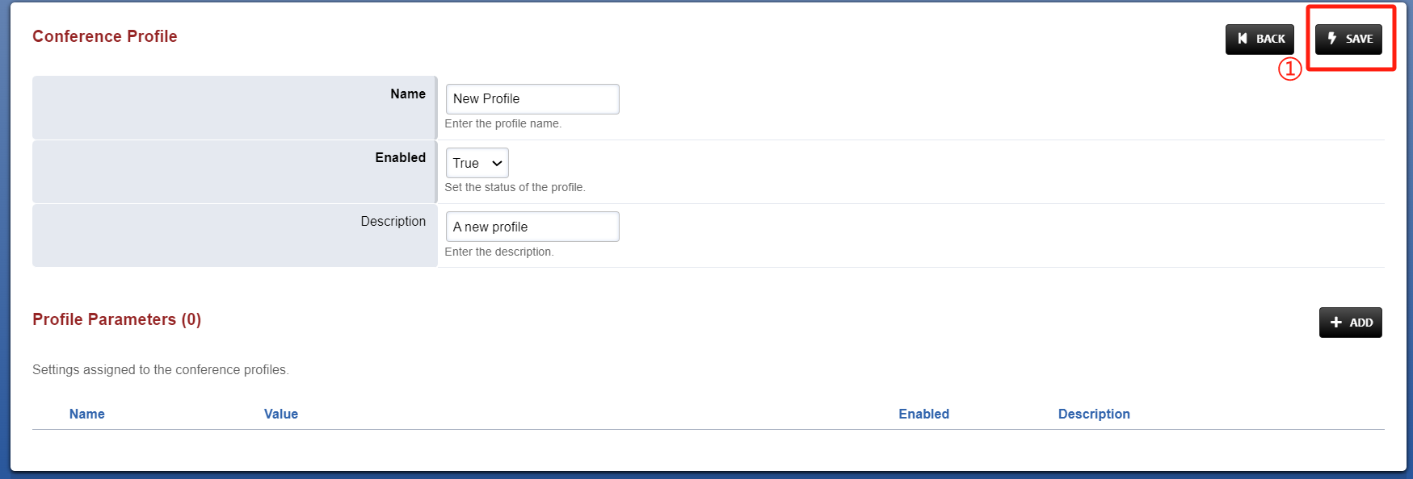

### 3.2 Apply

Steps:Add a conference/conference center and select a new profile(refer to ***Fusion PBX Conferences Configuration Guidence*** for new meeting room operation)

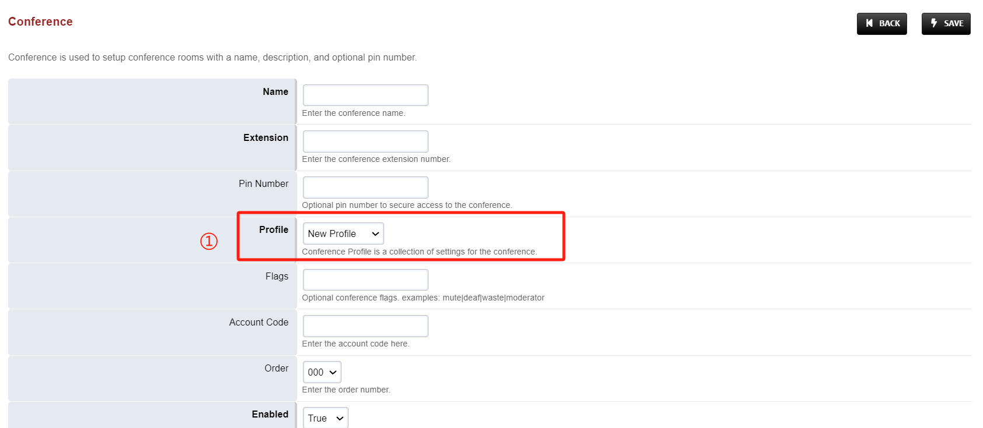

# Ⅳ Test result verification

## 1.Enter Conference

Now that the configuration is complete, we can go into the conference to test the profile wheter works.

Steps:Extension 5020, 5022 Dial Conference extenion 6000 -- 》Enter the PIN code of the conference --》After successful input, you hear a short "beep" tone -- 》You have entered the conference;

Tip: If you're the first person to enter the conference, you'll hear a tone that says, "You're currently the only person in the conference." and then MOH will play until the second person enters the room and the meeting begins.

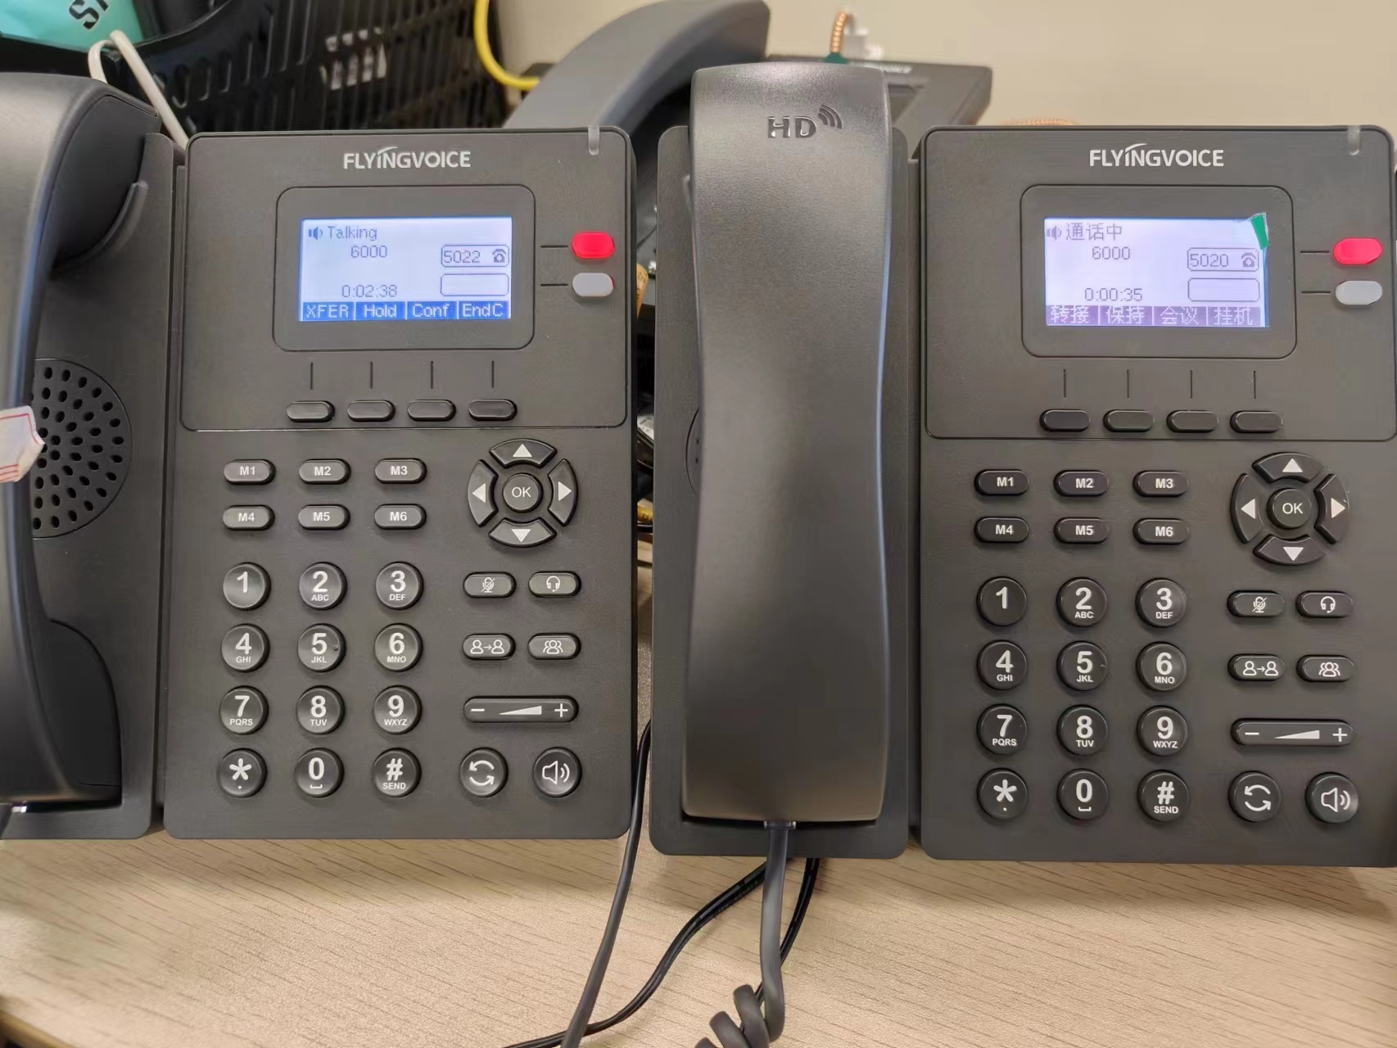

## 2.Test the profile wheter works

Test steps: Participants 5020 does the mute operation -- 》5020 hear the sepecial prompt sound(The special ring tone you set), other participants' handset can not hear 5020 speaking -- 》judgment configuration is effective