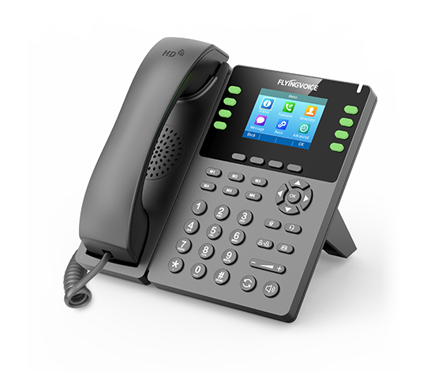

**Fusion PBX Conference Centers**

**Configuration Guide**

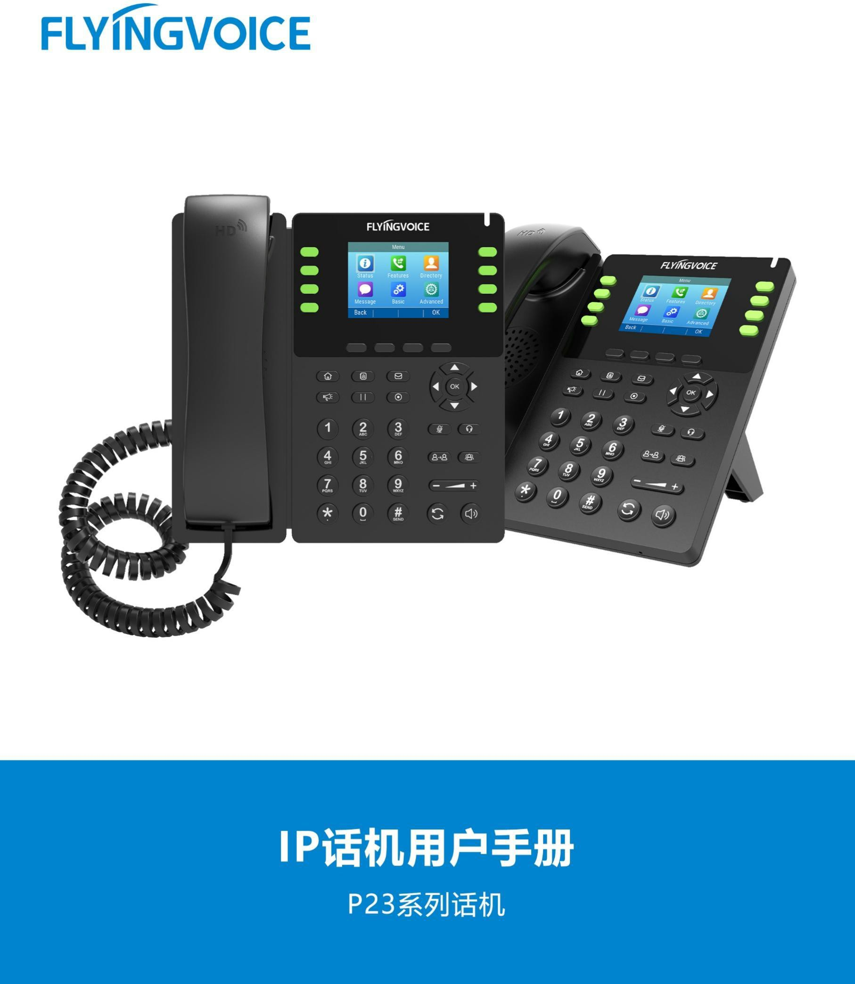

# Catalogue

Ⅰ Conference Center Introduction 1

Ⅱ Configuration Flow 1

Ⅲ Configuration Operation 2

1.Login the PBX management web 2

2. Add Conference Center 2

3. Fill in the specific parameters and save 2

4. Save the Configuration of conference center 3

5.Add rooms in the conference center 3

5.1 Add new room 4

5.2 Fill in the sepecific parameters of rooms 4

5.3 Save the configuration od the rooms 5

5.4 Check the status of conference rooms 6

Ⅳ Test result verification 6

1.Enter Conference 6

2.Conference rooms status check 7

2.1 Check the conference active status 7

2.2 Active Conference roomscheck 7

2.3 Conference rooms management and status details view 8

3.Judgement result 8

# Ⅰ Conference Centers Introduction

In addition to basic conference functionality, the Fusion PBX also supports conference centers functionality. A conference center is essentially a group of meeting rooms that can be organized based on cost centers, geographic locations, or other criteria.

When you set up a conference center, you can set up several rooms in it and it support many functions,including schedule, record and so on.

And these rooms can work at the same time, whether it's a small call need or a large call need such as a weekly call meeting for a large corporate department.

# Ⅱ Configuration Flow

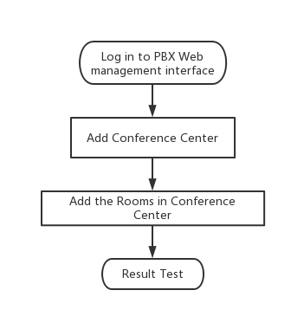

# Ⅲ Configuration Operation

## 1.Login the PBX management web

Contact the network administrator to obtain PBX domain name, user name and password information, login PBX web page management page.

Steps:input the domain name of pbx--》input the username and password --》Click Login

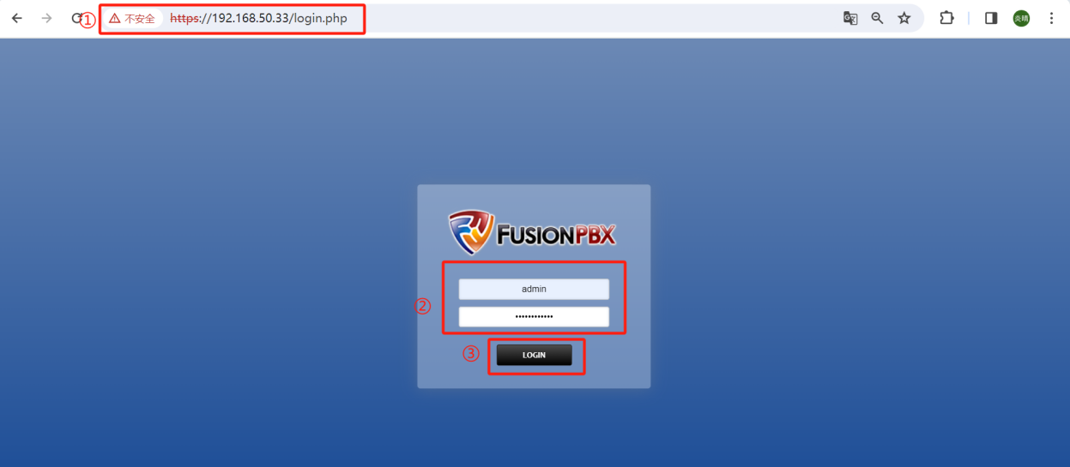

## Add a Conference Center

Steps：Applications--》Conference Centers--》+ ADD

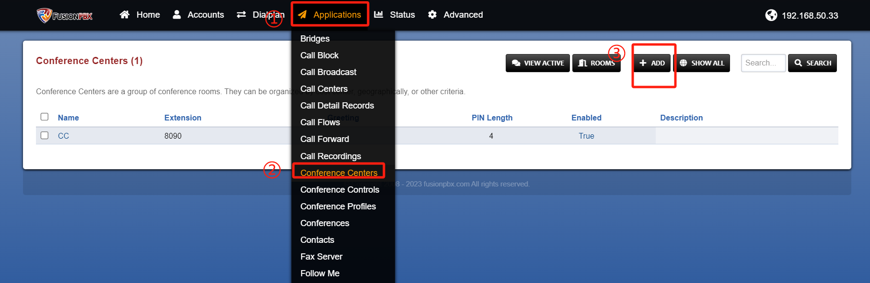

## Fill in the specific parameters and save

In the figure, the selected parameters in the red box are required, and the others are optional, and the parameters are explained in Table 1.

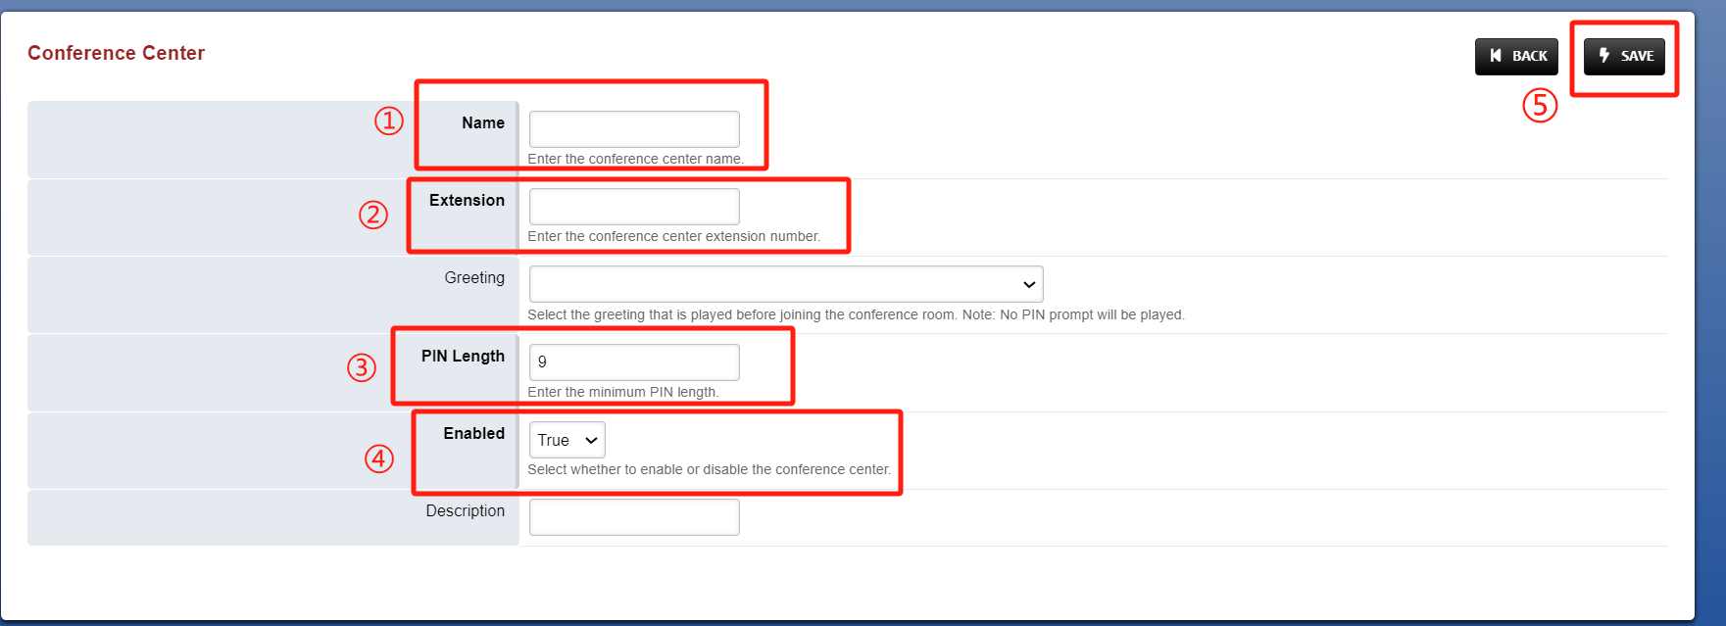

**Table1 Parameters Description**

|  |  |
| --- | --- |
| Parameters | Description |
| Name | Fill in the name of the conference center; |
| Extension | Enter the conference center extension number, which needs to be a new, never-before-seen number. |
| Pin Length | Set the length of PIN code in the conference center’s rooms; |
| Enabled | Select to true; |
| Description | The discription of conference center; |

## 4. Save the Configuration of the conference center

After saving successfully, it will automatically return to the previous screen and prompt the update complete.

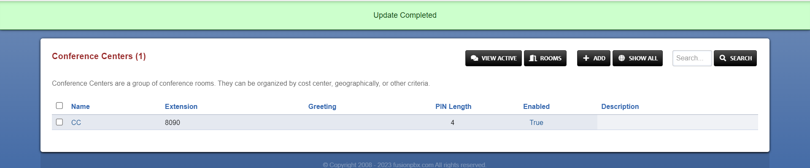

## 5.Add rooms in the conference center

The following operations can create 1 room. If you need more than one room, please add one by one according to the process.

### 5.1 Add a new room

Step:ROOMS--》+ADD

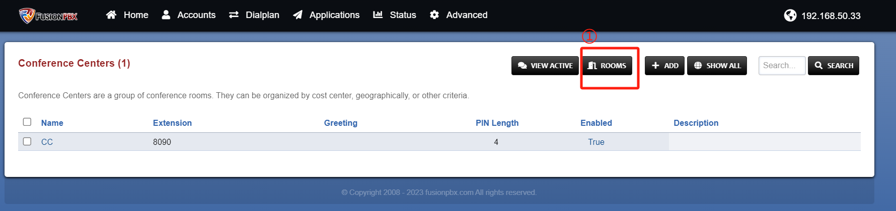

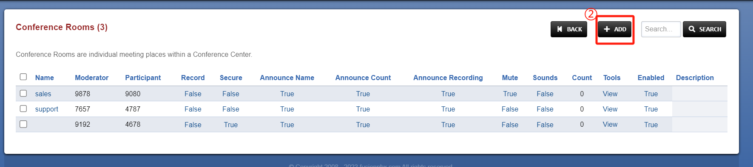

### 5.2 Fill in the sepecific parameters of the room

Create a room in the conference center to meet your needs. See Table 2 for a detailed description of parameters.In the figure, the red boxes selected are required parameters, and the rest are optional.

Steps:Fill in the parameters --》save

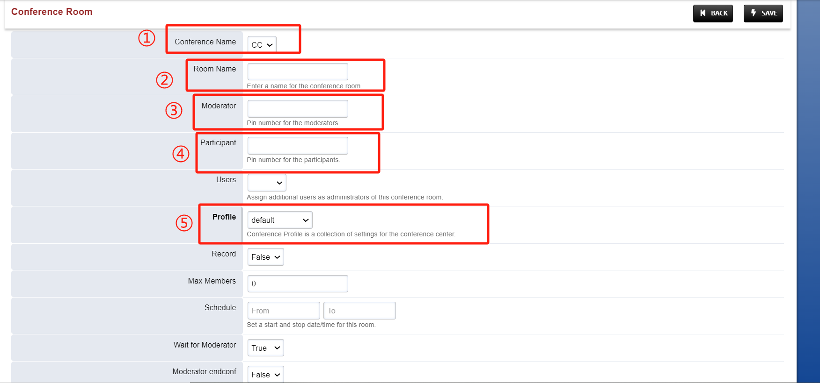

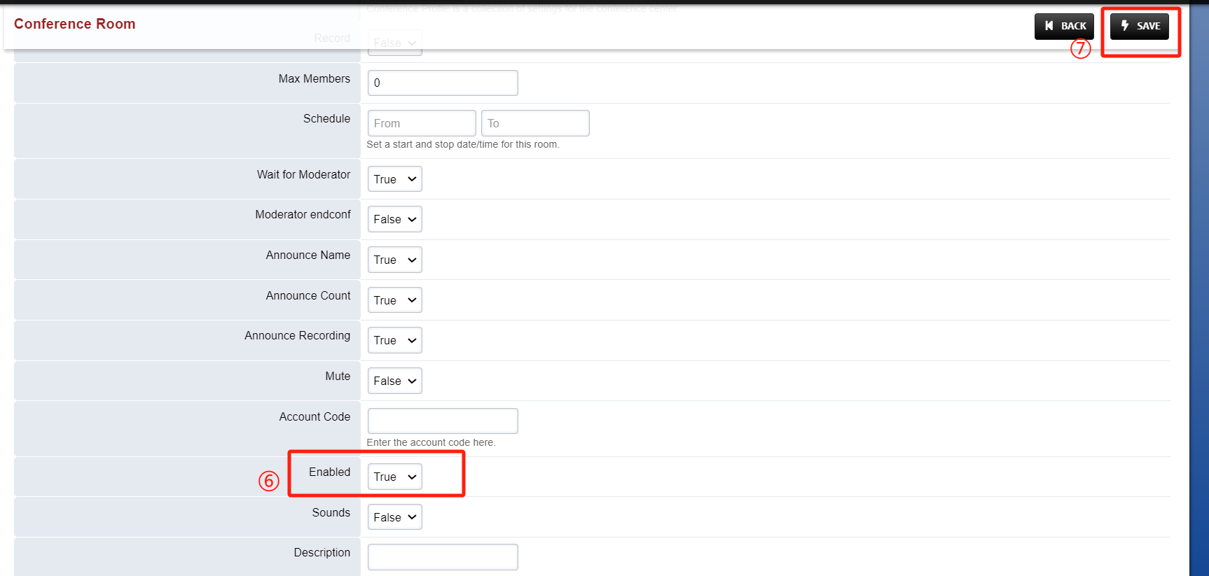

**Table 2 Parameters Description**

|  |  |
| --- | --- |
| Parameters | Description |
| Conference Name | Select the name of the corresponding conference center. |
| Room Name | Set the name of the room. |
| Moderator | Set the PIN code entered by the host when joining the meeting, so that it can be identified with ordinary participants. |
| Participant | Set PIN codes for attendees to join a meeting; |
| Users | Set up PBX users who can use the meeting room. |
| Profile | Select the conference profile. |
| Record | Choose whether to enable call recording. |
| Max Members | Select the maximum number of attendees; note that the maximum number in the Profile should be used, although there is no input limit here. |
| Schedule | Set the meeting time, which can be used to reserve a conference. |
| Wait for Moderator | Choose whether to wait for the host to enter before starting the conference. |
| Moderator endconf | Select whether the moderator has permission to end the meeting. |
| Mute | Choose whether to enable gagging. |
| Account Code | Set the code to open or close the conference. |
| Enabled | Select to true. |

### 5.3 Save the configuration od the rooms

Update completed.

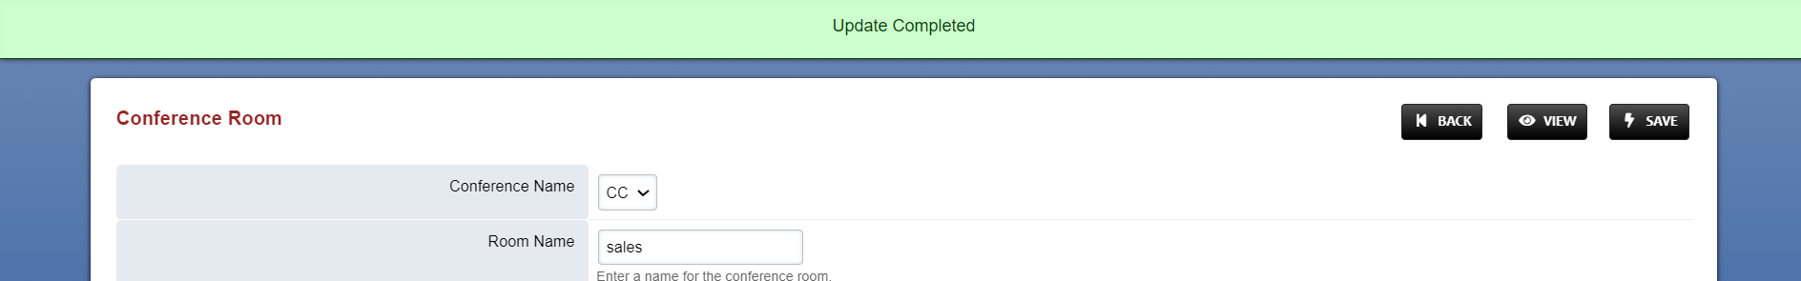

### 5.4 Check the status of conference rooms

Return to the previous page to view the created conference rooms.

Steps:BACK--》check rooms

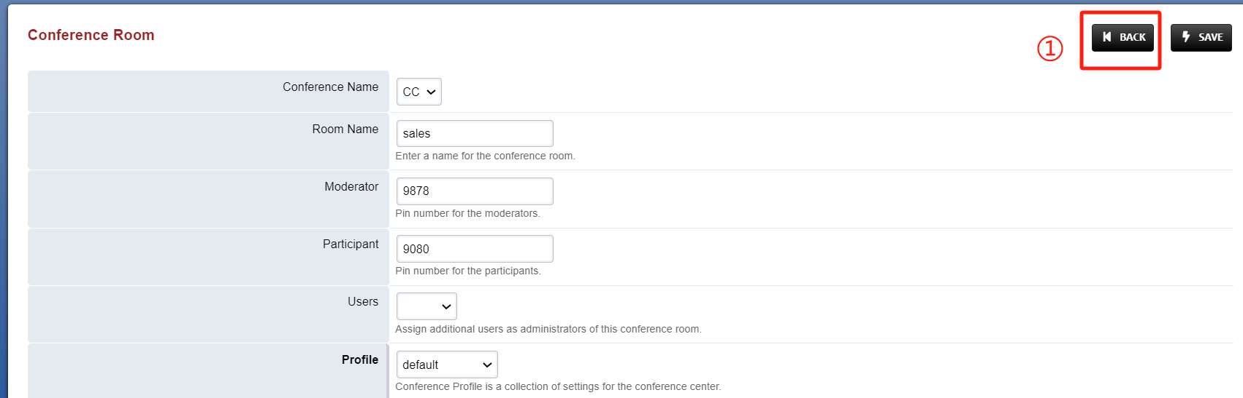

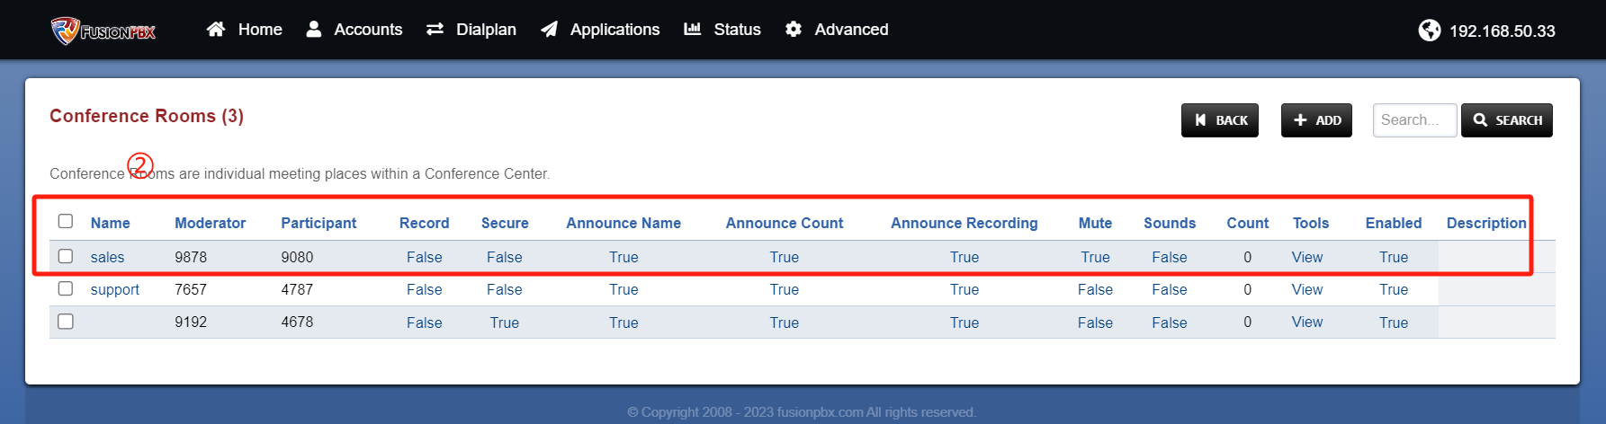

# Ⅳ Test result verification

## 1.Enter Conference

Now that the configuration is complete, we can go into the conference center and test that it works.

Steps:Extension 5020, 5022 Dial Conference center extenion 8090 -- 》Enter the PIN code of the Sales conference room --》After successful input, you hear “please save your name after the tone”and a short "beep" tone -- 》You have entered the Sales conference room;

Tip: If you enter a meeting room with the Wait for Moderator turned on, and you are the first participant (not the moderator) to enter the meeting room, you will hear MOH until the moderator enters the room and the meeting officially begins.

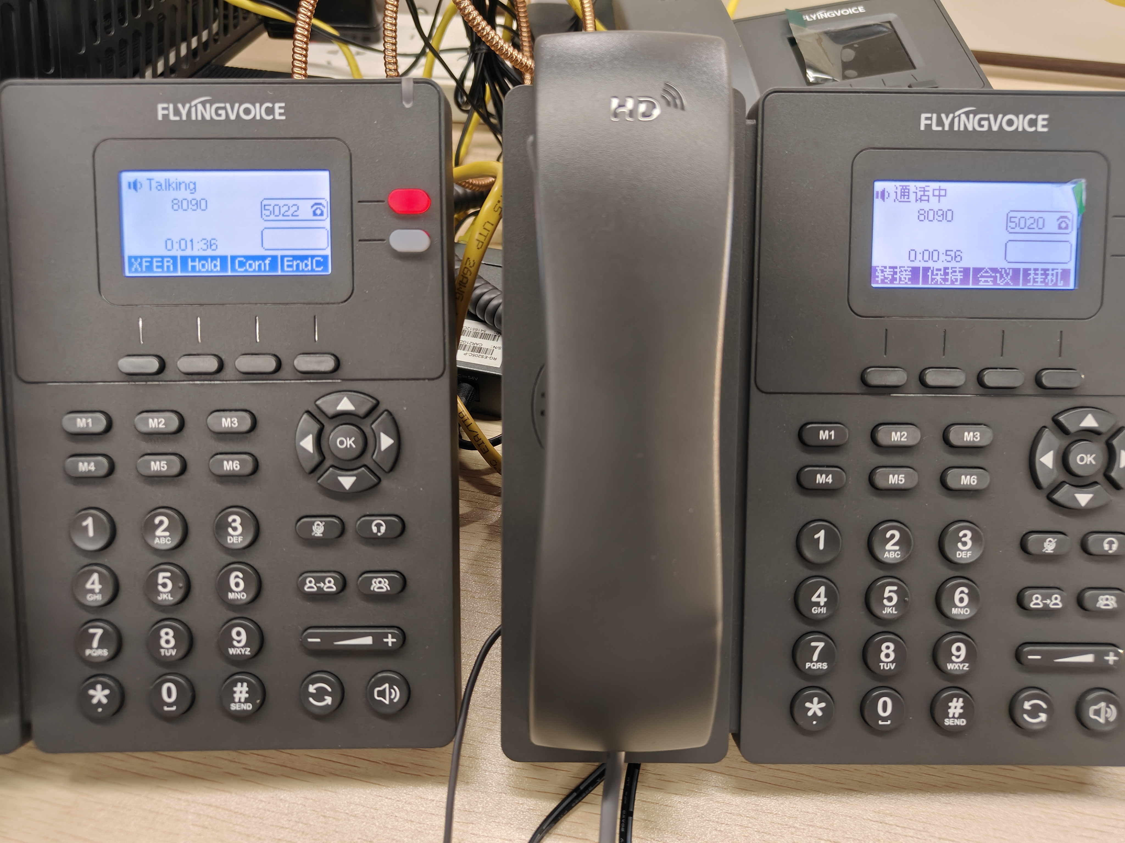

## 2.Conference rooms status check

### 2.1 Check the conference active status

On the Conference center configuration bar of the web page, click VIEW ACTIVE to view the active conference room status.

Steps:Click the VIEW ACTIVE

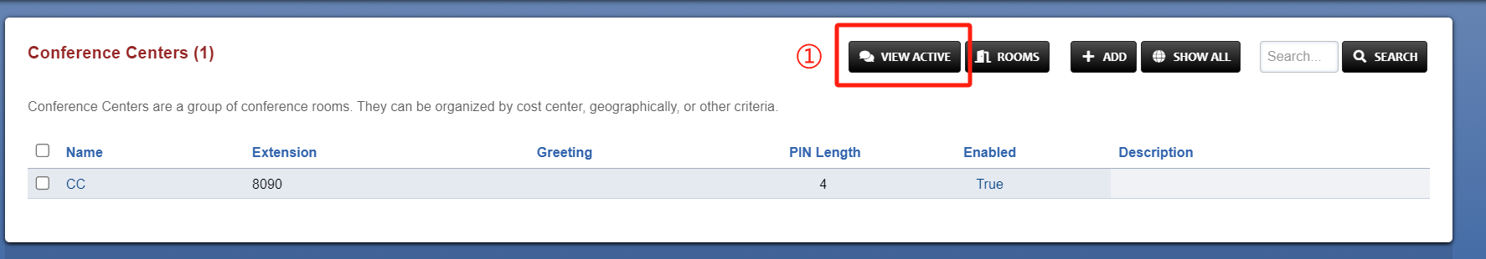

### 2.2 Active Conference roomscheck

You can see that the meeting room sales has been activated, the number of participants is 2, and the attendance PIN is 9080, indicating that these two people are ordinary attendees.

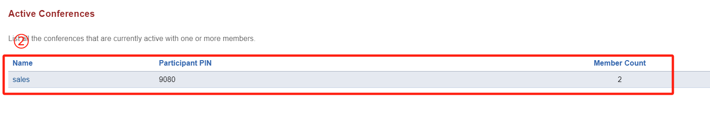

### 2.3 Conference rooms management and status details view

Steps:1)Enter the item 8090(conference center extension) to check the status details.

2)Click the buttons to Control attendee’s behavior.(mute/Lock/Kick...)

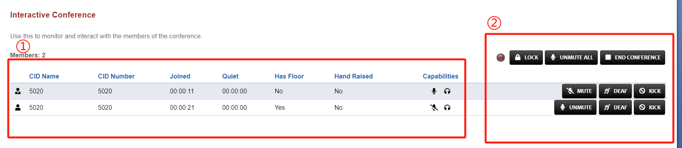

## 3.Judgement Result

When we can talresultk normally in the conference center and the PBX can see that the room is activated, we can judge that the configuration is successful.