Conference introduction and Configuration

1. introduction

By creating a conference , you can realize multi-person online meeting. Attendees don't have to move from one place to another to interact with attendees. You can initiate a meeting at anytime, anywhere.

1. Configuration Flow
2. Add Conference Room

Call Feature → Conference → Add

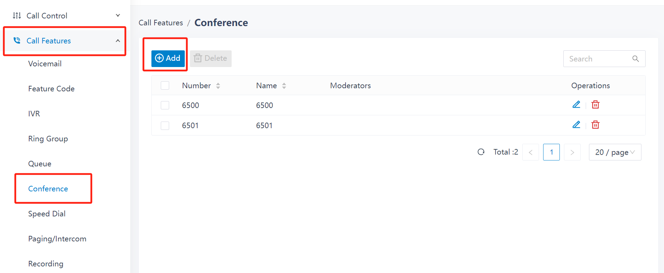

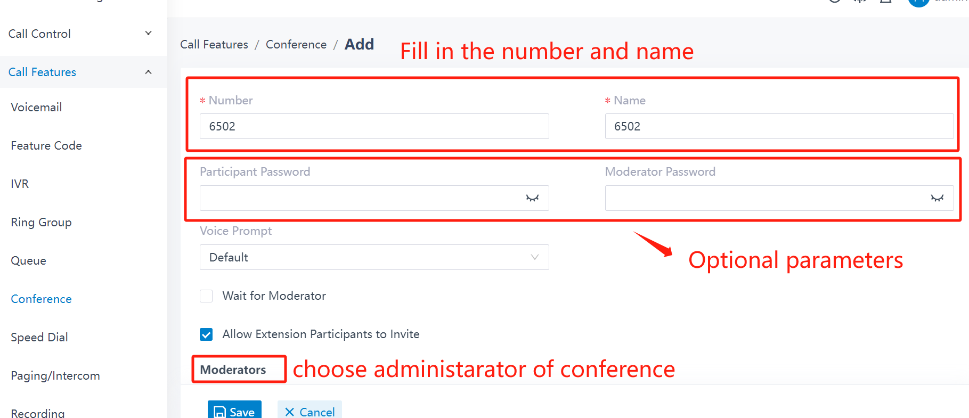

1. Join a Conference Call

Both internal and external users can call the conference number to join the conference call. If prompted for a password, enter the attendee password. If you're the only one on the conference, the system will play MOH to you.

1. Invite users to a Conference Call

Steps of operation：

1. During a conference call, press the # key.You are forced out of the conference call temporarily.
2. Dial the number that you want to invite.After the invited user joins or rejects the conference call, you will return to the conference call.
3. Conference Voice Menu

This is the conference voice menu.

