Distinctive Ringtone Introduction and Configuration

1. Introduction

By assigning different ring tones to different types of calls, employees can quickly identify the caller's intent through a unique ring tone without checking the caller's information on the phone.

① Set a special ring for internal calls: a specific ring tone for internal calls.

②　Set a special ring for incoming incoming calls: Incoming calls are rerouted to use a specific ring tone.

③　Set a special ring for queue calls: When an extension is serving multiple queues at the same time, use the feature ring to quickly identify queue calls.

④　Set special ring for ringing group calls: When an extension serves multiple ring groups at the same time, special ring can help him quickly identify the ring group to which the call belongs.

⑤　Set a special ring for IVR calls: Set a specific ring tone for each IVR.

1. Application scenario

①When the user hears the ringing of an incoming call, the user can directly distinguish the caller from a colleague.

②When an agent serves multiple queues at the same time, the feature ring helps him quickly identify the queue to which an incoming call belongs.

1. Configuration

Configure IP Phone on the web(The premise）：

① SIP Accounts → line 1 → Advanced → Enable the Alert Info Tone

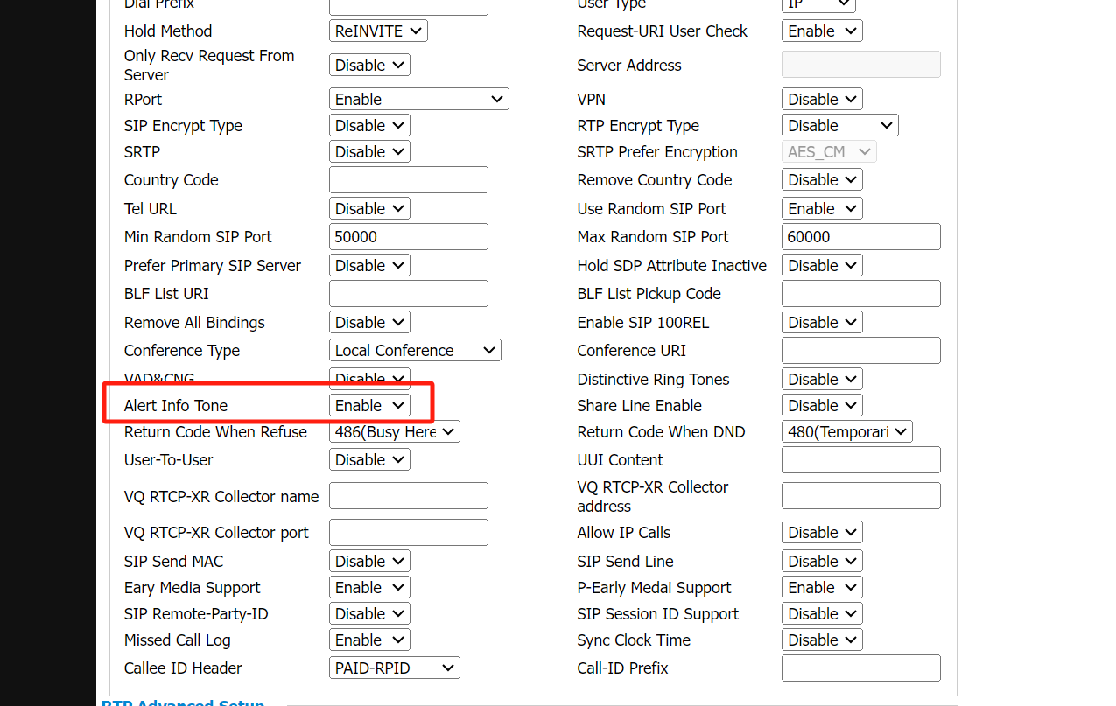

② SIP Accounts → Ring → Name the ringtone files

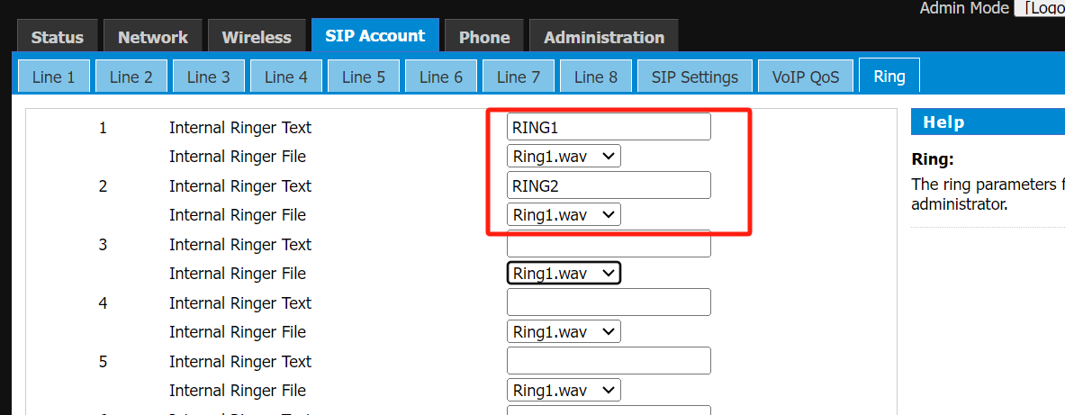

Set a special ring for internal calls:

PBX Settings → SIP Settings → Advaced → Fill in Internal Alert Info

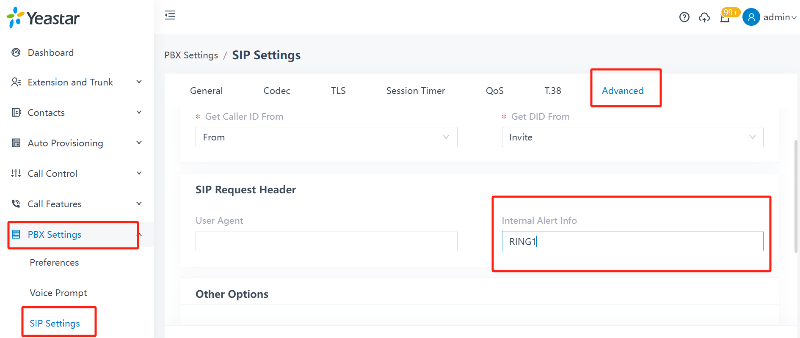

Set a special ring for incoming incoming calls:

Call Control → Inbound Route → choose your inbound route and edit→ Fill in the inbound alert info

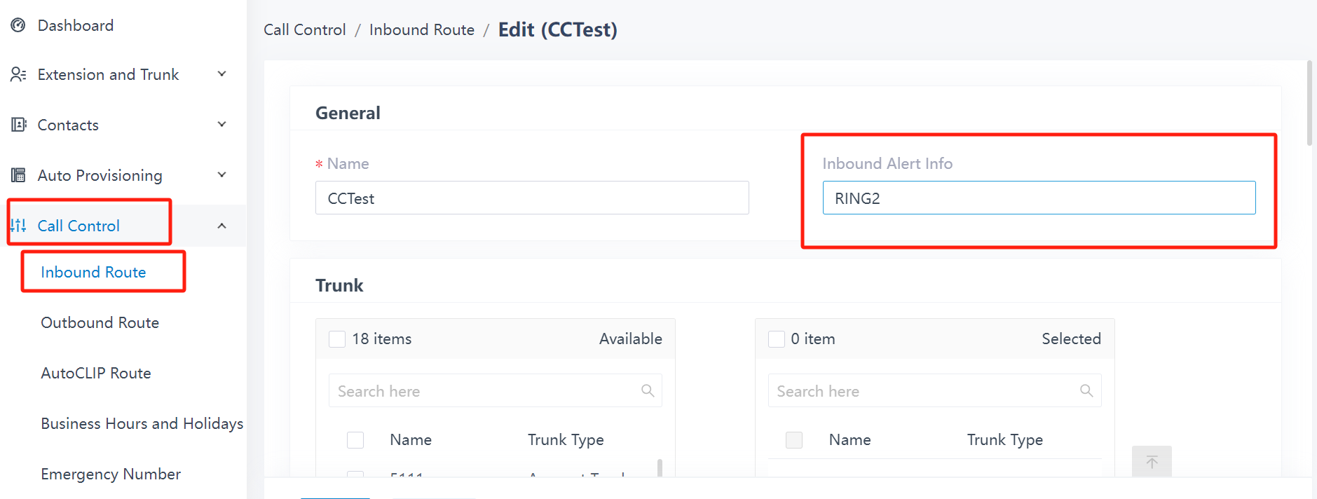

Set a special ring for queue calls:

Call Feature → Queue → Choose your queue and edit → Preferences → Fill in Queue Alert Info

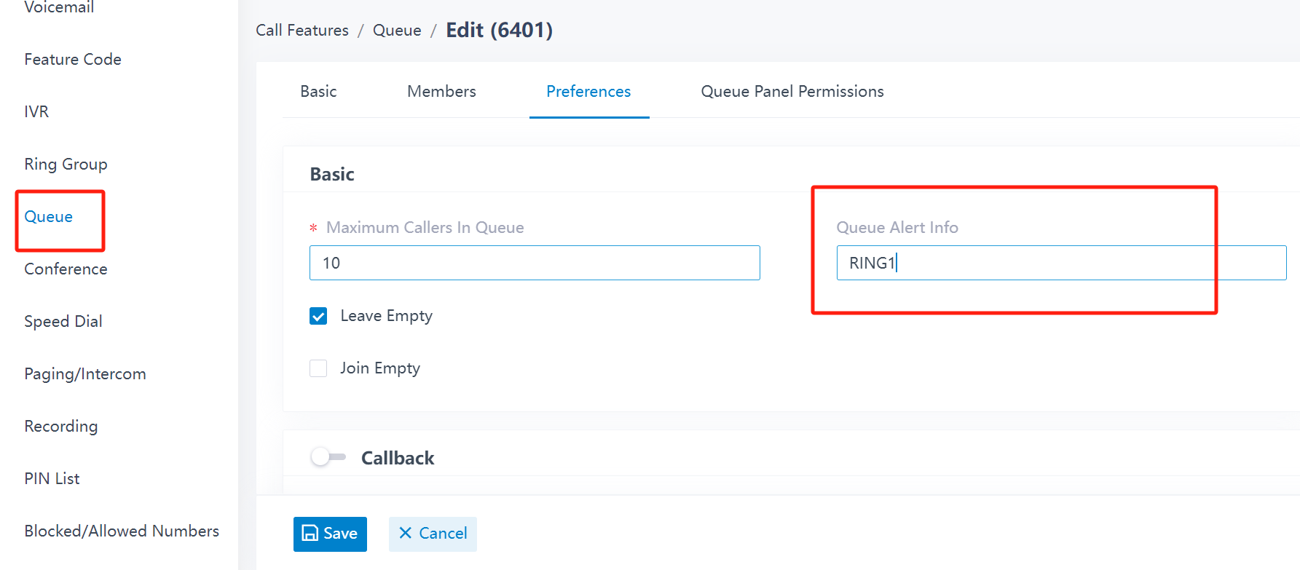

Set special ring for ringing group calls:

Call Features--》Ring Group--》Choose your group and edit--》Fill in Ring Group Alert Info

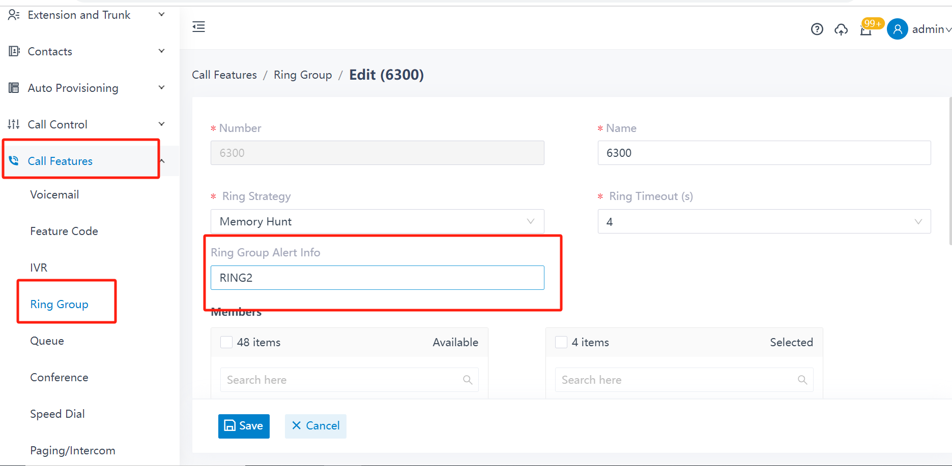

Set a special ring for IVR calls:

Call Features → IVR → Choose your IVR and edit → Basic → Fill in IVR Alert Info

