**Hot Desking Function**

**introduction and Configuration**

1. **Introduction**

It allows users to register the same extension in multiple terminals. When a call comes,the terminals will ring at the same time, and users can answer the call in any terminals. It is suitable for users whose office location is unfixed.

1. **Configuration Flow**

2.1 Set the IP Phone Concurrent Registrations（maximum number is 3）

Extension and Trunk -→ Extension -→ User -→ IP Phone Concurrent Registrations

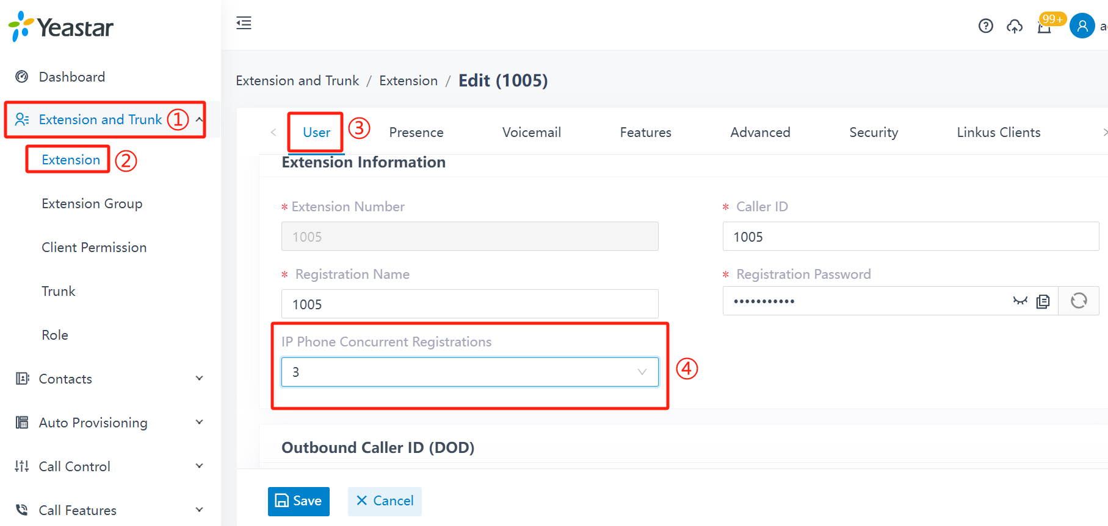

2.2 Register Extension to IP Phone

Login the web of IP Phone -→ Click VoIP -→ Click SIP Account Line1 -→ Fill in informations -→ Save & apply

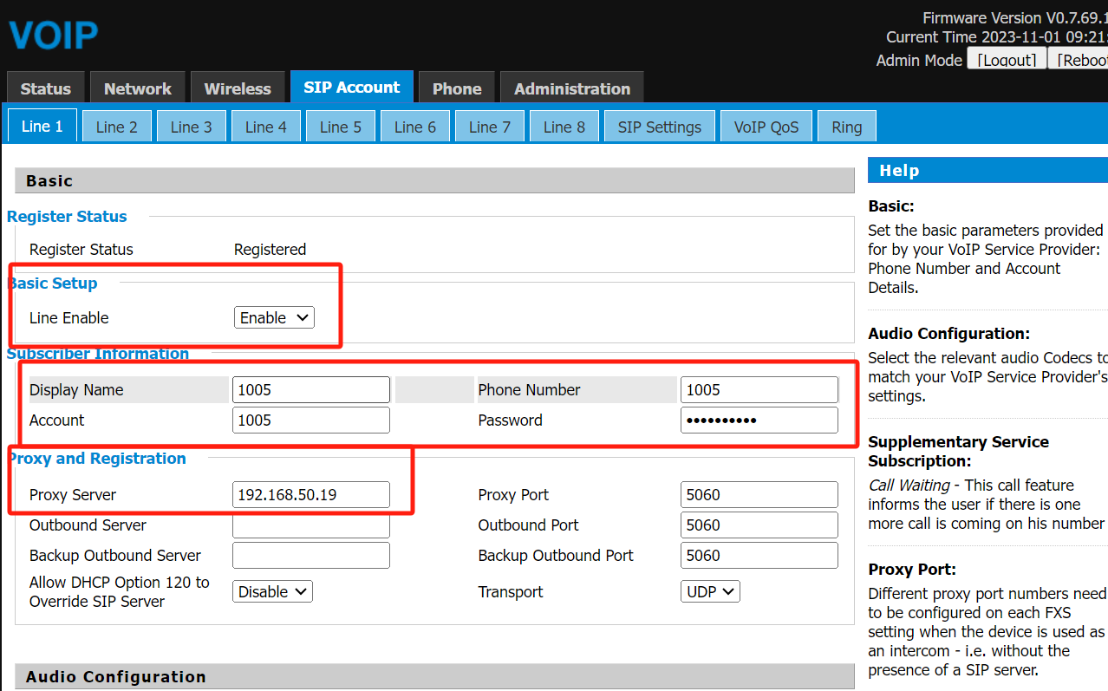

Check the Registeration status on PBX：

Extension and Trunk--》Extension--》Check status

